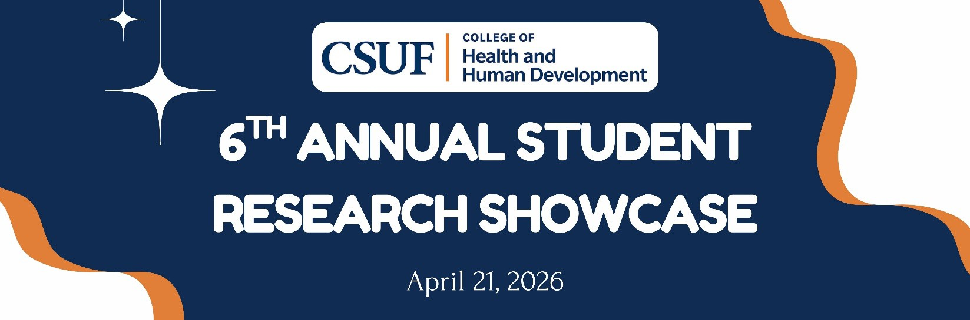

SCHEDULE AT A GLANCE

ORAL PRESENTATIONS

9:00 – 9:50 AM
Virtual Oral Presentation Room #1 (V1)
Zoom Link: https://fullerton.zoom.us/j/85292438560?from=addon
Presentation Title | Presenter(s) | Department/School
Physical Activity Levels and Tendon Pain Predict Short-term Outcomes in Patients with Achilles Tendinopathy | Kasey Markell | Kinesiology
The Relationship between Plantar Flexion Strength and Achilles Tendon Structure in Healthy Adults | Ryan Ritter | Kinesiology
Internal Religious-Professional Discord among Christian Social Work Students | Alex Hashimoto-Chiang | Social Work

10:00 – 10:50 AM
Virtual Oral Presentation Room #2 (V2)
Zoom Link: https://fullerton.zoom.us/j/83796871206?from=addon
Presentation Title | Presenter(s) | Department/School
Building on the Legacy of Latinx Parents' Leadership | Tania Torres Prieto | Child and Adolescent Studies
Rural-Urban Differences in Lung Cancer Prevalence in the United States | Heidy Ibarra | Public Health
Belonging in Uncertain Times: Strategies to Support Undocumented Graduate Students | Alex Ruiz Kaitlyn Lopez  Alvaro Gonzalez-Lovillo | Counseling

11:00 – 11:50 AM
Virtual Oral Presentation Room #3 (V3)
Zoom Link: https://fullerton.zoom.us/j/83620336368?from=addon
Presentation Title | Presenter(s) | Department/School
Growing Through Crisis | Thanh Bui | Social Work
Combat Veterans, Moral Injury, and Psychosocial Wellbeing | Joseph Caputo | Social Work
Psychological Distress and Life Satisfaction Among Transgender Individuals | Danae Christerson | Social Work

POSTER PRESENTATIONS

12:00 – 12:50 PM
Poster Session #1 (P1)
Location: Education Classroom – 2nd Floor Patio

Presentation Title | Presenter(s) | Department/School
The Impact of Ethnicity on Cognitive Decline Among Older Adult Americans | Cheryl Mae Mallabo | Social Work
Narrative Storytelling and HIV Awareness: A Pilot, Mixed-Methods Evaluation of a Community-Based Theatrical Intervention | May Marsh Jonathan Tovar | School of Nursing
Development of an E-Learning Module for Ultrasound-Guided Arterial Line Insertion | Ryan Scimeca Kimson Cantos Cyrus Heravi | School of Nursing
Increasing Pre-Exposure Prophylaxis (PrEP) Initiation for Patient at Risk For HIV and Support Supporting Patient Adherence | Tigist Teshale | School of Nursing
Enhancing Safety: A Program Evaluation of TeamSTEPPS | Claudia Orozco | School of Nursing
What is the relationship between childhood maltreatment and alcohol problems in adults? | Oceana Russo | Social Work
Community Resources and Stress Levels Among Caregivers of Children with Developmental Disabilities | Samantha Ortiz Alizieri | Social Work
Continuing Research in Analyzing Relationships between the Leg/Back Dynamometer, Conventional Deadlift, and Hexagonal Bar Deadlift in Resistance-Trained Individuals | Johnny Montes | Kinesiology
What are the Effects of Physical Activity on Depression in Adults? | Mia Lara | Social Work
The Relationship Between Basic Needs Security and Perceptions of Success for College Students | Eliana McElderry | Social Work
Enhancing Fall Prevention Strategies: RN and CAN Re-Education | Patricia Wekhomba | School of Nursing
Increasing Awareness of the Impact of Night Shift Work on New Graduate Nurses | Julia Apenahier | School of Nursing

1:00 – 1:50 PM
Poster Session #2 (P2)
Location: Education Classroom – 2nd Floor Patio

Presentation Title | Presenter(s) | Department/School
Exploring the Relationship Between Force Development and Mechanical Properties in Healthy and Injured Hamstrings | Julia Butz | Kinesiology
Association between Sexual Orientation and Cervical Cancer in the National Health Interview Survey, 2015-2024: Assessment by Hysterectomy Status | Alyssa Chapa | Public Health
How Self-Determined Motivation Predicts Exercise Attendance | Clay Corpuz | Kinesiology
Inclusive By Design: Strengthening Nursing Practice Through Simulation | Jordyn Alinder | School of Nursing
Developing an Awake Flexible Intubation Education and Training Module Using the Delphi Method | Patrick Dilena Carly Dorminy Cooper Wise | School of Nursing
Islamic Coping Skills and Spiritual Connection: How Does Islam  Serve as a Protective Factor Against Negative Well-being and Depression among Muslims? | Ranya Oubeid | Social Work
Diabetic Retinopathy in Pregnant Women | Miranda Guzman | Public Health

Expanding Screening and Education Regarding Disability Student Services (DSS) for Nursing Students | Long Hoang Merflor Hernando | School of Nursing
Post-Roe health knowledge, beliefs, and perceptions of well-women exams in underrepresented female CSUF students | Lauren Borjas | Public Health
Nursing on the Frontlines: The Critical Role of Nurses in Advancing Social Justice | Alexa Gabrielle Empleo | School of Nursing
Understanding how small-group trainers develop confidence in their training abilities: A qualitative study. | Lily Haeberle | Kinesiology

2:00 – 2:50 PM
Session: Poster Session #3 (P3)
Location: Education Classroom – 2nd Floor Patio

Presentation Title | Presenter(s) | Department/School
Racial/Ethnic Trends and Disparities in Breast Cancer Subtypes Impact on Survival Among Distant Stage Metastasis Diagnosis Patients | Maddie Gilman | Public Health
High Intensity, High Spirits? How Exercise Effort Influences Affect | Ariana Gonzalez Zoe Bravo | Kinesiology
Effects Of A 12-week Multicomponent Exercise Program on Balance and Gait Speed | Lily Merrick | Kinesiology
The importance of food and housing insecurity for California college students’ physical health | Edwin Valdez | Public Health
Reminiscence Therapy & Environmental Design: Dementia Care through the Lens of Generation X | Georgianna Esmeria | School of Nursing
Development of Phonics Literacy Skills in School Settings | Karen Dang | Child and Adolescent Studies
Does physical fitness moderate the association between fibromyalgia and depression? | Ethan Irwin | Kinesiology
Origami Therapy for Age-Friendly Wellness | Crystal Muljadi | School of Nursing
Exploring housing insecurity amongst LGBTQ+ young adults from marginalized backgrounds in Southern California | Xitlali Navarro | Public Health
Using Social Stories to Support Young Children During Challenging Times and Crises | Lyn Ortega Charlene Chang | Child and Adolescent Studies
Movement in the Making: Infant Walker Use and Developing Mobility | Jacob Aranki Bradey Quigley | Kinesiology
Waist Circumference and Metabolic Health in Children with and Without Prader–Willi Syndrome | Aron Rosas | Kinesiology

3:00 – 3:50 PM
Session: Poster Session #4 (P4)
Location: Education Classroom – 2nd Floor Patio

Presentation Title | Presenter(s) | Department/School
Perceptions and Experiences of the Fat Community in the GLP-1 Era | Katie Bradley | Social Work
Grit and Luck: Exploring Driving Factors for Nursing Student Success | Cynthia Garcia | School of Nursing
Comparative Trends and Disparities in the Prevalence and Diagnosis of Multiple Myeloma, Chronic Lymphocytic Leukemia, and Non-Hodgkin Lymphoma | Genevieve Gray | Public Health
Sexual Victimization and Mental Health Among Justice-Involved Youth | Danna Martinez Maravilla | Social Work
Examining the Relationship Between Parental Monitoring and  Behavioral Problems Amongst Youth with a History of Foster Care: A Secondary Analysis | Erica Simmons | Social Work

Tumor Laterality Differences in the Prognostic Impact of Histology Types on Colon Cancer Survival | Ryan Patel | Public Health
Demographic and Clinical Factors Associated with Radiation Therapy Receipt in Breast Cancer | Deniz Suzer | Public Health
Participation in physical activity in a community program and health- related quality of life | Enrique Flores | Kinesiology
From Voice to Action: Parent Motivation and Engagement in CBPR | Ilse Aguilera Diana Nava Angelique Recinos | Child and Adolescent Studies
Brain Health Awareness Among Middle Eastern and North African (MENA) Young Adults in the U.S: A Systematic Scoping Review | Zahraa Ghazi | Public Health
Conducting an online survey to assess CSUF students’ basic needs | Cailin Scheussler | Public Health
Smoking Status and Human Papillomavirus Vaccination Uptake | Naidaly Villalva Villa | Public Health

Please join us for a reception in honor of all our student presenters.
From 12:30-3:30 PM on the EC 2nd Floor Patio, small bites and refreshments will be available for presenters, students, faculty, staff, and families!

