
Understanding Your Catalog Year
What is my catalog year and why is it important?
The CSU and CSUF occasionally modify graduation requirements. If you have been in continuous attendance, you may choose to meet the CSUF campus graduation requirements in the CSUF catalog that was in effect in any of the three following instances:

- at the time you began continuous attendance at CSUF, OR if you are an upper division transfer student, at the time you began continuous attendance at the California Community College,
- at the time you transferred to the CSU campus, or
- at the time you graduate from the CSU campus.

By maintaining continuous attendance and selecting option (1) or (2), you can be assured that your CSU campus graduation requirements will not change. Your right to choose one of these options is called “catalog rights.”

Tip: If you are a new, first- time freshman in the fall of

2018, then your assigned catalog year is 2018 (2018-19). If you are a new transfer student in the fall of 2018 continuously enrolled in community college since fall 2015 or spring 2016, then your appropriate catalog year is 2015 (2015-16) or 2018 (2018-19).
Yes, as long as it aligns with one of the three circumstances listed above. Normally, it is in your best interest to commit to the catalog year, that is, the General Education, major and minor requirements, that were in effect when you first enrolled at CSUF or when you first began uninterrupted enrollment at a community college on your pathway to junior transfer to CSUF. This is because that is the catalog that holds the requirements that you anticipated at the time that you prepared to apply for admission.
Your catalog year’s requirements come as a package. For example, you may not elect to fulfill the major requirements of one year’s catalog, and the General Education requirements of a different year.

May I choose a catalog year other than what I was assigned when I first enrolled here?


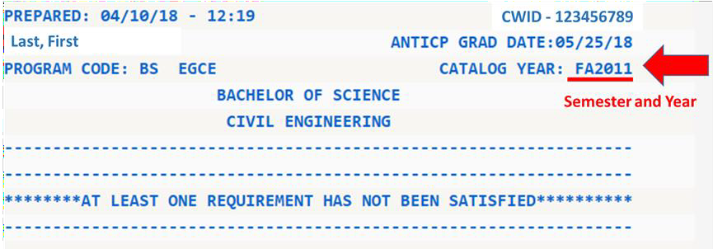
How will I know
which catalog year suits my
needs the best?
You may run a “what if” inquiry on your Titan Degree Audit (TDA) under a different catalog year. Your TDA displays your official catalog year of record at the top of the first page when you log in:

Visit your retention specialist, graduation specialist or major advisor to discuss your options if you have further questions. Find these individuals through your Student Success Center, listed at success.fullerton.edu, click on “Student Success Teams.”
Remember to seek major advising in your college, and General Education advising in the Academic Advisement Center, UH-123. (Exception: MCBE students may seek GE advising in their college.)

