US ARMY CADET COMMAND CADET WELCOME PACKET



BASIC CAMP 2024
DISTRIBUTION RESTRICTION: APPROVED FOR PUBLIC RELEASE; DISTRIBUTION IS UNLIMITED.
USACC, G3, CST Planning Branch.
1


DEPARTMENT OF THE ARMY

''!fll/lf;,•- .,i,16G,1i'
UNITED STATES ARMY ROTC CADET SUMMER TRAINING DETACHMENT 1ST CAVALRY REGIMENT ROAD
FORT KNOX, KENTUCKY 40121-5123

FEB 2 8 2024
ATCC-ST

MEMORANDUM FOR Cadet (Future American Soldier and Leader) SUBJECT: Basic Camp Cadet Welcome Letter

- As the Cadet Summer Training Commandant, I would like to welcome you to Basic Camp at Fort Knox, Kentucky. This summer will introduce you the U.S. Army profession and prepare you to meet the challenges ahead in your military career. I feel privileged to witness this critical phase of your journey as you transition towards becoming one of our Army's future leaders.

- Basic Camp is the first step in your preparation and training to commission as a Second Lieutenant. It is your first opportunity to immerse yourself in the Army culture and experience. The individual and collective training tasks learned here are the foundation on which all Soldiering is built. Through information briefs, rigorous training and specific Soldier skills, the training you will receive will shape and strengthen you both mentally and physically. You have chosen a profession of great meaning and honor requiring stead.fast leadership, trust, and resolve. You have an opportunity to be the future of our Army and lead our Soldiers wherever we are called to fight.

- Over the next four weeks you will receive instruction on physical fitness, character, teamwork, and resiliency. You will be exposed to the Army Leadership Attributes and Competencies through deliberate training and evaluations based on core Soldier skills. The final Field Training Exercise is a culminating event designed to provide a hands-on experience of Army small unit operations.

- During training you will be pushed beyond your comfort zone, and you will be deliberately challenged. It is important to remember you are not going through this alone and will be part of a team. You will also have a world class group of cadre to assist.

- I know each one of you possess the skills and determination to meet these challenges and I look forward to training alongside of you this summer.
C]1ii;;;?:)
AMANDA I. AZUBUIKE
Brigadier General, USA CST Commandant

Table of Contents
Section 1. COVID Information 4
Section 2. Basic Camp Training Strip 5
Section 3. Typical Training Day 6
Section 4. Graduation Requirements and Performance Evaluation 7
Section 5. Training Events Overview 8
Section 6. Administrative Guidance 13
Section 7. Packing Lists… 18

Section 1 - COVID Information
Cadets, cadre, and support personnel that test positive for COVID will be closely monitored and personally engaged to ensure recovery. USACC will set top priority to the Cadets’ mental health, physical recovery, and clear communication with the parents throughout the recovery process.

Section 2 - BC Training Strip
The Cadet Summer Training (CST) strip is divided into four phases: reception; integration; individual task development; tactical phase; and recovery & goal setting. Upon arrival to Fort Knox, Cadets will in-process and attend briefs such as Equal Opportunity (EO), Sexual Harassment/Assault Response and Prevention (SHARP), Army Values, Army history, and a component and accessions brief. Next focus is individual training such as weapon marksmanship and land navigation and prepare for collective tasks in field conditions. To culminate the field training exercise, the Cadets will complete a 10-kilometer foot march into the Garrison. During recovery & goal setting, Cadets will focus on maintenance of equipment, receive their final counseling, and graduation.
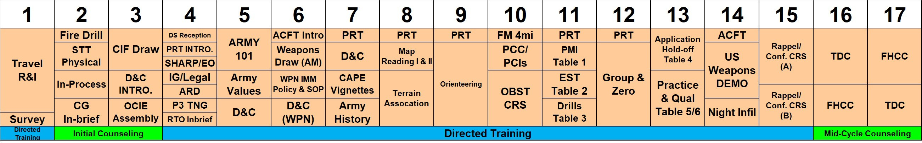
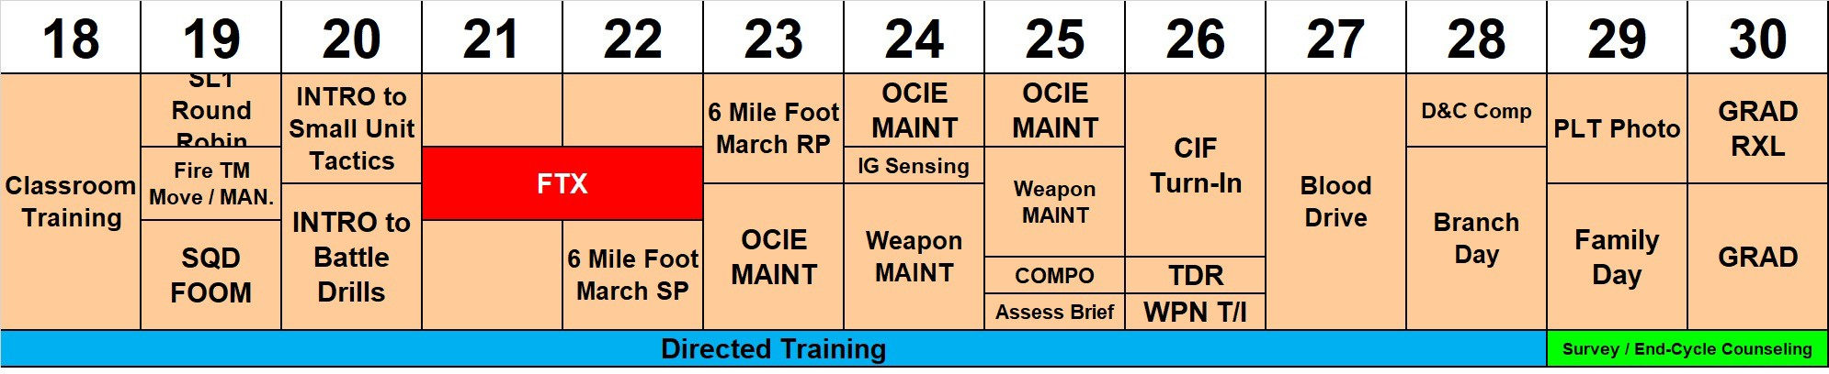
Figure 1- BC Training Strip

Section 3 - Typical Training Day
Typical garrison and field training days at CST consists of the following:

Garrison Training
Time | Activity Description
0500-0530 | Wake up, get dressed and make bed
0530-0700 | Physical Readiness Training (PRT)
0700-0800 | Personal hygiene, clean living area, and breakfast
0800-0900 | Move to training by foot or bus
0900-1230 | Training
1230-1330 | Lunch (movement is integrated into this time as well)
1330-1730 | Training
1730-1900 | Dinner
1900-2000 | Reinforcement Time. Cadets reflect on day’s events and receive leadership counseling
2000-2100 | Cadet Leader’s time
2100-2200 | Personal hygiene. Cadets generally use this time for barracks maintenance, uniform  preparation, and academic study for the next day’s training
2200 | Lights out

Field Training
Time | Activity Description
0500-0530 | Wake up, get dressed and make bed
0530-0630 | Personal hygiene, clean living area, and breakfast
0630-0700 | Move to training by foot or Light Medium Tactical Vehicle (LMTV)
0700-1230 | Training small unit tactics
1230-1300 | Lunch (movement is integrated into this time as well)
1300-1700 | Training small unit tactics
1700-1800 | Move to company area by foot or LMTV
1800-1900 | Dinner
1900-2000 | Reinforcement Time. Cadets reflect on day’s events and receive leadership counseling
2000-2100 | Cadet Leader’s time
2100-2200 | Personal hygiene. Cadets generally use this time for barracks maintenance, uniform preparation, and academic study for the next day’s training
2200 | Lights out
 |  | Figure 2- BC Training Day
Cadets are counseled by their chain of command at least three times on their camp performance, leadership assessments, and Basic Camp Evaluation Report (BACER). If there are discrepancies with the BACER, the Cadet must address the discrepancy with the chain of command PRIOR to leaving CST. BACERs will not be changed after a Cadet departs Basic Camp. There are many ways to address your chain of command with any concerns to include use of the open-door policy at the regimental, task force, and Commandant level.

Section 4 - Graduation Requirements and Performance Evaluation

GRADUATION REQUIRMENTS
- BC Cadets may not miss more than 48 hours of training, not to include required rest cycles (7 hours per night as per TRADOC Regulation).

- Cadets who fail to meet the prescribed standards will not receive completion credit for BC, unless they are given a waiver. Waivers are issued at the Task Force (TF) commander's (CDR) discretion upon recommendation by the Cadet's regimental cadre. Generally, a waiver is considered if the Cadet's performance is above average and/or the Cadet's potential for contracting is above average, and exceptional circumstances exist which interfered with the Cadet's completion of BC (e.g., a medical emergency, a family emergency, etc.).

PREFORMANCE EVALUATION

At the conclusion of BC, Cadets will receive an overall assessment of their performance on USACC Form 1059-BC (BACER). The purpose of this assessment is to inform the PMS for further professional development.

Section 5 - Training Events Overview

The training events outlined on the following slides provide an overview of “must attempt” events. You must understand the tasks to be trained and standards you will be expected to meet. For a more detailed view of the tasks, conditions, and standards for BC events and Soldier skills associated with BC, refer to the links directly following these slides.

Training Event Overview

Basic Rifleman Marksmanship (BRM)
Action: Maintain an M4-Series Rifle Carbine.
Condition: You have just returned from a mission with your loaded M4 series carbine and have been directed to conduct maintenance on your weapon. You have a small- arms case or a maintenance equipment case.
Standard: Clear, disassemble, clean, inspect, lubricate, assemble, and perform a function check on the M4. Maintain the magazine and ammunition.

Communication

Action: Operate a Single Channel Ground and Airborne Radio System (SINCGARS) Conditions: Given a requirement to contact a distant radio station, an operational SINCGARS, antenna, distant station, Signal Operations Instructions (SOI), and required references in an operational

environment.
Standards: Prepare SINCGARS in Single Channel (SC); establish communication with a distant station by successfully conducting a secure communication check according to required frequency.

Land Navigation

Action: Conduct Land Navigation in a scenario-based environment.
Condition: In a field environment, given a certified Land Navigation course, map, compass, and graphic control measures, complete the course in the allotted time. Standard: The Cadet, acting as a PL must plan, prepare, and execute Land Navigation operations in a scenario-based environment. Receive a GO by navigating from one point to another and meeting all requirements for the Land Navigation.
Machine Guns

Action: Maintain an M249 or M240B.
Condition: You have just returned from a mission with your loaded M249 or M240B and have been directed to conduct maintenance on your weapon. You have a small- arms case or a maintenance equipment case.
Standard: Clear, disassemble, clean, inspect, lubricate, assemble, and perform a function check on the M249 or M240B.

Range Card

Action: Prepare a range card for your position.
Conditions: During daylight, in a defensive fighting position, given an assigned primary sector of fire with recognizable targets; a secondary sector of fire with recognizable targets; blank standard range cards DA Form 5517-R; a pencil; a lensatic compass; and a map of your assigned sector of fire.
Standards: Prepare a range card for your position. Sketch in the terrain in your assigned sector of fire. Located and sketched in magnetic north. Using the appropriate symbol. Sketched in sector limits, the gun symbol, and dead space. In the DATA section wrote in the weapon, the unit, and other required data. Sketched in terrain features that offer likely targets and numbered them in priority.
Order and Formations of Movement

Action: Conduct individual, team, squad level movements.
Conditions: In a training environment, given your assigned weapon and a team or squad sized element; maneuver through different types of terrain; react to contact in different situations; engage the enemy; and learn the fundamentals of different types of maneuver formations.
Standards: Be able to successfully maneuver through different types of terrain and to react to enemy fire while maintaining the correct formation to overcome the objective.

Section 6 - Administrative Guidance

Cell Phones. Cadets will secure their personal cell phones throughout camp. However, Cadet cell phone usage times will be directed by CST cadre.
Medications. All medications must be in the original labeled container [(Over the Counter (OTC) or prescription-to include birth control pills)] along with most recent clinical note prescribing the medication. Medical cadre members may, at their discretion, examine the contents of any open bottle of medication to ensure the pills are all the same and consistent with the labeled contents.
- Category III and IV controlled substances will be reviewed by medical cadre.
- OTC medications for pain or allergies will remain with Cadets for ongoing use as intended and approved by the Food and Drug Administration (FDA); however, Cadets should be aware of the potential for the medication to mask symptoms of disease or injury. If the Cadet is taking the maximum daily recommended dose, the Cadet should be evaluated by a provider at the Cadet medical clinic. The major side effects of some OTC allergy medications are drowsiness and dehydration, both of which are dangerous in a field/training environment. Cadets concerned about allergies in the field environment should discuss this with the physician during their medical examination at CST.
- Metabolic enhancers, stimulants, and creatine supplements of ANY kind are PROHIBITED and will be stored for the duration of CST. You may bring healthy non- perishable, pre-packaged snacks such as protein bars with you to Fort Knox. There will also be time and facilities available for local purchase.
- All medications must be declared on DA Form 2807-1. Prescription medications will always remain in the Cadet’s control.
- Sharing of prescription drugs between individuals is illegal by both state and federal law. Cadets participating in the giving or receiving of prescription medications will be disciplined in accordance with the Uniform Code of Military Justice (UCMJ).
- There is no list of recommended OTC drugs; however, Cadets should bring any OTC drugs they are currently taking with a min of 30-day supply.
Personal belongings. Personal belongings (i.e., rings necklaces) will be secured by cadre to safeguard and protect Cadet’s property.
Prohibited Items. Cadre will confiscate the following:
- Weapons or ammunition of ANY type. No knives with blades longer than three (3) inches. Disposition of confiscated weapons and/or ammunition will be determined by the appropriate authorities.
- Pornography will be destroyed.
- Controlled substances (unprescribed), tobacco, or alcoholic beverages of any type.
- Tanker Boots, zipper boots and all cold weather boots will be confiscated and stored until completion of CST.

- Large amounts of cash (more than $500) will be safeguarded by cadre and will be returned upon completion of camp. Cadets will receive a hand receipt from cadre documenting the transaction.
- Contact lenses are prohibited during all phases of Basic Camp. You are required to wear prescription glasses in lieu of contact lenses at Basic Camp.

Postal Services. Cadets should bring an initial supply of stamps, writing paper, and envelopes to CST. Mailboxes for outgoing mail are located throughout the CST footprint. All outgoing mail should include the CST address and the return address.
To send mail to Advanced Camp Cadets, use the following address format:

CADET LAST NAME, FIRST NAME MI HQ, USACC, BC
XX REGT, XX COMPANY, XX PLATOON (specify) 24 RHINELAND STREET

FORT KNOX KY 40121-5117

All mail received before 6 May or after 14 August will be returned to sender.
To expedite delivery, packages sent to CST should NOT require signature, whenever possible.

Pay and Subsistence.
- Direct Deposit/Electronic Fund Transfer (EFT). All Cadets attending CST must have either a checking or savings account established prior to CST. Direct Deposit/EFT is mandatory for all CST attendees.
- Cadets in a current pay status will be paid on the 1st and 15th of the month by EFT. Cadet pay will be deposited directly into the same account as the monthly stipend checks are deposited.
- Family Separation. Green to Gold Active Duty (GTG-AD) Cadets who have dependents living with them are authorized Family Separation Allowance only if they successfully complete a minimum of 30 continuous days at AC. Once GTG-AD Cadets have returned to their home station, they will file a travel voucher through their ROTC Detachment. Upon payment of the travel voucher and receipt of the settlement voucher/notification, GTG- AD Cadets will submit DD Form 1561 with a copy of the settlement voucher/notification to the Fort Jackson Student Detachment which will process the pay adjustment. Expect this process to take 1-3 months.
- All Cadets should ensure funds have been deposited rather than assuming funds have been deposited into their applicable accounts.
- During BC, Cadet Pay questions should be addressed through the Regimental HRA to the CST Pay Team for resolution. Following AC, Cadet Pay questions should be addressed to the Detachment HRA or the Liaison at the CTLT, Nurse Summer Training Program (NSTP), and/or respective location.
- Green To Gold (GTG)-Active Duty (AD) Option Cadets:

  - GTG-AD Cadets will earn their regular pay and entitlements during AC and follow- on-training (FOT).
  - Base Allowance for Subsistence (BAS). GTG-AD Cadets will have government provided meals deducted from their BAS while attending AC and FOT. The BAS deduction must be submitted by the Cadet/ROTC detachment following completion of AC to the Fort Jackson Student Detachment which will process the pay adjustment. Expect this process to take from 1- 2 months.

Common Phone Numbers And Websites.
American Red Cross: 1-800-733-2767
CST Operations Center: 502-624-ROTC (secondary means of emergency contact) www.knox.army.mil/
www.flickr.com/photos/136737541@N05/
https://twitter.com/armyrotc www.facebook.com/cadetcommand

In Case of emergency, your family may initiate a Red Cross message by calling the following number and providing the required information.

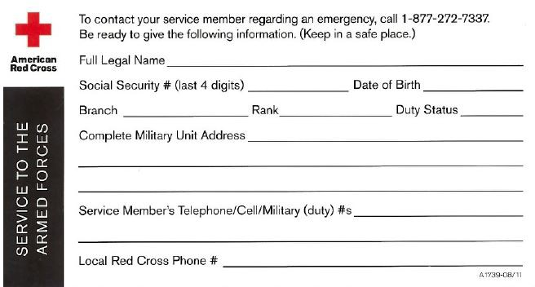
1-800-733-2767


Documents. Cadets must report with all documentation outlined on the personnel records checklist. Refer to Fig. 4 – Personnel Records Checklist.

It is your responsibility to coordinate with your HRA to ensure that you report with the appropriate documents.
CST CADET PERSONNEL RECORDS CHECKLIST
CADET NAME (LAST, FIRST, MIDDLE NAME, NAME EXTENSION): |  |  |  | HOST SCHOOL:
The following documents must be hand-carried to CST by ALL Cadets, unless directed otherwise. Any incomplete or incorrect packets will cause delay at in-processing and may negatively impact the Cadet’s ability to start training.
INITIAL | QTY | DOCUMENT | REMARKS
 | 2 | DAMPS Active Duty for Training orders (for all training)
 | 1 | DD Form 2983, Recruit/Trainee Prohibited Activities Acknowledgement | Must be signed within one calendar year of CST graduation date
 | 1 | Follow-On Training documents (copy of orders and travel itinerary etc.), as applicable | Type: Location:
 | 1 | Travel Itinerary and 1610, including all legs of travel | Do not schedule flights for prior to 1500 EST on graduation day.
 | 1 | Valid Common Access Card (CAC) with known PIN (ALL Contracted Cadets) | A new CAC is required if expiration date is within 60- days of CST report date. Fort Knox does not waiver the DoD proof of identification requirements for replacement CAC while in training. Ensure Cadets travel  with 2 forms of valid identification
 | 1 | Valid government-issued photo ID (non- contracted Cadets)
 | 1 set | Identification Tags | All Contracted Cadets
 | 1 | DD Form 93 | Must be signed within one year and a copy uploaded into iPERMS, prior to reporting to CST
 | 1 | SGLV Form 8286 (Servicemembers’ Group Life Insurance Election and Certificate) | Signed form must be uploaded into iPERMS prior to reporting to CST
 | 1 | Verify all bank and accounting information in CCIMM | Student/Cadet Information/Pay Tab
 | Optional | Early Release Request (if applicable) | Requests for Cadet Early Release will be approved by CST TF Commander
HRA NAME, PHONE NUMBER AND EMAIL ADDRESS:

Figure 4- Cadet Personnel Records Checklist

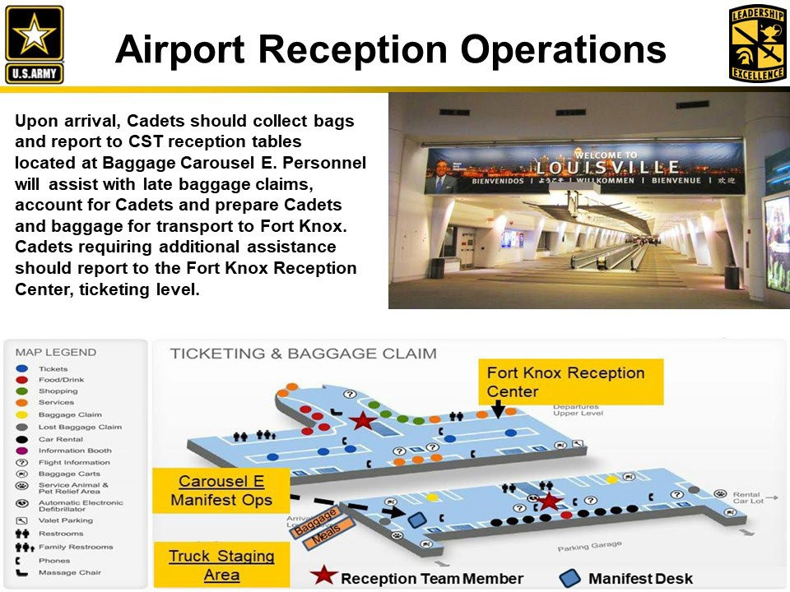

Change 1 to TAB B- (Non-Contracted Cadet Packing List) to Appendix 6 (Cadet Packing List) to Annex F (Sustainment) to USACC OPORD 23-09-026 Cadet Summer Training

(BEFORE PACKING, CHECK WITH YOUR CADRE FOR ANY CHANGES AND TO ENSURE YOU ARE USING THE CORRECT LIST). Note: CADETS ARE REQUIRED TO BRING 2 SETS OF EYEGLASSES. THE USE OF CONTACTS AT BASIC CAMP IS PROHIBITED DURING ALL PHASES.
Cadet Summer Training 2024 and Beyond Non-
Contracted Cadet Packing List (JAN 2024)
MS Level: |  |  | Cadet Name:
CST Regiment: |  |  | School: | Inspection Date:
** ACU clothing bag items will be in OCP pattern only**
Cadets will report to CST with signed copy of packing list and copy of KYLOC clothing bag records.
PMS or designated representative will validate all Cadet baggage prior to departure.
PGC | LIN | NSN | Nomenclature |  | Req | OH QTY | Campus Cadre Initials
Clothing Bag Items issued at Program Level (Uniform Sizes are NSN specific, must be in OCP pattern)
04009 | C05062 | 8415-01-630-8905 | Cap, Patrol, Army Combat Uniform OCP | Size | 1
03976 | C05065 | 8415-01-623-5052 | Coat, ACU OCP (Permethrin). | Size | 2
93664 |  | 8455-01-524-4476 | Patch, US Flag |  | 1
35608 |  | 8455-01-531-6334 | Tape, US Army, ACU Velcro |  | 2
99204 |  | 8455-00-000-9995 | Nametape, ACU Velcro |  | 2
29636 |  | 8455-01-528-8869 | Patch, Unit, Cadet Command |  | 1
03977 | T05051 | 8415-01-623-3923 | Trousers, ACU OCP (Permethrin). | Size | 2
04015 | B05007 | 8415-01-630-9491 | Belt, Rigger's, Coyote | Size | 1
04011 | T05049 | 8430-01-630-5523 | T-Shirt, Moisture-Wicking, Coyote. | Size | 2
02882 | S89914 | 8440-01-508-3357 | Socks, Boot, Black / Green. | Size | 2
04039 | B60315 | 8430-01-632-2475 | Boots, Combat, Hot Weather OR  Boots, Combat Temperate |  | 1
04040 | B13584 | 8430-01-632-5324 | Boots, Combat, Hot Weather OR  Boots, Combat Temperate | Size | 1
04118 | G05021 | 8415-01-644-4837 | Gloves, Light Duty Utility, (LDUG) | Size | 1
03983 | T05044 | 8415-01-623-2516 | T-Shirt, APFU, Short Sleeve | Size | 1
03982 | T05042 | 8415-01-623-2466 | Trunks, APFU | Size | 1
36096 | B14729 | 8465-01-604-6541 | Bag, Duffel, Nylon, Improved |  | 1
OCIE items issued at Program Level (Camouflage patterns can be mixed (UCP with OCP))
29011 | R97425 | 8465-01-525-0578 | Rifleman Set, MOLLE, components A thru F below:  (Build a complete Core Rifleman Set before ordering a new one) |  | 1
29001 | DA655K | 8465-01-525-0577 | A. Fighting Load Carrier, MOLLE |  | 1
29009 | DA6593 | 8465-01-525-0589 | B. Pouch, Hand Grenade, MOLLE |  | 2
29010 | DA6562 | 8465-01-525-0606 | C. Pouch, M4 Two Mag, MOLLE |  | 3
29008 | DA6588 | 8465-01-525-0585 | D. Pouch, Canteen, General, MOLLE |  | 2
28970 | DA653Y | 8465-01-524-5232 | E. Carrier, Hydration System, MOLLE |  | 1
28969 | DA657E | 8465-01-524-5250 | F. Pack, Assault, MOLLE |  | 1
28701 | DA651E | 8465-01-519-2304 | Bladder, Hydration System (Multiple sizes available. Match bladder size with hydration carrier) |  | 1
29128 | DA650F | 8465-01-524-8368 | Pack, Frame, MOLLE |  | 1
91709 | DA654J | 8465-01-524-5285 | Ruck, Large, MOLLE |  | 1
28967 | DA6517 | 8465-01-524-7232 | Waistbelt, Molded, MOLLE |  | 1
29004 | DA6545 | 8465-01-524-8407 | Carrier, Entrenching Tool, MOLLE |  | 1
28966 | DA652Z | 8465-01-524-7240 | Straps, Shoulders, Frame, MOLLE |  | 1
28968 | DA655V | 8465-01-524-7226 | Pouch, Sustainment, MOLLE |  | 2
28992 | DA657S | 8465-01-524-8415 | Buckle, Male Shoulder, MOLLE |  | 2
28958 | DA657W | 8465-01-524-7241 | Load Lifter Attachment, MOLLE |  | 2
Modular Sleep System:
21267 | DA658Z | 8465-01-398-0685 | Bag, Patrol, Sleeping / Foliage Green / X-LG {MSS} |  | 1
77777 | DA6506 | 8465-01-416-8517 | Bivy Cover Sleeping {MSS} |  | 1
77777 | DA659E | 8465-01-547-2670 | Stuff Sack Large Compression Blk {IMSS} |  | 1
21228 | M24944 | 8465-01-393-6515 | Mat Sleeping (Foam Pad or Self inflating) |  | 1
NA | MC20CH | 5120-00-878-5932 | Entrenching Tool (E-Tool) Hand, Folding, Heavy-Duty |  | 1
34494  03129 | K34733 H53175 | 8470-01-092-7527  8470-01-529-6329 | Helmet, Ground Troops / Parachutist (PASGT) (CIF does not have the parts to service the old kevlar) OR Helmet, Advanced Combat (ACH) Size |  | 1
03113 | C28472 | 8415-01-521-8808 | Cover, Helmet | Size | 1
10328 | DA151M | 8415-01-524-5842 | Helmet, Band Camouflage (Cat eyes) |  | 1
NA | HA4084 | 4240-01-630-8327 | Spec Industrial ESS Crossbow w/case or UVEX XC Eyewear, Blk Frame |  | 1
03144 | DA1556 | 8415-01-530-2157 | Elbow Pads |  | 1
03143 | DA1588 | 8415-01-530-2350 | Knee Pads |  | 1
04713 | C96536 | 8465-01-115-0026 | Canteen, 1 Quart, Water, Plastic |  | 2
10404 | F54817 | 8465-00-165-6838 | Cup, Canteen |  | 1
NA | J05017 | 8415-01-641-0778 | Jacket, Extended Cold Weather, GEN lll Layer 5 (issued via ODO) | Size | 1
NA | T57106 | 8415-01-527-1551 | Trousers, Extended Cold Weather, GEN lll Layer 5 (issued via ODO) | Size | 1
32523 | P17415 | 8405-01-547-2555 | Poncho, Wet Weather (May issue 8340-01-600-4807 TARP if available) |  | 1
32522 | L70789 | 8405-01-547-2559 | Liner, Wet Weather, Poncho |  | 1
06284 | B13907 | 8465-00-530-3692 | Bag, Barracks |  | 1
42193 | B15825 | 8465-00-261-6909 | Bag, Waterproof |  | 1
28979 | DA654S | 8465-01-524-7638 | Pouch, External Medical |  | 1
Packing List Validation
Date: |  |  | Host School:
Inspector Rank, Name: |  |  | Inspector Signature:
PMS Name: |  |  | PMS E-mail and Phone Number:
School POC: |  |  | Phone Number:

Items issued at Program level |  | Req | O/H QTY | Campus Cadre Initials
CST Packing List Inventory Signed by Campus Cadre |  | 1
Ranger Handbook |  | 1
Camouflage Stick - Light Green / Loam |  | 2
550 Cord (Green / Black) |  | 30M
Protractor, Map |  | 1
Compass, Lensatic (2 preferred if available at program) |  | 1
Belt, Reflective, Yellow |  | 1
Individual Cadet provides the following items:
Civilian Apparel- For 'travel and off duty activities' while at CST (i.e. family day) the prescribed 'uniform' is as follows: Cadets will carry  a set of PTs (PT SS shirt, PT shorts) and running shoes in their carry on baggage. |  | Req | O/H QTY | Campus Cadre Initials
Pants, Khaki, or conservative length khaki shorts (one pair will be used for travel) |  | 2
Shirt, polo / golf style, in solid color (preferably school and / or ROTC branded) (one will be used for travel) |  | 2
Shoes, weather appropriate (no open toe shoes allowed) |  | 2
(NO inappropriate clothing, tank tops, t-shirts with foul/profane language, short shorts, etc. No athletic style clothing will be worn on family day, travel days or after graduation.)
Underwear, cotton |  | 7 (min)
Socks, Athletic, plain white or black (Must cover / be above ankle but no higher than mid calf. No stripes or logos) |  | 6
Shoes, Running |  | 1
Towel, Bath, Brown |  | 2
Shoes, Shower |  | 1
Padlock, Combination (keys are often lost) |  | 3
Tags, Identification w / medical tags if required |  | 1 Set
Wristwatch |  | 1
Headlamp w / red lens (extra batteries and bulb) |  | 1
Pad, Writing, pocket size for notetaking (write in the rain prefered) |  | As Req
Pencil, mechanical, 0.5mm |  | 3
Pen, Black Ink |  | As Req
Personal Hygiene Items (min 30-day supply required) |  | As Req
Wipes, Baby or Towelettes, Cleansing (80 pack) |  | 1
Sunscreen |  | 1 (min)
Mirror, small, portable, shaving |  | 1
Razor w / 4 blades and Cream, Shaving |  | As Req
Toothbrush and Toothpaste |  | As Req
Clipper, Nail |  | As Req
Soap, bar w / Soap Container (unscented) |  | As Req
Comb / Brush |  | As Req
Deodorant |  | As Req
Spray, Bug (DEET) |  | 1 (min)
Detergent, Laundry (High Efficiency ONLY) |  | As Req
Prescription medications: Must be in original labeled container (over the counter or prescription, to include birth control pills) along with most recent clinical note prescribing medication. Medical Cadre members may, at their discretion, examine contents of any open bottle of medication to ascertain pills are all same and consistent with labeled contents. MUST DECLARE DURING MEDICAL INPROCESSING.  (USACC Circular 145-5, pg 9) |  | As Req
Cadet-Provided Optional Items
Cap, Synthetic Microfleece, Green or Black (PT Cap) |  | 1
T-Shirt, Cotton, Sand (Recommend additional t-shirts for AC Cadets due to extended FTX) |  | 3
Shorts, spandex, grey or black, no logo |  | 2
Socks (Black / Green) (Recommend additional socks for Advanced Camp Cadets) |  | 7
Dryer, Hair |  | 1
Kit, Sewing |  | 1
Beads, Pace Count |  | 1
Cord, Bungee, med size (black / brown / green / ACU) |  | 5
Bag, Zip-Lock, Gallon Size |  | 10
100 mph Tape (green) |  | 10ft min
Washcloth, White or Brown |  | 2
Alcohol Markers |  | 1 pack
Mandatory Female additional items
Underwear, Cotton (White, black, or neutral color as per AR 670-1 20-28a(2)) |  | 7
Bra, Sports, suitable for running (White, black, or neutral color as per AR 670-1 20-28a(2)) |  | 5
Hair accessories, plain design, matching hair color |  | As Req
Wipes, Feminine / Additional Baby Wipes UNSCENTED (About 2-3 per day, 20-day supply) |  | As Req
Personal Feminine Hygiene Items (20 days for the field in the A bag or Ruck Sack) |  | As Req
Pads/Tampons (unscented, recommend w/applicator, additional ziplock bags for storage of used / unused products) |  | As Req
Optional Female additional items
If Birth Control is utilized, the following methods are authorized during training: (Recommend birth control method be implemented 90 days prior to training)
Intrauterine Devices (IUD) Mirena, ParaGard ONLY
Birth Control Pills (45-day supply) |  | As Req
Patch (Ortho-Evra is NOT recommended)
Implant - Nexplanon
Female Urinary Diversion Device (FUDD) or similar Item  NSN: 4510-01-470-2805 (or neutral color if purchasing non-Army issued model) |  | 1
Packing List Validation
Date: | Host School:
Inspector Rank, Name: Inspector Signature:
PMS Name: PMS E-mail and Phone Number:
School POC: Phone Number:

