Campus Based CBEF Access Instructions

Step 1: Cadet must first have a valid, working GoArmy Account
- If you DO NOT have a GoArmy User ID (email) and Password, go to Step 2
- If you DO have a GoArmy User ID (email) but FORGOT your Password or Password has expired (expires in 45 days), go to Step 3
- If you DO have a working GoArmy User ID (email) and Password, go to Step 4
- It is highly recommended that you use a personal email for this such as Gmail, Hotmail, Yahoo, etc. (not iCloud or any .ORG or .EDU email). Make sure the email account you use is working properly as GoArmy will send emails to it.

Step 2: Create a GoArmy.com Account
- Go to https://my.goarmy.com/
- Read Privacy & security Notice, click “Accept” then “Submit”.
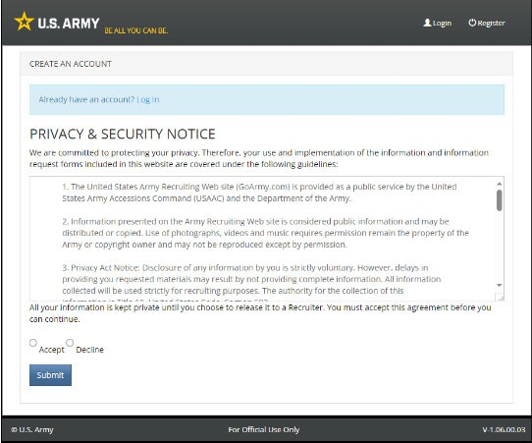

- Create an Account: Enter all required information and click “Submit”. If using a cell phone, be sure you do not include an extra space before or after anything entered.
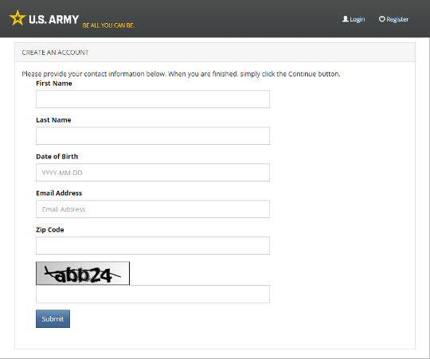

- Notification that you will receive an email verification will be next. You can now close GoArmy and check your email.
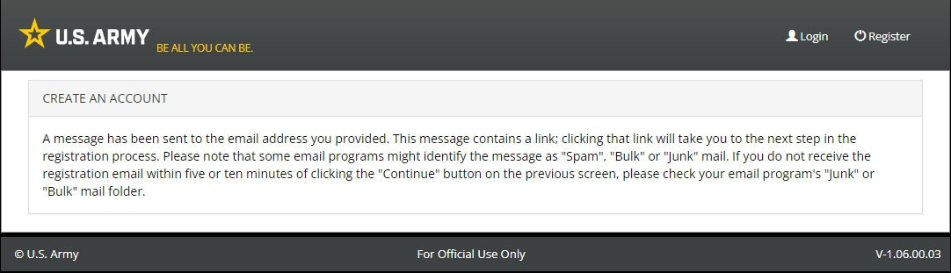

- An email confirmation will arrive to your email Inbox. Click on the link contained in your email.
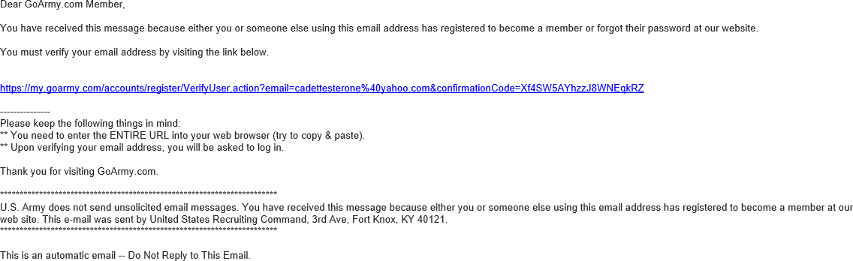

- Create your new password.
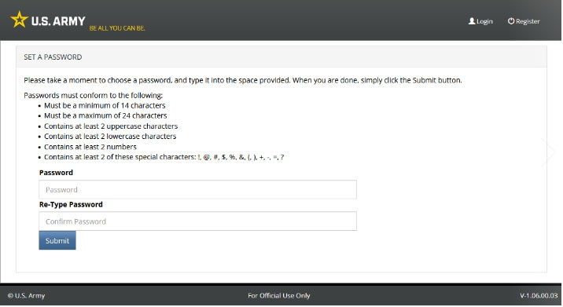
Be sure and follow the rules closely. Click “Submit” and the below screen will appear so you can validate your login.

- Validating your new GoArmy login by first clicking “Accept”.
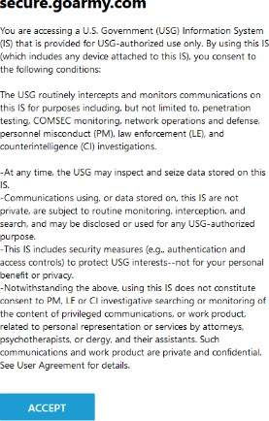

- Enter email and password and click Logon.
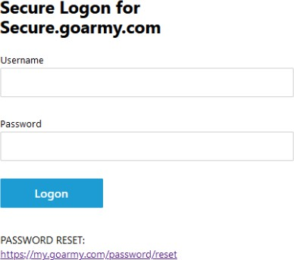

- Successful login will show this. Otherwise, you will get an error.
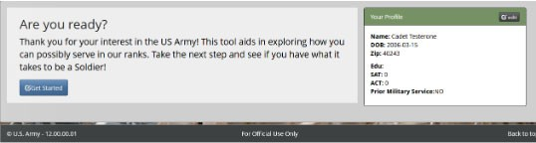
- Now you can leave this site and not return unless you forget your password or your password expires at 45 days.

Step 3: Reset Forgotten or Expired GoArmy Password
- Go to URL https://my.goarmy.com/password/reset/ and enter the Email Address you registered with and the Image Code and click Submit.
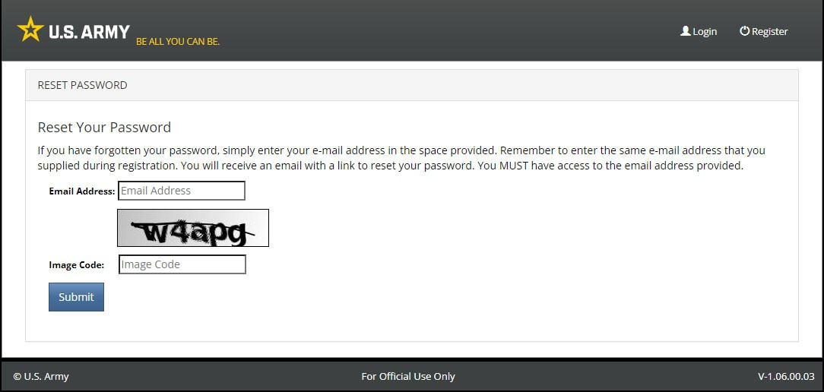

- A message states that you will receive a password reset email.
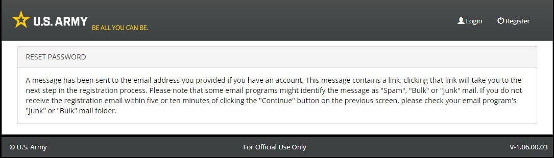
- Go to step 2E above as the process to reset your password is the same as when creating a new one. For password resets, follow the rules closely as your new password cannot be similar to the last 5 passwords. Your password will expire in 45 days without warning.

Step 4: Log into CBEF
- Go to CBEF https://cbef.usarmyrotc.com/
- Click “Accept” on the DOD notice and Consent banner.
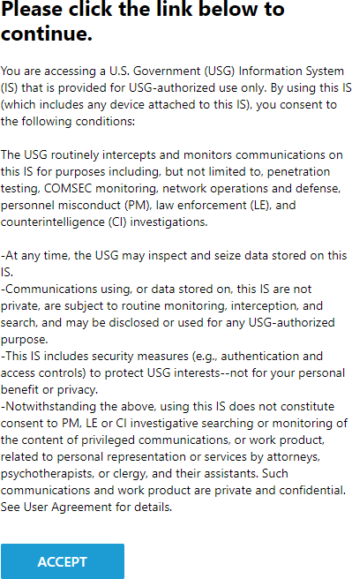

- Enter your GoArmy Username (email) and password and click “Logon”
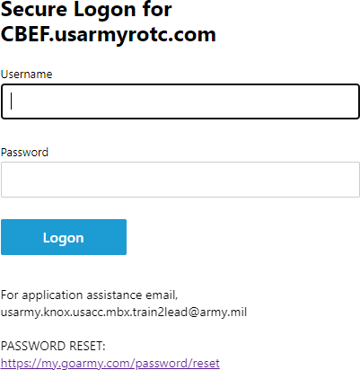

- Click “Accept” on the DOD Notice and Consent Banner
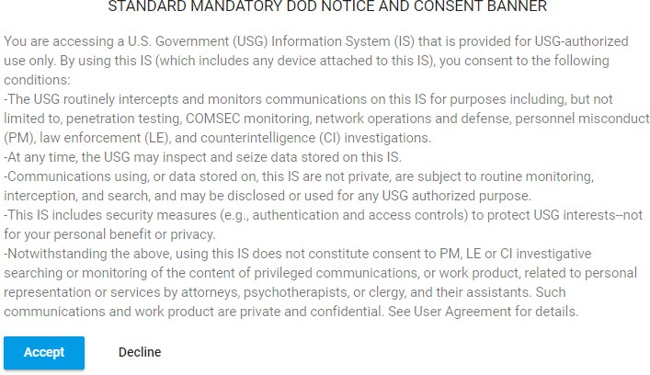

- Enter the last four digits of your SSN and then your “Home of Record” (HOR) Zip Code. Click “Next”. Note: The “Home of Record” Zip Code should be your Zip Code of origin rather than the Zip Code of where you live now at or near the school you attend.
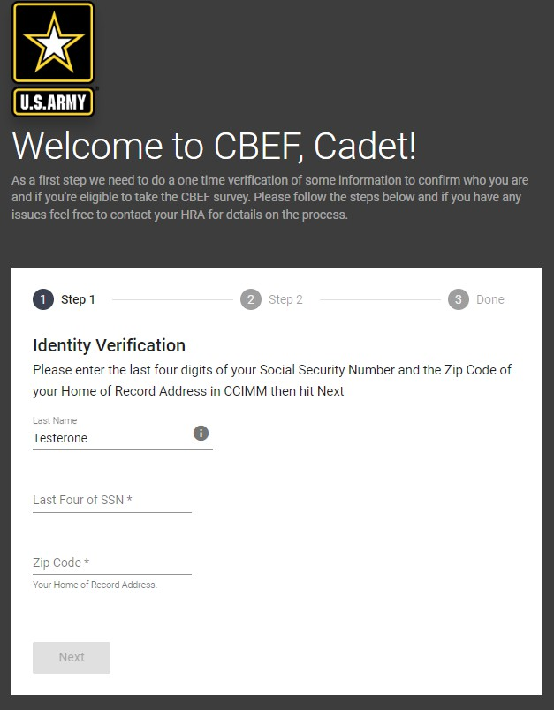

- If you get a “Verification failed” message (below), then what you entered does not match what your Recruiter put in the CCIMM database. You must contact your Recruiter and verify the SSN and HOR Zip Code as one or both of those will need to be corrected in CCIMM. You may also get this error if your Recruiter has not created a profile in CCIMM for you. Contact them in either case.

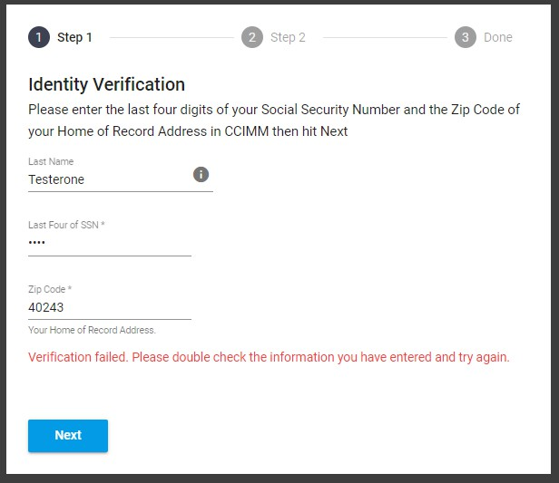
- Choose the correct HOR address that matches the Zip Code you entered above and click “Next”.
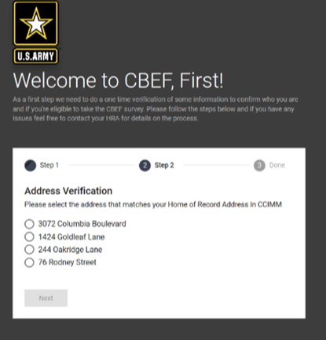

- You have been authenticated! Click “Continue” to be sent to your dashboard where you can begin the CBEF survey. Continue until complete. Be honest and consistent throughout. Try to complete the survey in one sitting so that you remember how you answered previous questions. Each page has 5 questions and you can change them until you click “Next”. Once you do, you cannot go back.
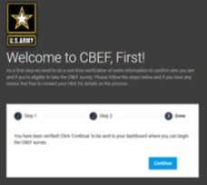

Troubleshooting:
- When setting up a new GoArmy account and waiting for emails, be patient. It sometimes takes up to an hour to receive these emails. If you never get an email to setup your new or changed password, go to step 2 again and re‐register with GoArmy using a different personal email address. You can register with GoArmy multiple times using the exact same information as long as you use a different email address. CBEF does not care what your email address is as long as you have a good, working GoArmy account.
- When setting up your password and submitting, if you get an error, it may be because your password does not adhere to the rules or you entered it in differently the second time. Check the quality of your password and be sure and enter it exactly twice.
- Once in CBEF, if your authentication fails, contact your Recruiter to have them fix what they entered in the CCIMM database. Last name, HOR Zip Code and Last 4 of your SSN must match exactly or you will not be able to proceed.
- Once you have your GoArmy account working, login to CBEF and try and take the survey in one session. If you do this, you will never have to worry about your password expiring in 45 days.
- Be very careful and aware of the fact that using a cell phone to do this sometimes causes extra spaces before and after your names. We highly suggest that you use a Windows PC to do this, but it is not mandatory.

