


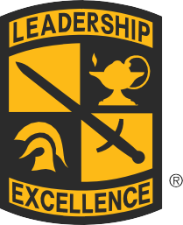
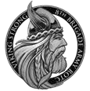
8TH BRIGADE
ARMY ROTC
NURSING
RECOGNIZING YOUR MERIT.
If you distinguish yourself academically and have a strong record of participation in extracurricular activities, you may qualify for a 2-, 3-, or 4-year merit-based scholarship. This may include allowances for books, monthly stipend, NCLEX* Prep Course, and clinical supply reimbursement. If you are applying while in high school, you could be eligible for the Army ROTC National Scholarship by starting the application after your junior year.

The following courses are required at most nursing schools prior to enrollment into the upper division of a BSN program. Applicants can distinguish themselves with strong academic achievements in these courses during high school:

MATH/STATISTICS
NATURAL SCIENCES: anatomy and physiology, chemistry with lab, microbiology with lab
SOCIAL SCIENCES: psychology/sociology/growth and development

$420 per month, per year for personal expenses
$1,200 per year for books
*100% coverage for full tuition and fees based on merit and grades, and the option to cover room and board instead, for qualifying cases.
*NCLEX: National Council Licensure Examination for Registered Nurses.

WE’D LOVE TO HEAR FROM YOU!

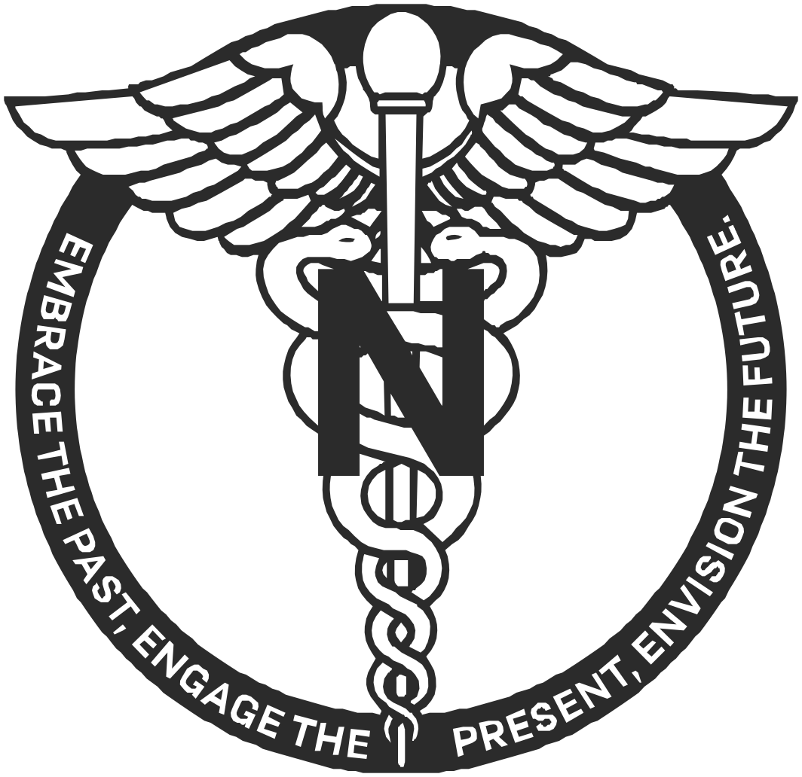
8th BRIGADE ARMY ROTC NURSING
E-mail: usarmy.knox.usacc.list.bde-8-nurse@army.mil
Phone: (253) 477-3576 or (253) 477-3575
Find us on Social Media @8bdearmyrotc

SCHOLARSHIPS

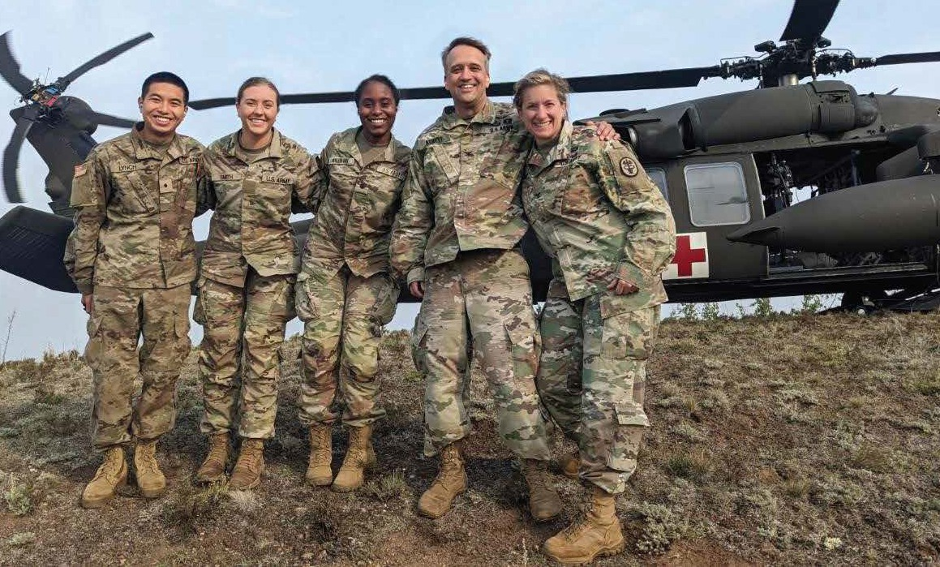


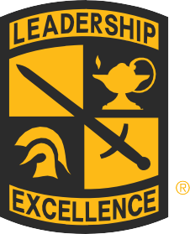


The Army Nurse Corps represents more than 11,000 Soldiers dedicated to providing high-tech, quality health care for military personnel, their families, and military retirees all over the world. They support humanitarian missions and respond to natural disasters, experiences unmatched as a civilian nurse. The Army can be an invaluable resource for continuing your nursing education in one of the following nurse specialties:
IMPROVE YOUR SKILLS. PURSUE A SPECIALTY.
CRITICAL CARE BEHAVORIAL HEALTH PERIOPERATIVE EMERGENCY TRAUMA GYNECOLOGY/ OBSTETRICS PUBLIC HEALTH
,
ar
of om nd ed ve
As an ROTC Cadet
you can receive a two, three, or four-ye
scholarship that covers the full cost tuition and fees as well as provide a ro and board grant, book allowance a monthly stipend. Add that to a guarante job after graduation with a competiti salary and regular pay increases!
MEDICAL SURGICAL

EARN UP TO $35,000 IN BONUSES

Graduate degree programs can also be fully funded once eligibility requirements are met. To learn more, including which specialties offer a bonus, scan the QR Code below!
CERTIFIED REGISTERED NURSE ANESTHETIST NURSE PRACTITIONER
CLINICAL NURSE SPECIALIST PhD NURSING SCIENCE
AND MANY MORE!

BECOME MORE THAN A NURSE. BECOME A LEADER.
As a new Officer and nurse, the Army Nurse Corps will provide leadership development training and a clinical orientation program aimed at allowing a safe and effective transition as a future healthcare leader. Army ROTC is offered at more than 500 partnership nursing schools throughout the United States and its territories. While you take courses towards your nursing degree, Army ROTC electives will teach you the principles of management, strategy, and command. You will have the conﬁdence to make decisions and think under pressure. The combined curriculum is designed to not only make you a better nurse, but a more disciplined and self-assured person, ready to lead and motivate others.
Lorem ipsum

ADVANCED CLINICAL TRAINING. CHALLENGES AND REWARDS.
Nurse Summer Training Program (NSTP) is a clinical training opportunity offered between your junior and senior year. You will experience real-life situations that most nurses will not encounter until after graduation. Through one-on-one training, you will work with an experienced Army Nurse in a choice of multiple specialty areas at selected Military Treatment Facilities. As a member of the Army healthcare team, you will lead others, develop priority of care, evaluate patient outcomes, and carry out nursing interventions. It is an unforgettable program that teaches you more about nursing and sets you ahead of your peers.

START CHANGING LIVES. START LEADING.
In the Army Nurse Corps, you will have clinical experiences and leadership opportunities that will serve you well throughout your nursing career. Sooner than civilian nurses, you will gain the ability to handle more health-related situations. You’ll be able to take on greater responsibilities and learn what it takes to lead. You will utilize your nursing expertise and serve your country as an Officer in the Army. Make not only a profound difference in the lives of Soldiers in the Army, but in the lives of their families, friends, and general public. The path to becoming an Army Nurse Corps Officer starts with ROTC.

