
Directions to the Golf Research Laboratory at Cal State University, Fullerton

From the South
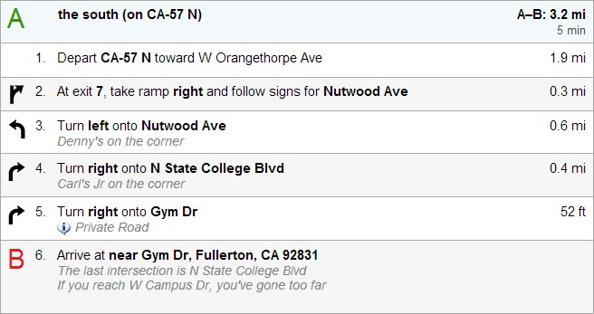
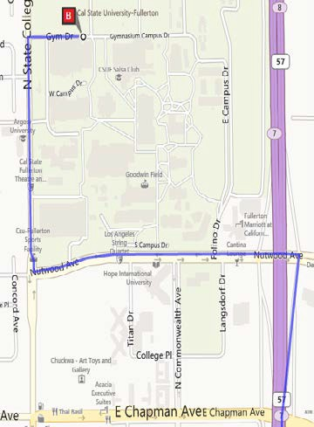
From the West
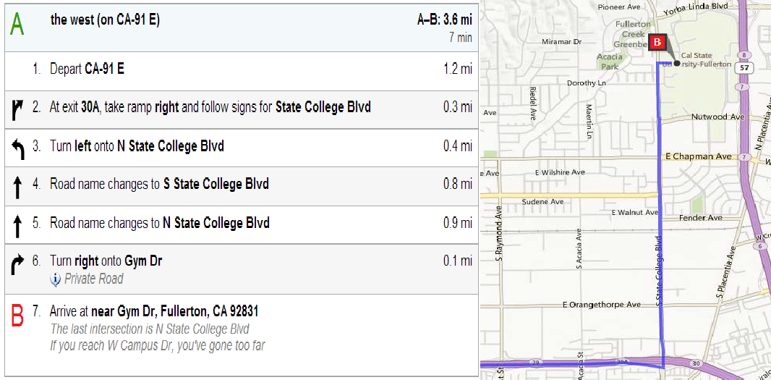

From the North
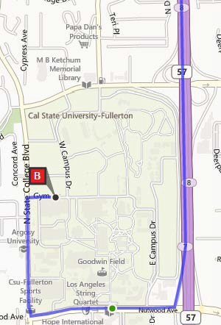
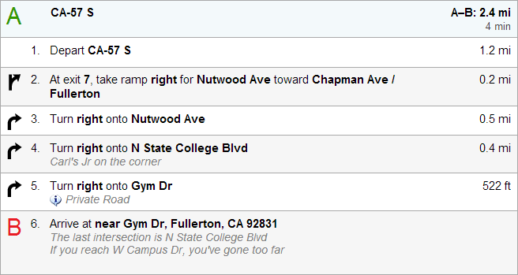

From the East
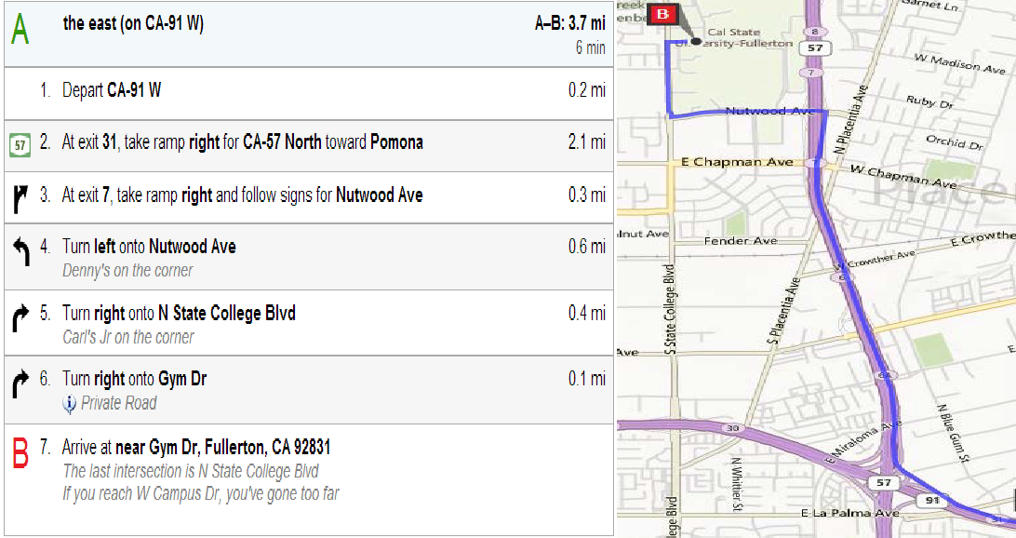

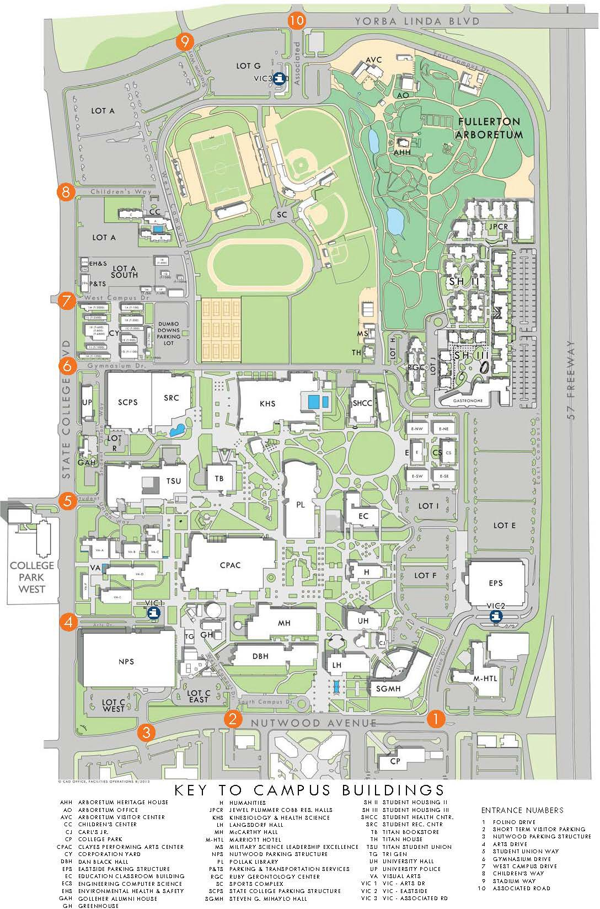
Parking Lots highlighted in Red

Turn on Gym Dr.

Parking Locations (Highlighted with red box on the map)
- Both lots are located off of Gym Dr.

State College Parking Structure (SCPS) Floors 2-6
Located on the south side of Gym Drive

Dumbo Downs Parking Lot
Located on the north side of Gym Drive

