Student Name/CWID:
Advisor Name:
Date:

This advising packet provides comprehensive advice for all required coursework in the Bachelor of Science (BS) degree in Child and Adolescent Studies: Family & Community Contexts Concentration (CHAF). Course information is organized into these categories:
1. General Education (GE) & American Government 2
2. CAS Core Courses (taken by all majors regardless of concentration) 3
3. Family & Community Contexts (CHAF) Concentration Requirements 4
Concentration-Specific Assessment Class 4
Elementary Education Practicum Classes 5
Family & Community Contexts (CHAF) Topical Classes 6
Diversity Classes (choose 1 class) 6
Topical Development Classes (choose 5 classes) 6
Important Reminders: 7
Considerations in Selecting Topical Development Courses: 7
4. Graduation Unit Requirements 8

General Education (GE) & American Government
GE Category | Recommendation | Class Taken | Notes
Lower-Division GE
1 English Communication
1A Written Communication
1B Critical Thinking
1C Oral Communication
2 Math & Quant Reasoning
2A Math & Quant Reasoning
3 Arts & Humanities
3A Intro to Arts
3B Intro to Humanities
4 Social & Behavioral Sciences
4A Intro to Soc & Behav Sci | CAS 101 |  | This course also counts as part of the CAS Core.
4B Am History, Inst & Values
5 Physical & Biol Sciences
5A Physical Science
5B Biological Science
5C Laboratory Experience
6 Ethnic Studies
American Gov Graduation Req
Upper-Division GE
2U Impli/Explore Math & Quant Reasoning | SOCI 303 |  | This course also counts as a Topical Development course and may meet graduate school prerequisites.  You must take either 2U or 5U. You do not need to take both.
3U Explore Arts or Humanities
4U Explor Soc & Behav Sci | CAS 340, CAS 365, CAS/AFAM 370, HUSR/COUN 380, PSYC 341, PUBH 321, SOCI 351, or SOCI 385 |  | These courses also count as a Topical Development course.
5U Impli/Explore Phys & Biol Sciences | BIOL 305 |  | This course also counts as a Topical Development course and may meet graduate school prerequisites.  You must take either 2U or 5U. You do not need to take both.
Z Cultural Diversity |  |  | Your 3U or 4U class may also meet your Z requirement.
- 3 GE classes must be upper-division (300+) classes taken at the CSU: 3U, 4U, and either 2U or 5U. These GE Categories are listed in orange above.
- Additional information is available at https://www.fullerton.edu/general-education/

CAS Core Courses (taken by all majors regardless of concentration)

CSUF CAS Class | Class Taken | Notes
CAS 100 Foundations for Success in CAS  OR  CAS 200 Thriving as a Transfer Student in CAS |  | CAS 100/200 should be taken in your first year at CSUF.
CAS 101 Intro to Child Devel
CAS 201 Child, Family, & Comm
SPED 371 Exceptional Individual
CAS 300 Effective Prof Comm
CAS 301 Inquiry & Method Devel
CAS 302 Cultural Competence in Development
CAS 325A Conception to Age 8
CAS 325B Age 9 to Adolescence
CAS 490T Topical Seminar

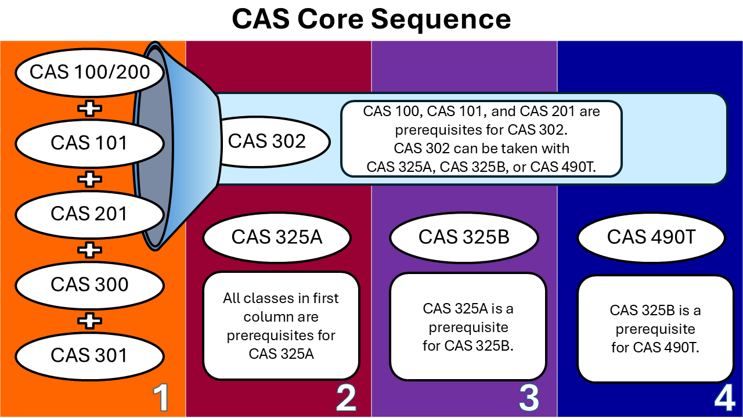

Family & Community Contexts (CHAF) Concentration Requirements

Concentration-Specific Assessment Class
CSUF CAS Class | Class Taken | Notes
CAS 310 Assessment & Observation in Devel

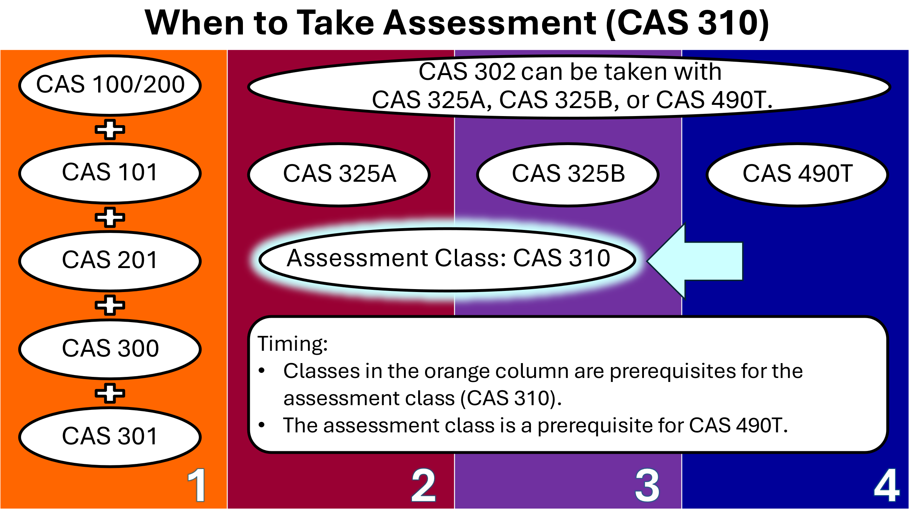

Family & Community Contexts Practicum Classes
CSUF CAS Class | Class Taken | Notes
CAS 394 Intro Practicum in CAS
CAS 494 Adv Practicum in Young, Family, Comm

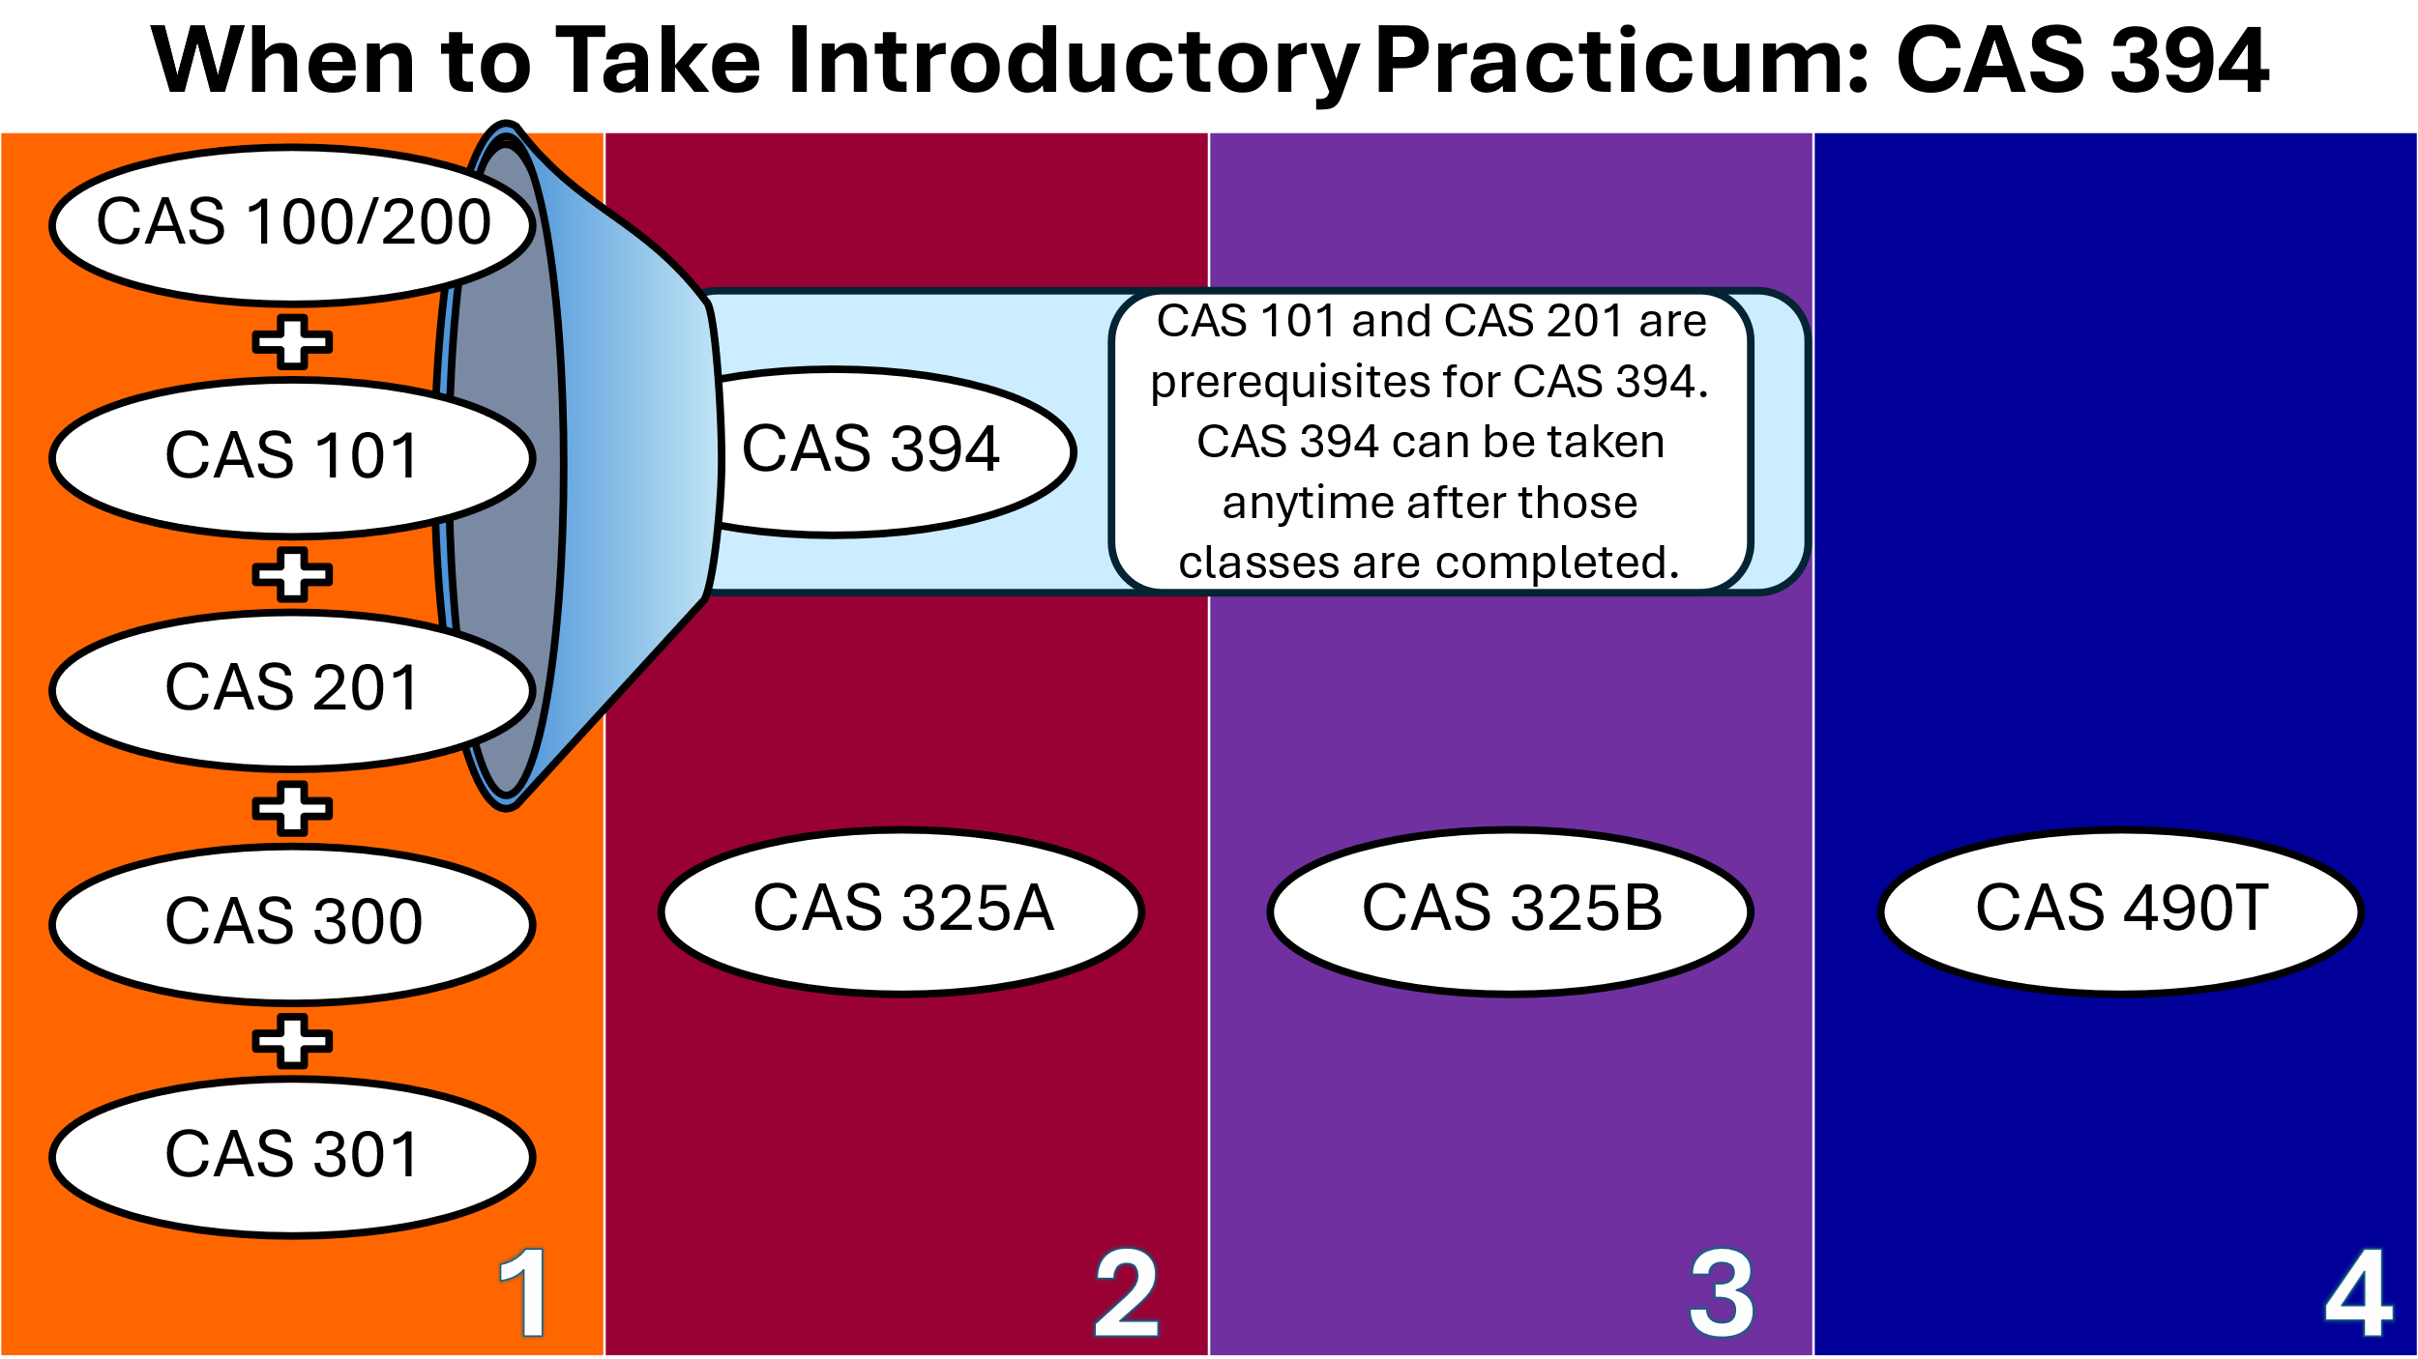
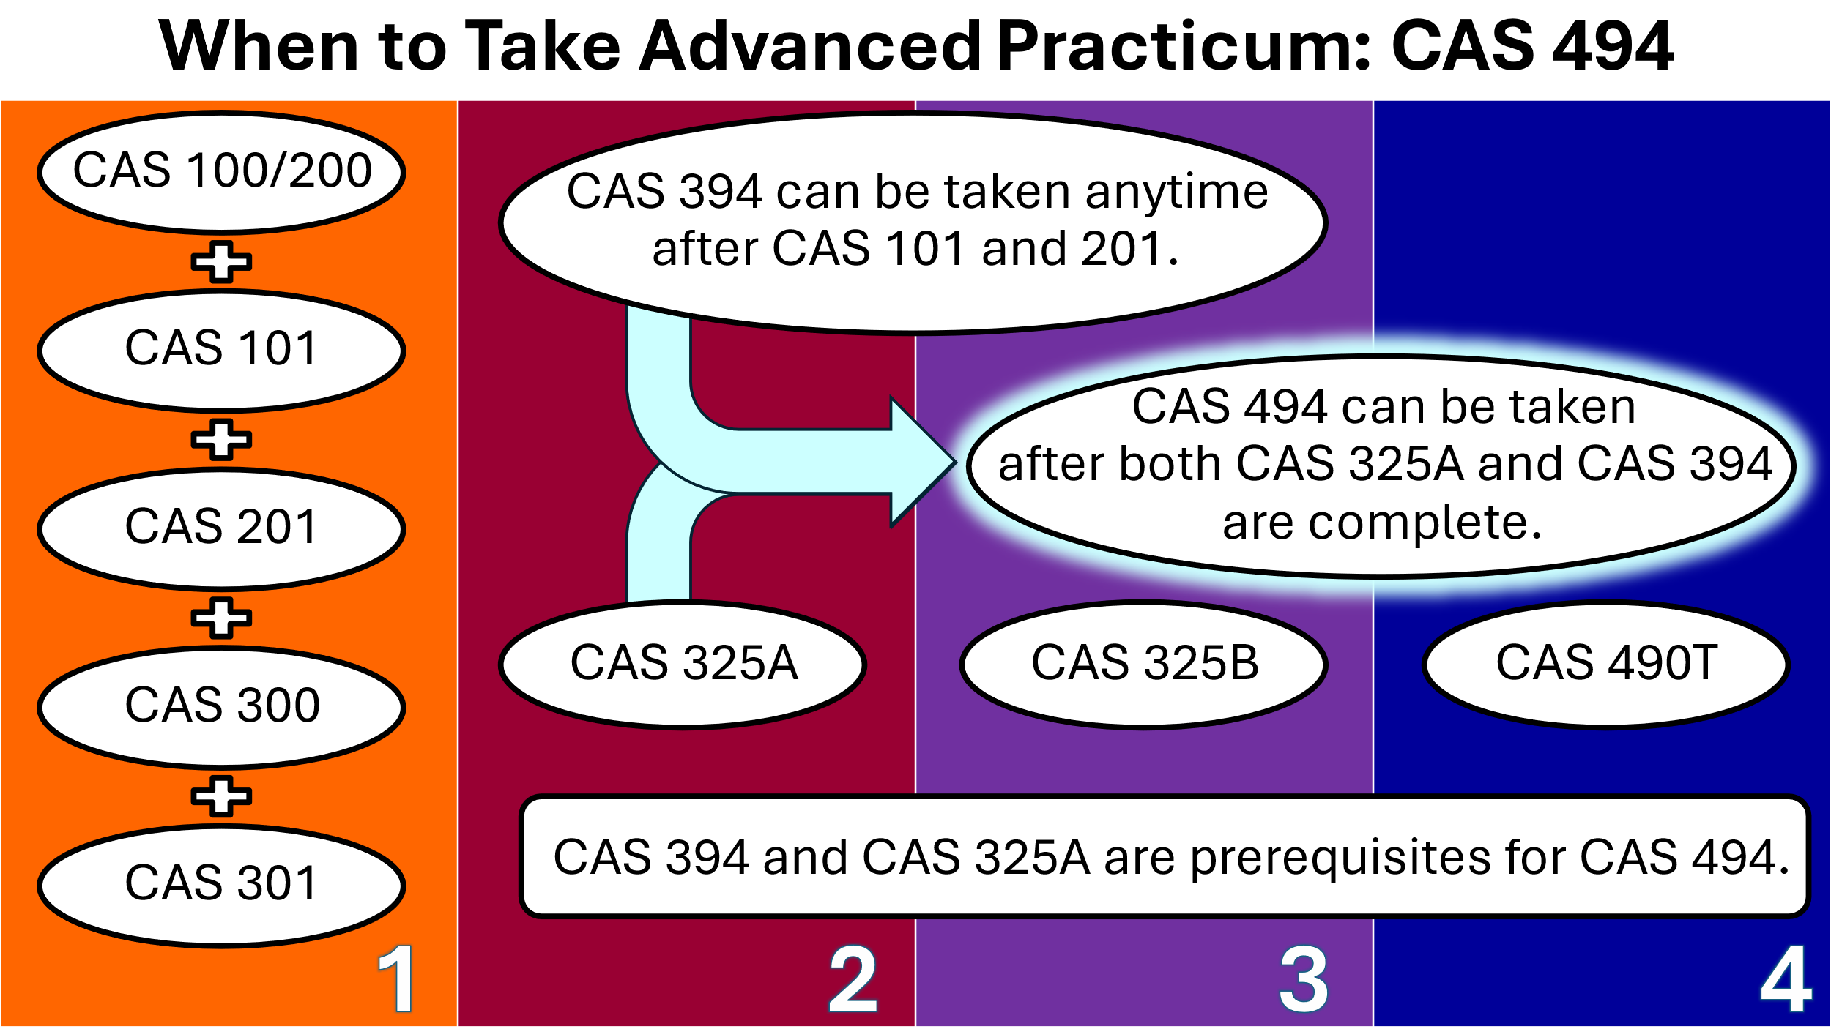

Family & Community Contexts (CHAF) Topical Developmental Classes
To fulfill concentration requirements, CHAF majors select SIX additional courses from the following list. We strongly recommend students select topical courses based on their professional interests, the requirements of graduate programs they will apply for, and the target populations they plan to work with.

Courses must meet these requirements:
- At least THREE courses must be CAS.
- At least THREE courses must be upper-division (having a number 300 or higher).

Family Context Classes (choose 2 classes)
- CAS 340 Parenting Today
- CAS 345 Devel Div Family Contexts or SOCI 351 Sociology of Families
- HCOM 318 Family Communication

Risks, Supports & Community Context Classes (choose 2 classes)
- CAS 326 Optimizing Devel of the School-Age Child
- CAS 327 Optimizing Devel of Adolescents
- CAS 360 Adolescents & the Media
- CAS 365 Adolescent Pregnancy
- CAS/AFAM 370: Dev Afr Am Child/Youth
- CAS 380 Adol Sex & Intimacy
- PUBH 321 Drugs & Society
- HUSR 430 Child Abuse & Hum Srv
- PSYC 341 Abnormal Psych or SOCI 366 Deviant Behavior
- SOCI 413 Juvenile Delinquency
- SOCI 385 Family Violence

Areas of Additional Study Classes (choose 2 classes)

Measurement / Statistics
- PSYC 201 Elem Stats or SOCI 303 Stats for Social Sciences
- PSYC 300 Intermed Stats & Rsch

Biology
- BIOL/KNES 210 Hum Anat/Physio
- BIOL 305 Hum Heredity & Devel
- PSYC 306 Biopsychology
- BIOL/KNES 191A Hum Anat/Physio
- BIOL/KNES 191B Hum Anat/Physio

Theoretical and/or Clinical Approaches
- CAS 328 Child Life
- COMD 307 Speech & Lang Devel
- HUSR/COUN 380 Th of Counseling
- HUSR 475 Hum Svcs Policy/Pract
- PSYC 302 Learning & Memory
- PSYC 431 Th of Personality
- PSYC 481 Svy of Clinical Psyc
- SOCI 300 Social Work

Recommended  Topical Development Classes | Class Selected | Notes
Family Context Class #1
Family Context Class #2
Risks, Supports & Community #1
Risks, Supports & Community #2
Area of Additional Study #1
Area of Additional Study #2

Important Reminders:
- At least 2 topical development classes must be in each category.
- Community College equivalents may be accepted for up to 3 Topical Development Classes. The remaining 3 classes must be taken at CSUF.
- At least 3 Topical Development Courses must be upper division (course number of 300 or higher).

Considerations in Selecting Topical Development Courses:
- GE 2U/5U (one class is required for these categories)
  - SOCI 303 meets GE 2U
  - BIOL 305 meets GE 5U
- Common prerequisites for psychotherapy programs include:
  - PSYC 341
  - HUSR/COUN 380
- CAS 328 is required for work in Child Life (www.childlife.org).
- Students seeking careers in physical health fields should visit the CSUF Health Professions Advising (https://www.fullerton.edu/healthprofessions/).

Graduation Unit Requirements
Type of Course | Total | Notes
- Transferred
- Completed at CSUF
- In progress
- Enrolled for Future Semester
- Left in major
- Left in GE
- Left in American Government
- Required for next steps
- General electives needed to reach 120
Minimum Units Needed for Graduation | 120

