|  |
| --- |
| Student Name/CWID: |
| Advisor Name: |
| Date: |

This advising packet provides comprehensive advice for all required coursework in the Bachelor of Science (BS) degree in Child and Adolescent Studies: Elementary Education Concentration (CHAP). Course information is organized into these categories:

1. General Education (GE) & American Government 2

2. CAS Core Courses (taken by all majors regardless of concentration) 3

3. Elementary Education (CHAP) Concentration Requirements 4

Concentration-Specific Assessment Class 4

Elementary Education Practicum Classes 5

Elementary Education (CHAP) Topical Classes 6

Family Context (choose 1 class) 6

Arts (choose 1 class) 6

Kinesiology/Physical Education (choose 1 class) 6

Language Arts (choose 1 class) 6

Math (choose 1 class) 6

Science (choose 1 class) 6

Important Reminders: 7

4. Graduation Unit Requirements 8

# General Education (GE) & American Government

|  |  |  |  |
| --- | --- | --- | --- |
| GE Category | Recommendation | Class Taken | Notes |
| Lower-Division GE |  |  |  |
| 1 English Communication |  |  |  |
| 1A Written Communication |  |  |  |
| 1B Critical Thinking |  |  |  |
| 1C Oral Communication |  |  |  |
| 2 Math & Quant Reasoning |  |  |  |
| 2A Math & Quant Reasoning |  |  |  |
| 3 Arts & Humanities |  |  |  |
| 3A Intro to Arts |  |  |  |
| 3B Intro to Humanities |  |  |  |
| 4 Social & Behavioral Sciences |  |  |  |
| 4A Intro to Soc & Behav Sci | CAS 101 |  | This course also counts as part of the CAS Core. |
| 4B Am History, Inst & Values | AFAM/ASAM/ CHIC/HIST 190 |  | These classes meet a prerequisite for CSUF teaching credential programs. |
| 5 Physical & Biol Sciences |  |  |  |
| 5A Physical Science |  |  |  |
| 5B Biological Science |  |  |  |
| 5C Laboratory Experience |  |  |  |
| 6 Ethnic Studies |  |  |  |
| American Gov Graduation Req |  |  |  |
| Upper-Division GE |  |  |  |
| 2U Impli/Explore Math & Quant Reasoning |  |  |  |
| 3U Explore Arts or Humanities | ART 380, THTR 311 or ENGL 341 |  | This course also counts as a Topical Development course. |
| 4U Explor Soc & Behav Sci | EDEL 325 |  | EDEL 325 is a required prerequisite for the multiple subject and Pk-3 credential programs.  If you are seeking a SPED credential, see recommended classes at [this link.](https://ed.fullerton.edu/sped/academic-programs/cred-sped.php) |
| 5U Impli/Explore Phys & Biol Sciences |  |  | You must take ***either 2U or 5U.*** You do not need to take both. |
| Z Cultural Diversity | EDEL 325 |  | EDEL 325 (recommended in 4U) will also meet area Z. |

* 3 GE classes must be upper-division (300+) classes taken at the CSU: 3U, 4U, and either 2U or 5U. These **GE Categories are listed in orange** above.
* Additional information is available at <https://www.fullerton.edu/general-education/>

# CAS Core Courses (taken by all majors regardless of concentration)

|  |  |  |
| --- | --- | --- |
| CSUF CAS Class | Class Taken | Notes |
| CAS 100 Foundations for Success in CAS  OR  CAS 200 Thriving as a Transfer Student in CAS |  | CAS 100/200 should be taken in your first year at CSUF. |
| CAS 101 Intro to Child Devel |  |  |
| CAS 201 Child, Family, & Comm |  |  |
| SPED 371 Exceptional Individual |  |  |
| CAS 300 Effective Prof Comm |  |  |
| CAS 301 Inquiry & Method Devel |  |  |
| CAS 302 Cultural Competence in Development |  |  |
| CAS 325A Conception to Age 8 |  |  |
| CAS 325B Age 9 to Adolescence |  |  |
| CAS 490T Topical Seminar |  |  |

The CAS core sequence has a structured order enforced by prerequisites. 
The classes in column 1 (CAS 100 or 200, CAS 101, CAS 201, CAS 300, and CAS 301) are prerequisites for CAS 302 and CAS 325A. 
The class in column 2 (CAS 325A) is a prerequisite for CAS 325B.
The class in column 3 (CAS 325B) is a prerequisite for CAS 490T).


# Elementary Education (CHAP) Concentration Requirements

## Concentration-Specific Assessment Class

|  |  |  |
| --- | --- | --- |
| CSUF CAS Class | Class Taken | Notes |
| CAS 310 Assessment & Observation in Devel |  |  |

Although it is not part of the CAS core, the CAS assessment course (CAS 310) is related to the CAS core sequence. All of the classes in column 1 (CAS 100 or 200, CAS 101, CAS 201, CAS 300, and CAS 301) are prerequisites for CAS 310. CAS 310 is a prerequisite for CAS 490T. 
Assuming you are a full-time student, you should take CAS 310 with either CAS 325A or CAS 325B. 

## Elementary Education Practicum Classes

|  |  |  |
| --- | --- | --- |
| CSUF CAS Class | Class Taken | Notes |
| CAS 394 Intro Practicum in CAS |  |  |
| CAS 454 Practicum in Transitional EC  OR  CAS 474 Practicum in Early Care and Edu |  |  |

CAS majors take two practicum (fieldwork) classes. The first, CAS 394, is part of the CAS core. 

All of the classes in column 1 (CAS 100 or 200, CAS 101, CAS 201, CAS 300, and CAS 301) are prerequisites for CAS 394.  


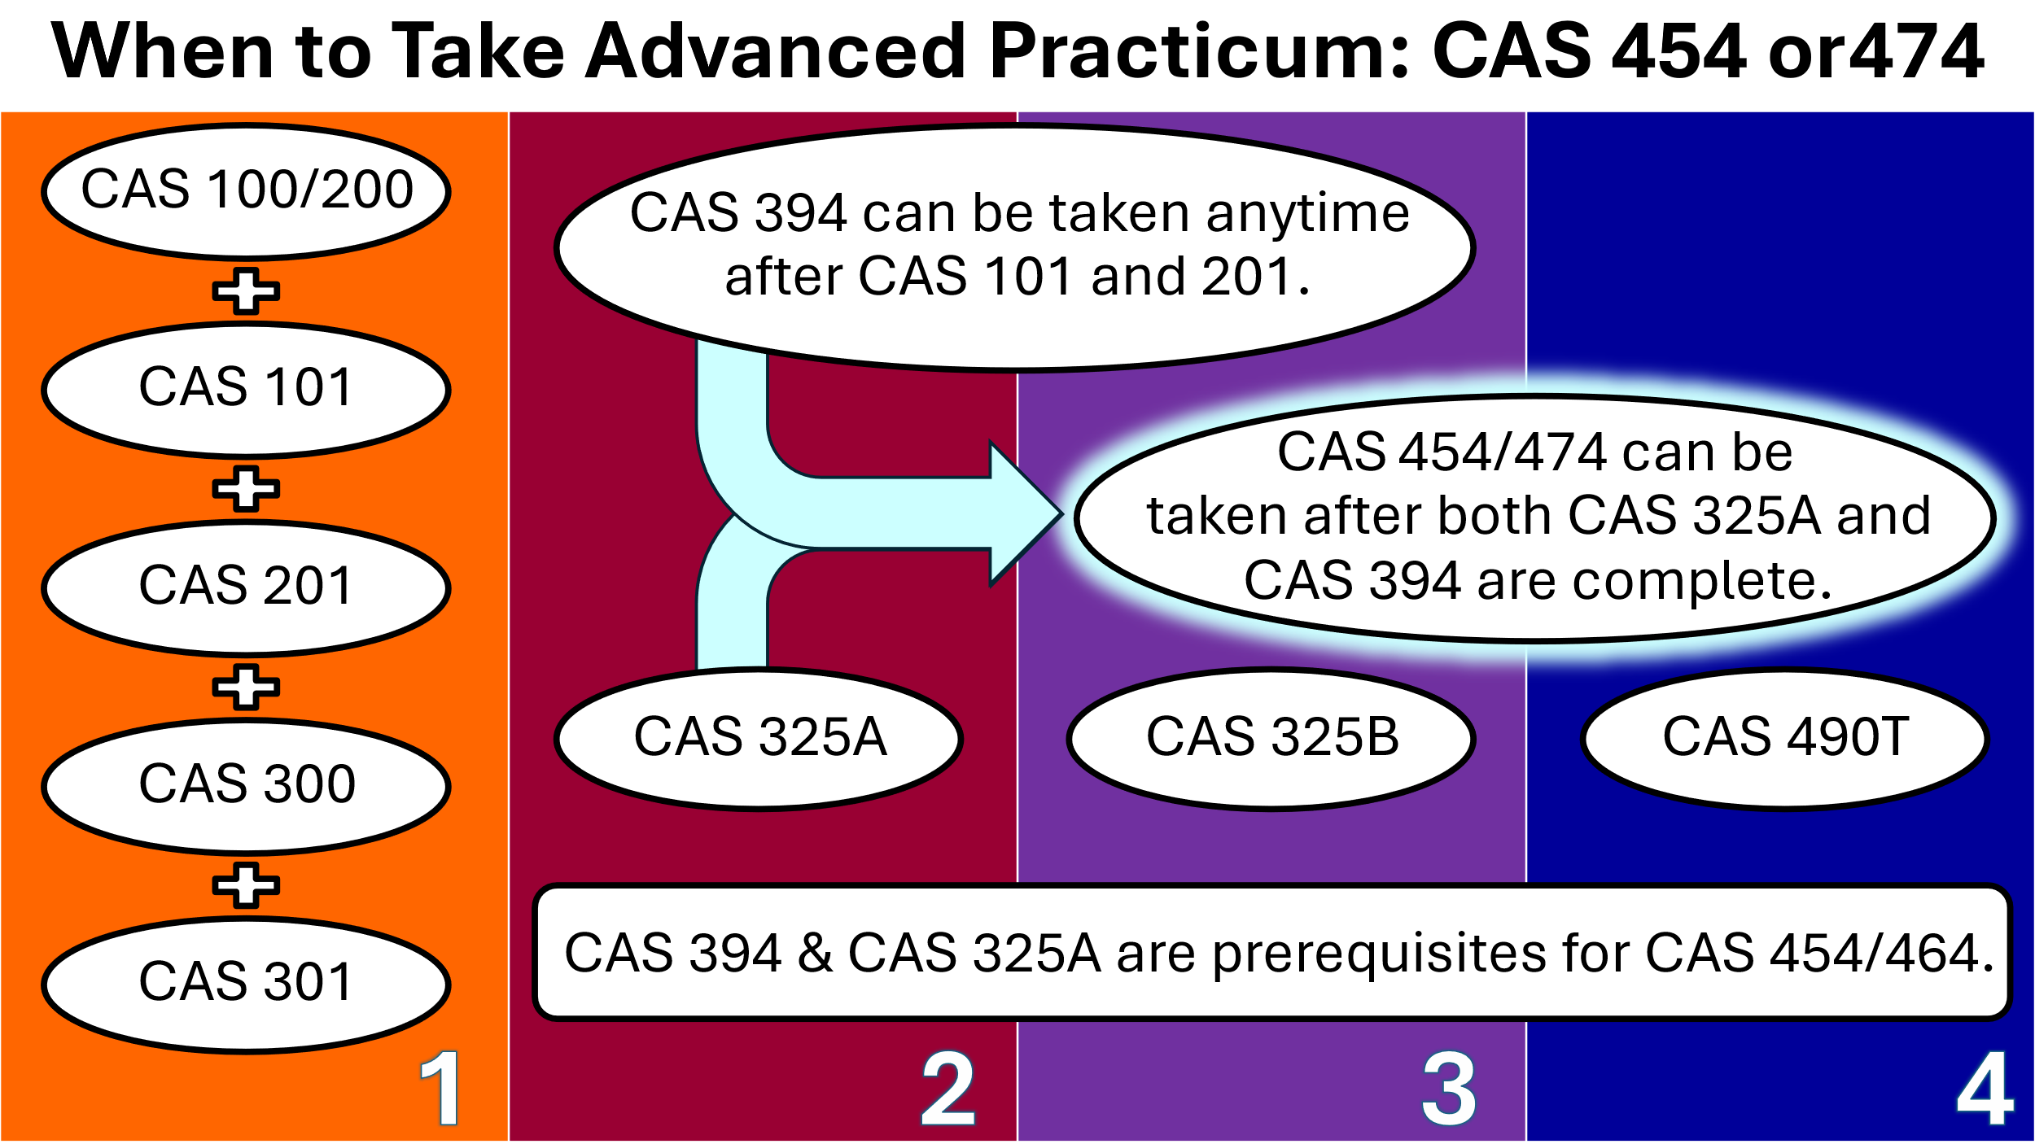

## Elementary Education (CHAP) Topical Classes

To fulfill concentration requirements, CHAP majors select **SIX additional courses** from the following list. Every CAS major must take a CAS class on family. The other five topical courses for this concentration meet the multiple subject subject matter competency for credential programs.

#### Courses must meet these requirements:

* At least **ONE** course must be in the Family Context category.
* At least **THREE** courses must be upper-division (having a number 300 or higher).

**See the next pages for our specific course recommendations for early childhood professionals working in preschool centers and family childcare. If you are interested in post-baccalaureate or credential programs, please see the advising guides for Pk-3rd credentials, Multiple Subject credentials, Special Education credentials, and graduate school.**

### Family Context (choose 1 class)

* CAS 340 Parenting Today
* CAS 341 Working with Parents of Young Children
* CAS 345 Devel in Div Family Contexts

### Arts (choose 1 class)

* ART 380 Art & Child Development
* DANC 471 Creative Dance for Children
* MUS 433 Music in Childhood
* THTR 402A Drama for Children

### Kinesiology/Physical Education (choose 1 class)

* KNES 386 Movement & the Child

### Language Arts (choose 1 class)

* ENGL 341 Children’s Literature
* THTR 311 Oral Interpretation of Children’s Literature

### Math (choose 1 class)

* MATH 303A Fundamentals of Elementary Math

### Science (choose 1 class)

* BIOL 453 Life Science Concepts
* GEOL 410 Planet Earth for Educators

|  |  |  |
| --- | --- | --- |
| Recommended  Topical Development Classes | Class Selected | Notes |
| Family Context (choose one) |  |  |
| Arts (choose one) |  |  |
| Kinesiology/Physical Ed (choose one) |  |  |
| Language Arts (choose one) |  |  |
| Math (choose one) |  |  |
| Science (choose one) |  |  |

### Important Reminders:

* At least 1 topical development class must be in each category.
* Community College equivalents may be accepted for up to 3 Topical Development Classes. The remaining 3 classes must be taken at CSUF.
* At least 3 Topical Development Courses must be upper division (course number of 300 or higher).

# Graduation Unit Requirements

|  |  |  |
| --- | --- | --- |
| Type of Course | Total | Notes |
| * Transferred |  |  |
| * Completed at CSUF |  |  |
| * In progress |  |  |
| * Enrolled for Future Semester |  |  |
| * Left in major |  |  |
| * Left in GE |  |  |
| * Left in American Government |  |  |
| * Required for next steps |  |  |
| * General electives needed to reach 120 |  |  |
| Minimum Units Needed for Graduation | **120** |  |