Student Name/CWID:
Advisor Name:
Date:

This advising packet provides comprehensive advice for all required coursework in the Bachelor of Science (BS) degree in Child and Adolescent Studies: Early Childhood Education Concentration (CHAC). Course information is organized into these categories:
1. General Education (GE) & American Government 2
2. CAS Core Courses (taken by all majors regardless of concentration) 3
3. Early Childhood Education (CHAC) Concentration Requirements 4
Concentration-Specific Assessment Class 4
Early Childhood Education Contexts Practicum Classes 5
Early Childhood Education (CHAC) Topical Classes 6
Early Childhood Education Curriculum Class (choose 1 class) 6
Family Context Classes (choose 1 or 2 classes) 6
Areas of Additional Study Classes (choose 3 or 4 classes) 6
Important Reminders: 7
Infant/Toddler Focus 7
4. Graduation Unit Requirements 8

General Education (GE) & American Government
GE Category | Recommendation | Class Taken | Notes
Lower-Division GE
1 English Communication
1A Written Communication
1B Critical Thinking
1C Oral Communication
2 Math & Quant Reasoning
2A Math & Quant Reasoning
3 Arts & Humanities
3A Intro to Arts
3B Intro to Humanities
4 Social & Behavioral Sciences
4A Intro to Soc & Behav Sci | CAS 101 |  | This course also counts as part of the CAS Core.
4B Am History, Inst & Values | AFAM/ASAM/ CHIC/HIST 190 |  | These classes meet a prerequisite for CSUF teaching credential programs.
5 Physical & Biol Sciences
5A Physical Science
5B Biological Science
5C Laboratory Experience
6 Ethnic Studies
American Gov Graduation Req
Upper-Division GE
2U Impli/Explore Math & Quant Reasoning |  |  | You must take either 2U or 5U. You do not need to take both.
3U Explore Arts or Humanities | ART 380 |  | This course also counts as a Topical Development course.
4U Explor Soc & Behav Sci | CAS 340 or  CAS/AFAM 370  EDEL 325 |  | CAS 340 and CAS/AFAM 370 count as a GE Z and a Topical Development course.  EDEL 325 is a required prerequisite for the multiple subject and Pk-3 credential programs.
5U Impli/Explore Phys & Biol Sciences |  |  | You must take either 2U or 5U. You do not need to take both.
Z Cultural Diversity | CAS 340 or  CAS/AFAM 370 |  | One GE course in areas 2, 3, 4, or 5 must also be a Z course. If you take the classes recommended in 4U, they will also meet area Z.
- 3 GE classes must be upper-division (300+) classes taken at the CSU: 3U, 4U, and either 2U or 5U. These GE Categories are listed in orange above.
- Additional information is available at https://www.fullerton.edu/general-education/

CAS Core Courses (taken by all majors regardless of concentration)

CSUF CAS Class | Class Taken | Notes
CAS 100 Foundations for Success in CAS  OR  CAS 200 Thriving as a Transfer Student in CAS |  | CAS 100/200 should be taken in your first year at CSUF.
CAS 101 Intro to Child Devel
CAS 201 Child, Family, & Comm
SPED 371 Exceptional Individual
CAS 300 Effective Prof Comm
CAS 301 Inquiry & Method Devel
CAS 302 Cultural Competence in Development
CAS 325A Conception to Age 8
CAS 325B Age 9 to Adolescence
CAS 490T Topical Seminar

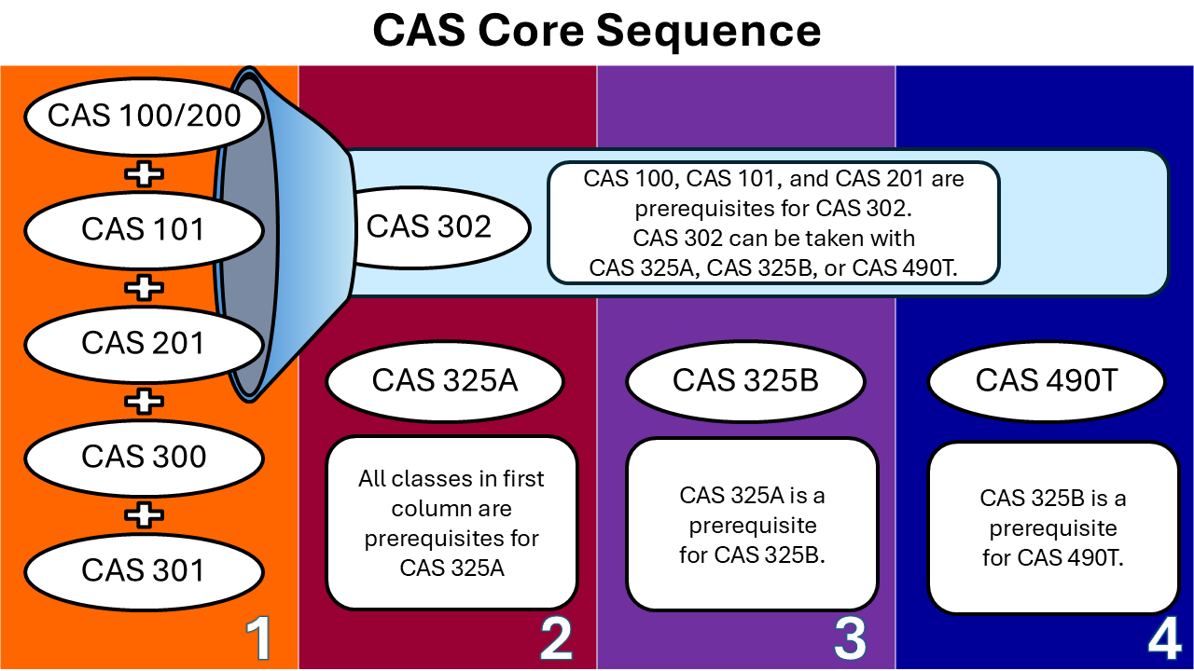

Early Childhood Education (CHAC) Concentration Requirements

Concentration-Specific Assessment Class
CSUF CAS Class | Class Taken | Notes
CAS 305 Advanced Assess in EC

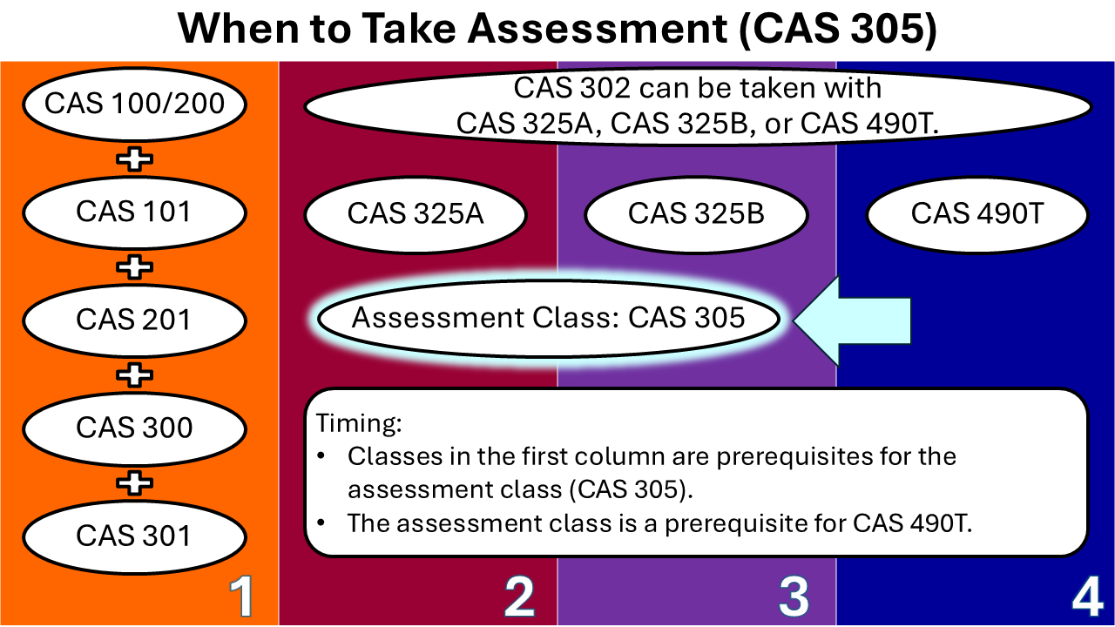

Early Childhood Education Contexts Practicum Classes
CSUF CAS Class | Class Taken | Notes
CAS 394 Intro Practicum in CAS
CAS 454 Practicum in Transitional EC
OR
CAS 464 Practicum in Early Care and Edu

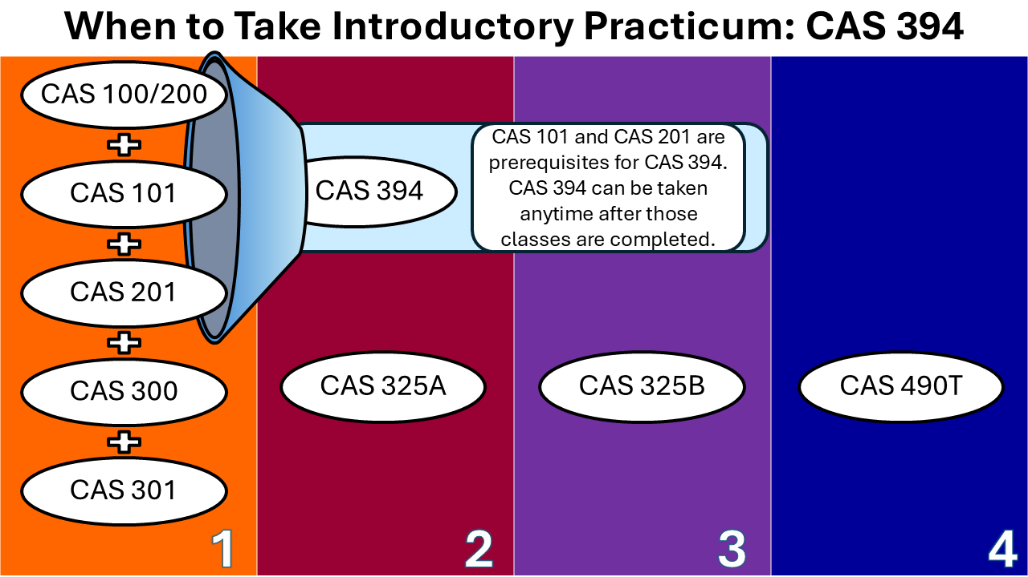
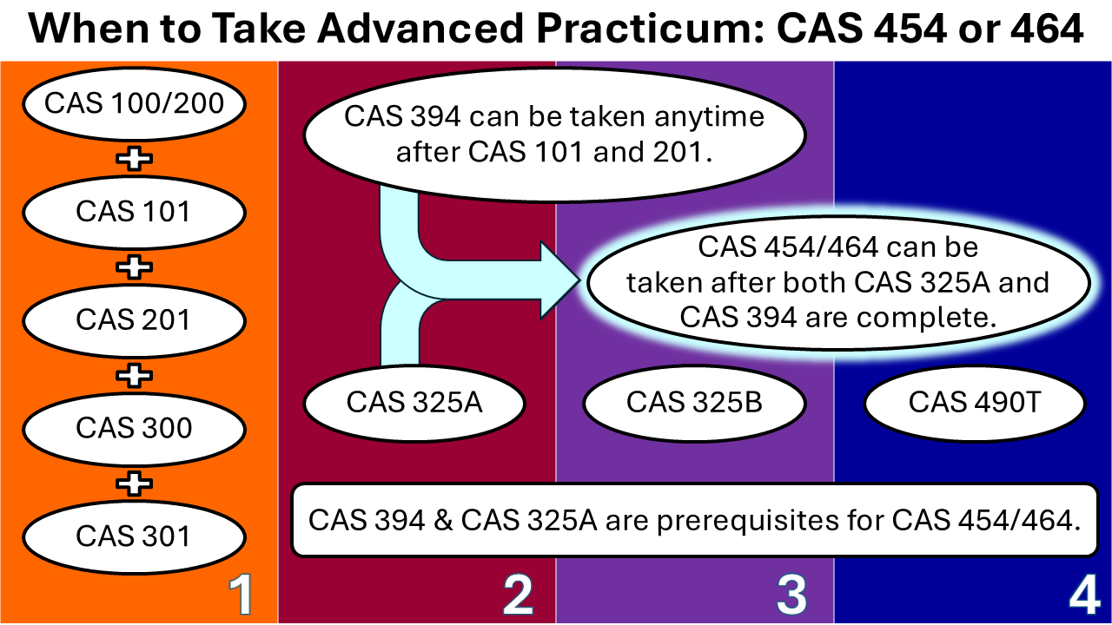

Early Childhood Education (CHAC) Topical Developmental Classes
To fulfill concentration requirements, CHAC majors select SIX additional courses from the following list. Every CAS major must take a CAS class on family. We strongly recommend students select topical courses based on their professional interests, the requirements of graduate programs they will apply for, and the target populations they plan to work with.

Courses must meet these requirements:
- At least ONE course must be in the ECE Curriculum category
- At least ONE course must be in the Family Context category.
- At least THREE courses must be CAS.
- At least THREE courses must be upper-division (having a number 300 or higher).
See the next pages for our specific course recommendations for early childhood professionals. If you are interested in post-baccalaureate or credential programs, please see the advising guides for Pk-3rd credentials, Early Childhood Special Education credentials, and graduate school.

Early Childhood Education Curriculum Class (choose 1 class)
- CAS 250: Intro to Early Childhood Curriculum
- Equivalent class at a Community College (C-ID = ECE 130)

Family Context Classes (choose 1 or 2 classes)
- CAS 340 Parenting Today
- CAS 341 Working with Parents Young Child
- CAS 345 Devel Div Family Contexts

Areas of Additional Study Classes (choose 3 or 4 classes)

Curricular Subjects
- ART 380 Art & Child Development
- CAS 140 Intro to Early Childhood Ed
- CAS 206 Health & Safety in EC
- CAS 215 Observations in EC
- CAS 221 Responsive Care Infant/Toddler
- CAS 352 Numeracy & Science in EC
- CAS 353 Learning & Motivation in EC
- CAS 391 Leadership in EC
- MUS 433 Music in Childhood
- READ 340 Early Lang & Lit in Div Child

Development
- CAS 321 Adv Study Infant/Toddler
- CAS 328 Child Life
- CAS 346 Advanced Preschool Devel
- CAS 370/AFAM 370 African American Children

Special Education
- SPED 400 Early Childhood SpEd
- SPED 425 Culture, Lang, Dis/Ability, IEP

Recommended  Topical Developmental Classes | Class Selected | Notes
ECE curriculum class |  | CAS 250 is the only class at CSUF
Family context class (choose one)
Areas of Additional Study (choose 3)
- ART 380 |  | Also meets GE 3U
- CAS 340 or CAS/AFAM 370 |  | Also meets GE 4U
Choose family OR additional study class as the sixth class

Important Reminders:
- At least 1 topical development class must be in the “ECE Curriculum” category.
- At least 1 topical development class must be in the “Family Context” category.
- Community College equivalents may be accepted for up to 3 Topical Development Classes. The remaining 3 classes must be taken at CSUF.
- At least 3 Topical Development Courses must be upper division (course number of 300 or higher).
- At least 3 Topical Development Courses must be CAS classes (offered by or cross-listed with the CAS department).

Infant/Toddler Focus
If you plan to work with Infants and/or toddlers, these courses enhance your understanding of these age groups.
- CHAC family context class:
  - CAS 341 Working with Parents of Young Children
- CHAC area of additional study:
  - CAS 221 Responsive Care for Infants and Toddlers
  - CAS 321 Advanced Study of Infants and Toddlers
- Recommended general elective: SOCI 385 Family Violence

Graduation Unit Requirements
Type of Course | Total | Notes
- Transferred
- Completed at CSUF
- In progress
- Enrolled for Future Semester
- Left in major
- Left in GE
- Left in American Government
- Required for next steps
- General electives needed to reach 120
Minimum Units Needed for Graduation | 120

