Student Name/CWID:
Advisor Name:
Date:

This advising packet provides comprehensive advice for all required coursework in the Bachelor of Science (BS) degree in Child and Adolescent Studies: Adolescent/Youth Development Concentration (CHAY). Course information is organized into these categories:
1. General Education (GE) & American Government 2
2. CAS Core Courses (taken by all majors regardless of concentration) 3
3. Adolescent/Youth Development (CHAY) Concentration Requirements 4
Concentration-Specific Assessment Class 4
Elementary Education Practicum Classes 5
Adolescent/Youth Development (CHAY) Topical Classes 6
Diversity Classes (choose 1 class) 6
Topical Development Classes (choose 5 classes) 6
Important Reminders: 7
Considerations in Selecting Topical Development Courses: 7
4. Graduation Unit Requirements 8

General Education (GE) & American Government
GE Category | Recommendation | Class Taken | Notes
Lower-Division GE
1 English Communication
1A Written Communication
1B Critical Thinking
1C Oral Communication
2 Math & Quant Reasoning
2A Math & Quant Reasoning
3 Arts & Humanities
3A Intro to Arts
3B Intro to Humanities
4 Social & Behavioral Sciences
4A Intro to Soc & Behav Sci | CAS 101 |  | This course also counts as part of the CAS Core.
4B Am History, Inst & Values | AFAM/ASAM/ CHIC/HIST 190 |  | These classes meet a prerequisite for CSUF teaching credential programs.
5 Physical & Biol Sciences
5A Physical Science
5B Biological Science
5C Laboratory Experience
6 Ethnic Studies
American Gov Graduation Req
Upper-Division GE
2U Impli/Explore Math & Quant Reasoning | SOCI 303 |  | This course also counts as a Topical Development course and may meet graduate school prerequisites.
3U Explore Arts or Humanities
4U Explor Soc & Behav Sci | CAS 330, CAS 340,CAS/AFAM 370, or CHIC 332 |  | These courses also count as a Topical Development course. If you are seeking a teaching credential, see recommended classses at this link.
5U Impli/Explore Phys & Biol Sciences |  |  | You must take either 2U or 5U. You do not need to take both.
Z Cultural Diversity | CAS 340, CAS/AFAM 370, CHIC 332 |  | These courses also count as a Topical Development course.
- 3 GE classes must be upper-division (300+) classes taken at the CSU: 3U, 4U, and either 2U or 5U. These GE Categories are listed in orange above.
- Additional information is available at https://www.fullerton.edu/general-education/

CAS Core Courses (taken by all majors regardless of concentration)

CSUF CAS Class | Class Taken | Notes
CAS 100 Foundations for Success in CAS  OR  CAS 200 Thriving as a Transfer Student in CAS |  | CAS 100/200 should be taken in your first year at CSUF.
CAS 101 Intro to Child Devel
CAS 201 Child, Family, & Comm
SPED 371 Exceptional Individual
CAS 300 Effective Prof Comm
CAS 301 Inquiry & Method Devel
CAS 302 Cultural Competence in Development
CAS 325A Conception to Age 8
CAS 325B Age 9 to Adolescence
CAS 490T Topical Seminar

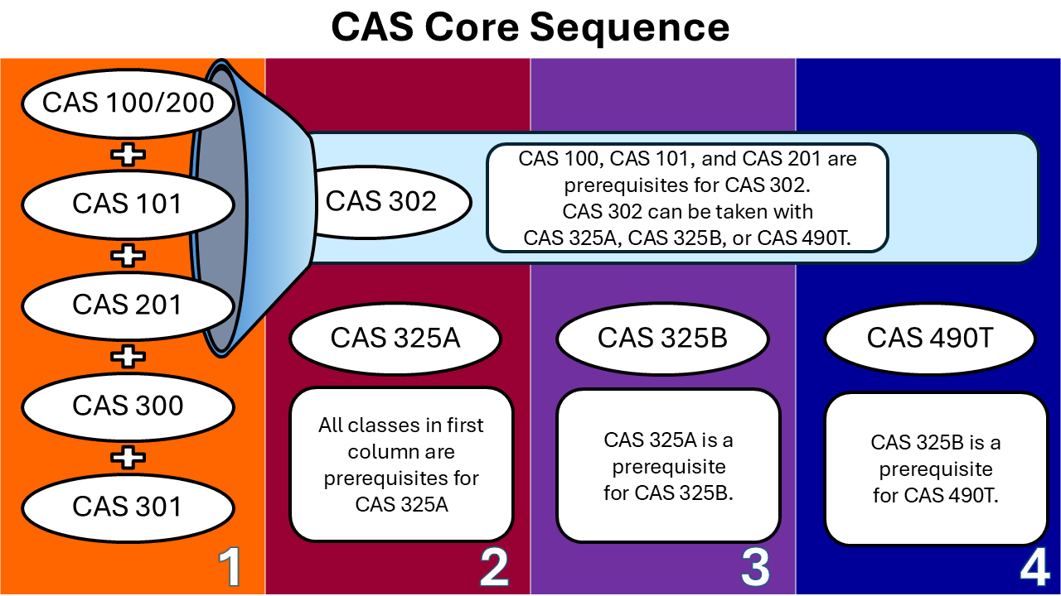

Adolescent/Youth Development (CHAY) Concentration Requirements

Concentration-Specific Assessment Class
CSUF CAS Class | Class Taken | Notes
CAS 310 Assessment & Observation in Devel

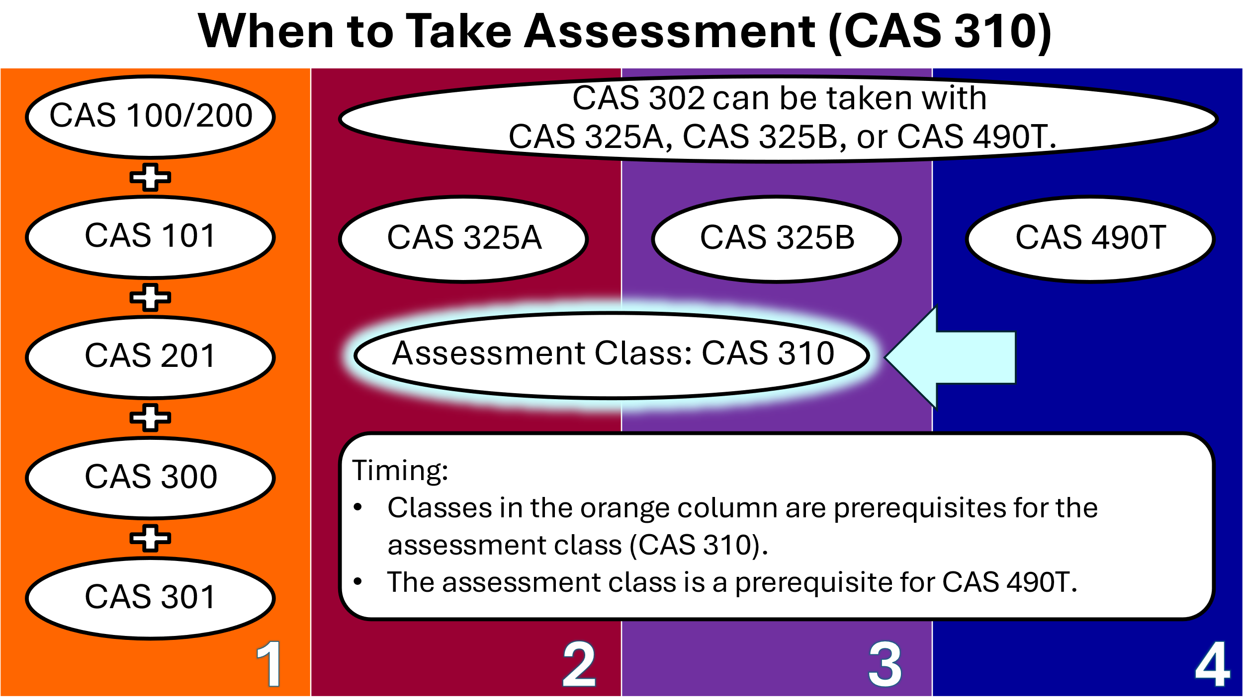

Elementary Education Practicum Classes
CSUF CAS Class | Class Taken | Notes
CAS 394 Intro Practicum in CAS
CAS 494 Adv Practicum in Young, Family, Comm

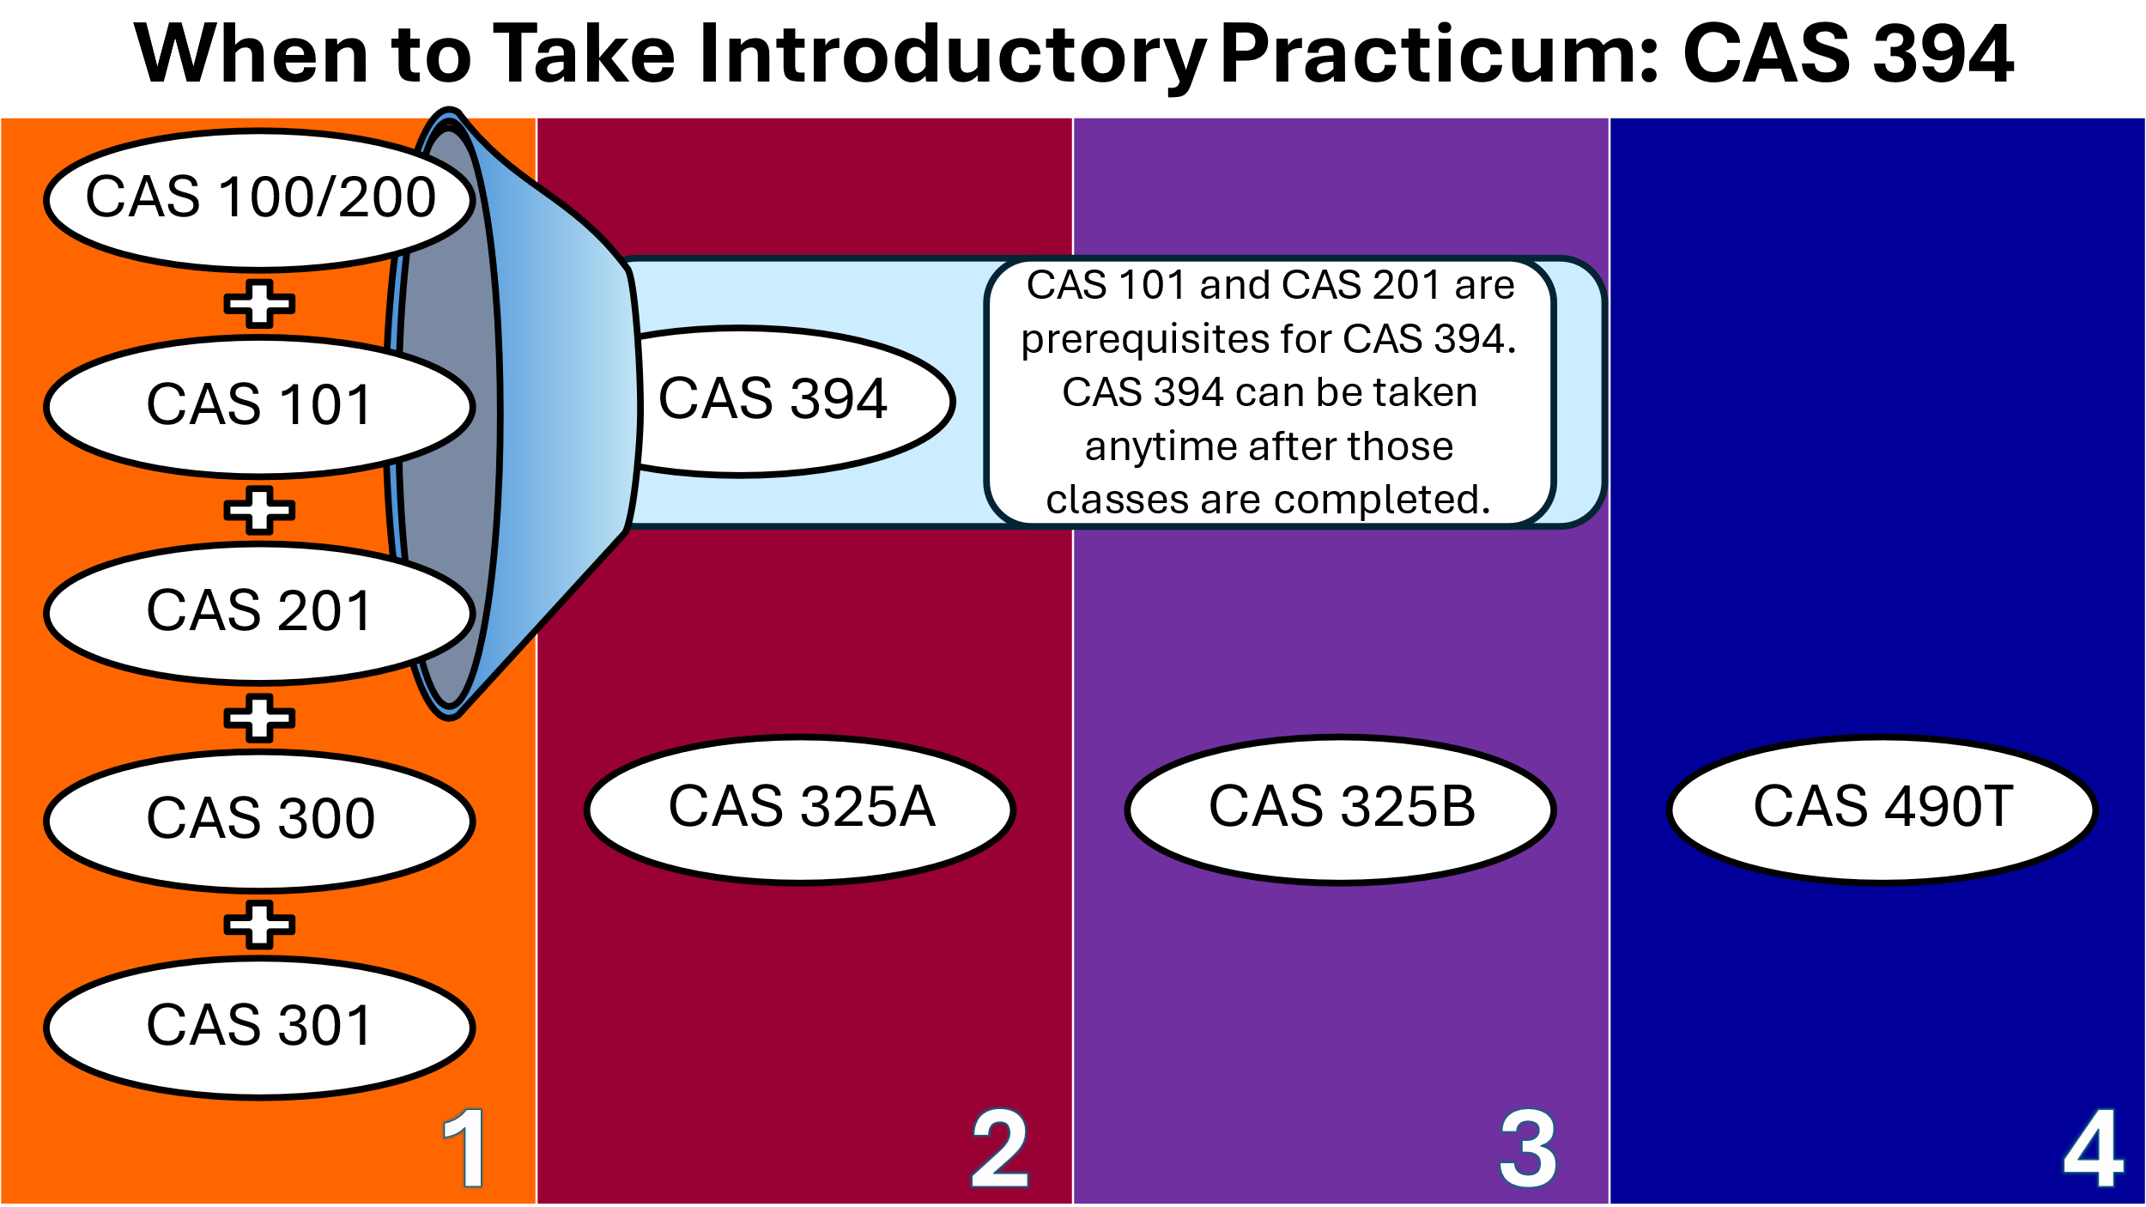
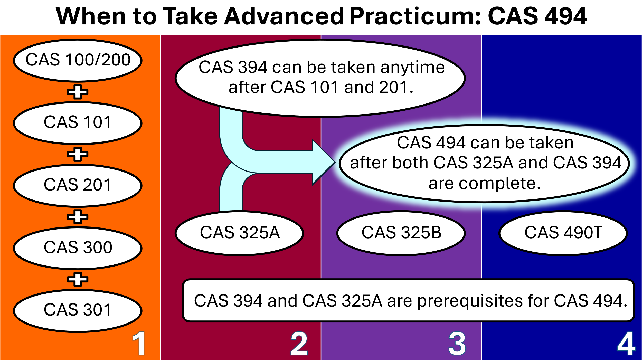

Adolescent/Youth Development (CHAY) Topical Classes
To fulfill concentration requirements, CHAY majors select SIX additional courses from the following list. We strongly recommend students select topical courses based on their professional interests, the requirements of graduate programs they will apply for, and the target populations they plan to work with.

Courses must meet these requirements:
- At least ONE course must be in the Diversity category.
- At least THREE courses must be CAS.
- At least THREE courses must be upper-division (having a number 300 or higher).
See the next pages for our specific course recommendations for early childhood professionals working in preschool centers and family childcare. If you are interested in post-baccalaureate or credential programs, please see the advising guides for Single Subject credentials, Special Education credentials, and graduate study.

Diversity Classes (choose 1 class)
- CAS 345 Devel in Div Family Contexts
- CAS/AFAM 370 Devel African American Children and Youth
- CHIC 332 The Chicano Adolescent
- EDSC 340 Diversity in Secondary Schools

Topical Development Classes (choose 5 classes)
- CAS 327 Opt Devel During Adol
- CAS 330 Adol & Early Adulthood
- CAS 340 Parenting 21st Century
- CAS 345 Devel in Diverse Family Contexts
- CAS 360 Adol & the Media
- CAS 365 Adol Pregn and Parenting
- CAS/AFAM 370 Af-Am Child & Youth
- CAS 375 Adolescent Identity
- CAS 380 Adol Sexualty & Intimate
- CHIC 332 The Chicano Adolescent
- EDSC 330 Devel Lit. in Sec Schools
- EDSC 340 Diversity in Sec Schools
- HUSR 385 Proposal Writing,
- HUSR 425T Contemp Issues in HUSR
- HUSR 430 Child Abuse
- KNES 387 Movement & Adolescent
- PSYC 201 Intro Stats
- PSYC 311 Educational Psyc
- SOCI 303 Stats for Social Sciences
- SOC 413 Juvenile Delinquency
- SPED 322 Intro Pos Behavior Support

Recommended  Topical Development Classes | Class Selected | Notes
Diversity Class (choose one) |  | EDSC 340 is a prerequisite for the single subject credential program.
Topical Development (choose five)

Important Reminders:
- At least 1 topical development class must be in each category.
- Community College equivalents may be accepted for up to 3 Topical Development Classes. The remaining 3 classes must be taken at CSUF.
- At least 3 Topical Development Courses must be upper division (course number of 300 or higher).

Considerations in Selecting Topical Development Courses:
- SOCI 303 also meets GE 2U
- EDSC 330 is a prerequisite for the single subject credential program.
- CHIC 332 meets GE 4U and is a prerequisite requirement for the single subject credential program.
- SPED 322 is a prerequisite for special education credentials.

Graduation Unit Requirements
Type of Course | Total | Notes
- Transferred
- Completed at CSUF
- In progress
- Enrolled for Future Semester
- Left in major
- Left in GE
- Left in American Government
- Required for next steps
- General electives needed to reach 120
Minimum Units Needed for Graduation | 120

