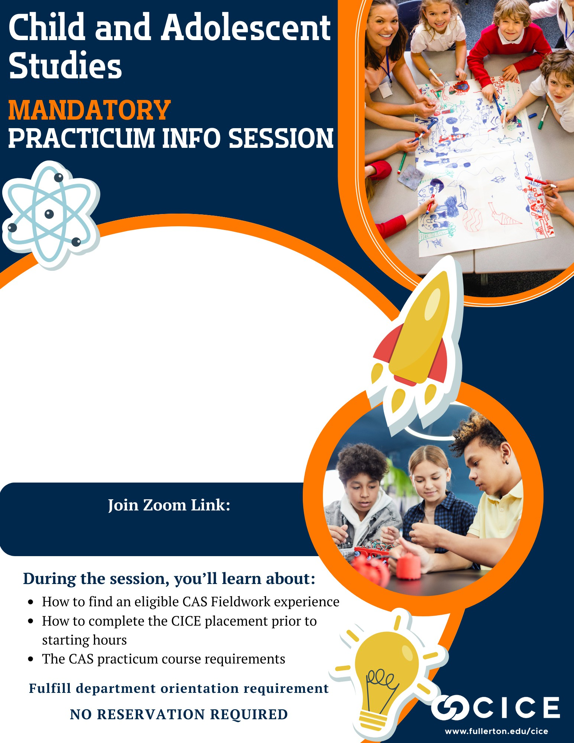

Upcoming 75-Minute Sessions
- Wed., Nov. 4 @ 5:00pm  - Mon., Nov. 16 @11:00am  - Thurs., Dec. 3 at 6:00pm  - Thurs., Dec. 17 at 10:00am  - Fri., Jan. 8 at 11:00am  - Tues., Jan. 12 at 3:00pm  - Thurs., Jan. 14 at 4:00pm  - Wed., Jan. 20 at 2:00pm | - Fri., Jan. 22 at 10:00am  - Mon., Jan. 25 at 11:00am  - Thurs., Jan. 28 at 2:00pm  - Mon., Feb. 1 at 5:00pm  - Thurs., Feb. 4 at 10:00am  - Fri., Feb. 12 at 10:00am  - Thurs., Feb. 18 at 11:00am

www.fullerton.edu/cice/orientation

