Student Name/CWID:
Advisor Name:
Date:

This advising packet provides comprehensive advice for all required coursework in the Bachelor of Science (BS) degree in Child and Adolescent Studies: Elementary Education Concentration (CHAP). Course information is organized into these categories:
1. General Education (GE) American Government 2
2. CAS Core Courses (taken by all majors regardless of concentration) 3
3. Elementary Education (CHAP) Concentration Requirements 4
Concentration-Specific Assessment Class 4
Elementary Education Practicum Classes 5
Elementary Education (CHAP) Topical Classes 6
Family Context (choose 1 class) 6
Arts (choose 1 class) 6
Kinesiology/Physical Education (choose 1 class) 6
Language Arts (choose 1 class) 6
Math (choose 1 class) 6
Science (choose 1 class) 6
Important Reminders: 7
4. Graduation Unit Requirements 8

General Education (GE) American Government
GE Category | Recommendation | Class Taken | Notes
Lower-Division GE
1 English Communication
1A Written Communication
1B Critical Thinking
1C Oral Communication
2 Math & Quant Reasoning
2A Math & Quant Reasoning
3 Arts & Humanities
3A Intro to Arts
3B Intro to Humanities
4 Social & Behavioral Sciences
4A Intro to Soc & Behav Sci | CAS 101 |  | This course also counts as part of the CAS Core.
4B Am History, Inst & Values | AFAM/ASAM/ CHIC/HIST 190 |  | These classes meet a prerequisite for CSUF teaching credential programs.
5 Physical & Biol Sciences
5A Physical Science
5B Biological Science
5C Laboratory Experience
6 Ethnic Studies
American Gov Graduation Req
Upper-Division GE
2U Impli/Explore Math & Quant Reasoning
3U Explore Arts or Humanities | ART 380, THTR 311 or ENGL 341 |  | This course also counts as a Topical Development course.
4U Explor Soc & Behav Sci | EDEL 325 |  | EDEL 325 is a required prerequisite for the multiple subject and Pk-3 credential programs.  If you are seeking a SPED credential, see recommended classses at this link.
5U Impli/Explore Phys & Biol Sciences |  |  | You must take either 2U or 5U. You do not need to take both.
Z Cultural Diversity | EDEL 325 |  | EDEL 325 ( recommended in 4U) will also meet area Z.
- 3 GE classes must be upper-division (300+) classes taken at the CSU: 3U, 4U, and either 2U or 5U. These GE Categories are listed in orange above.
- Additional information is available at https://www.fullerton.edu/general-education/

CAS Core Courses (taken by all majors regardless of concentration)

CSUF CAS Class | Class Taken | Notes
CAS 100 Foundations for Success in CAS  OR  CAS 200 Thriving as a Transfer Student in CAS |  | CAS 100/200 should be taken in your first year at CSUF.
CAS 101 Intro to Child Devel
CAS 201 Child, Family, & Comm
SPED 371 Exceptional Individual
CAS 300 Effective Prof Comm
CAS 301 Inquiry & Method Devel
CAS 302 Cultural Competence in Development
CAS 325A Conception to Age 8
CAS 325B Age 9 to Adolescence
CAS 490T Topical Seminar

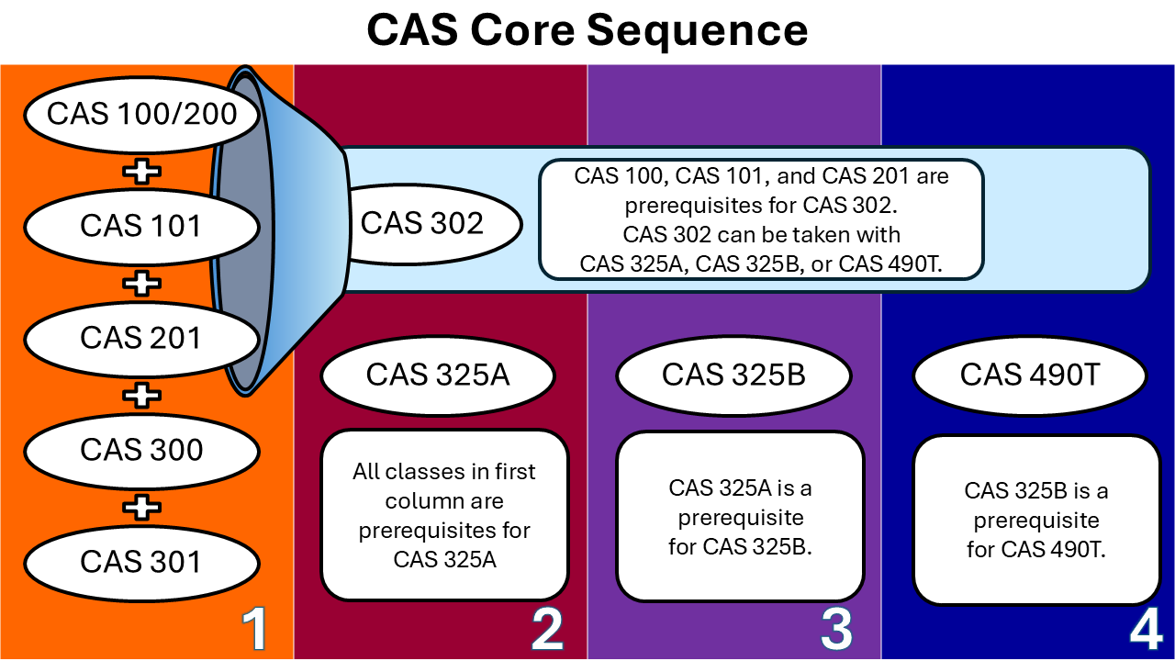

Elementary Education (CHAP) Concentration Requirements

Concentration-Specific Assessment Class
CSUF CAS Class | Class Taken | Notes
CAS 310 Assessment & Observation in Devel

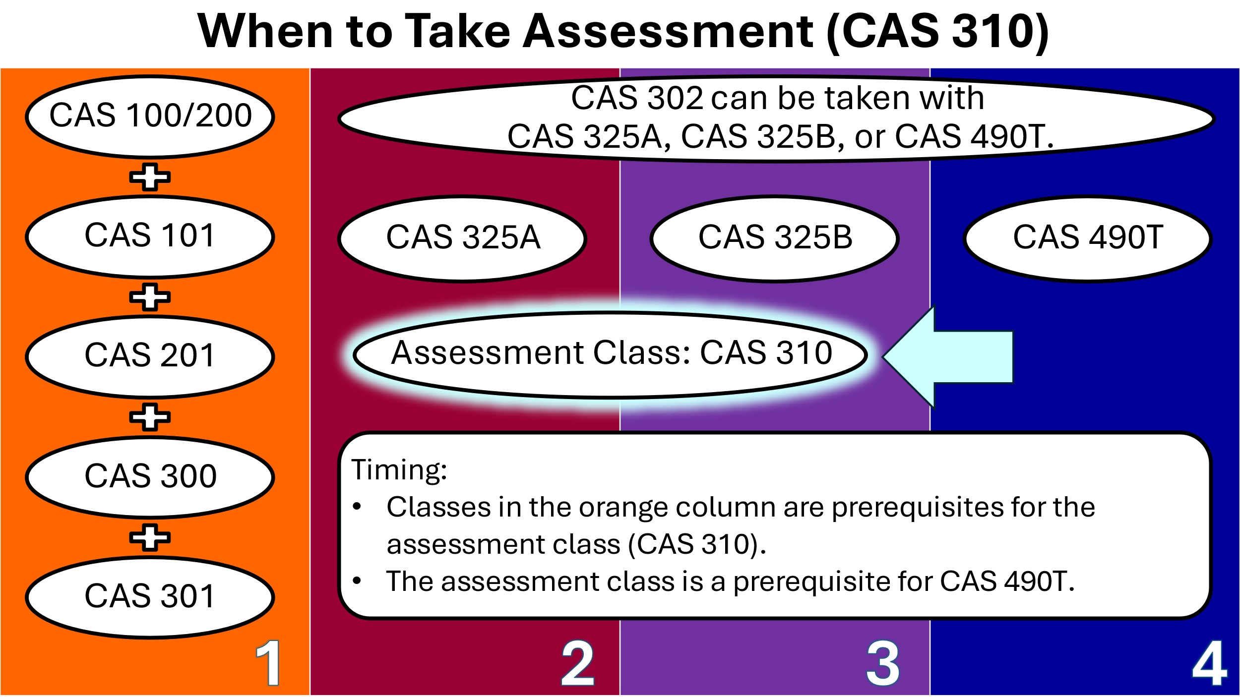

Elementary Education Practicum Classes
CSUF CAS Class | Class Taken | Notes
CAS 394 Intro Practicum in CAS
CAS 454 Practicum in Transitional EC
OR
CAS 474 Practicum in Early Care and Edu

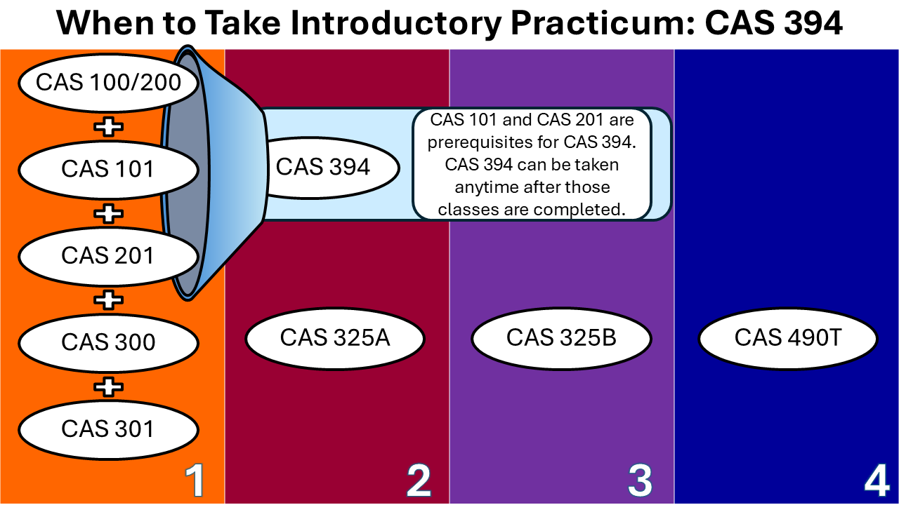
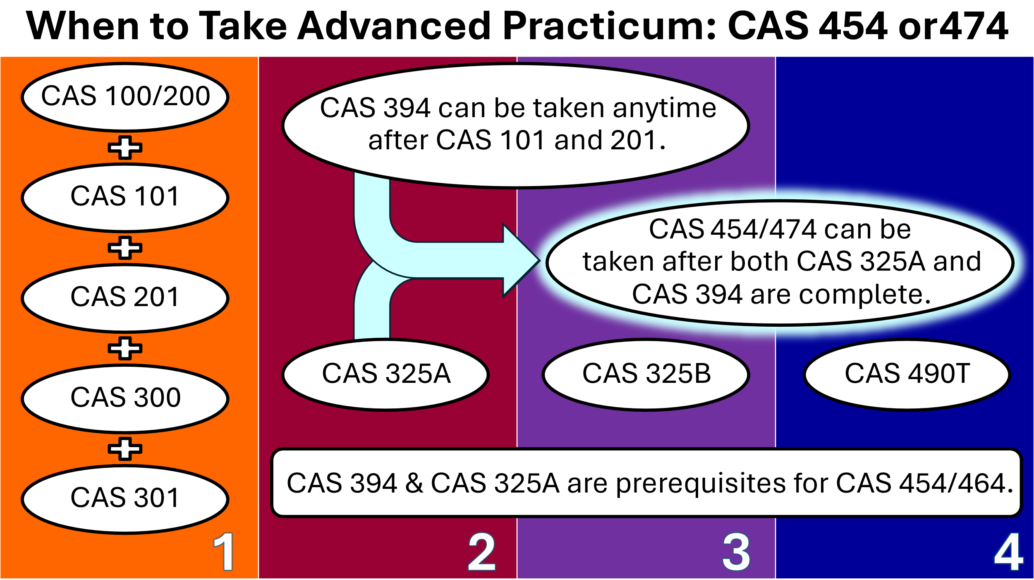

Elementary Education (CHAP) Topical Classes
To fulfill concentration requirements, CHAP majors select SIX additional courses from the following list. Every CAS major must take a CAS class on family. The other five topical courses for this concentration meet the multiple subject subject matter competency for credential programs.

Courses must meet these requirements:
- At least ONE course must be in the Family Context category.
- At least THREE courses must be upper-division (having a number 300 or higher).
See the next pages for our specific course recommendations for early childhood professionals working in preschool centers and family childcare. If you are interested in post-baccalaureate or credential programs, please see the advising guides for Pk-3rd credentials, Multiple Subject credentials, Special Education credentials, and graduate school.

Family Context (choose 1 class)
- CAS 340 Parenting Today
- CAS 345 Devel Div Family Contexts

Arts (choose 1 class)
- ART 380 Art & Child Development
- DANC 471 Creative Dance for Children
- MUS 433 Music in EC
- THTR 402A Drama for Children

Kinesiology/Physical Education (choose 1 class)
- KNES 386 Movement & the Child

Language Arts (choose 1 class)
- ENGL 341 Children’s Literature
- THTR 311 Oral Interpretation of Children’s Literature

Math (choose 1 class)
- MATH 303A Fundamentals of Elementary Math

Science (choose 1 class)
- BIOL 453 Life Science for Educators
- GEOL 410 Planet Earth for Educators

Recommended  Topical Development Classes | Class Selected | Notes
Family Context (choose one)
Arts (choose one)
Kinesiology/Physical Ed (choose one)
Language Arts (choose one)
Math (choose one)
Science (choose one)

Important Reminders:
- At least 1 topical development class must be in each category.
- Community College equivalents may be accepted for up to 3 Topical Development Classes. The remaining 3 classes must be taken at CSUF.
- At least 3 Topical Development Courses must be upper division (course number of 300 or higher).

Graduation Unit Requirements
Type of Course | Total | Notes
- Transferred
- Completed at CSUF
- In progress
- Enrolled for Future Semester
- Left in major
- Left in GE
- Left in American Government
- Required for next steps
- General electives needed to reach 120
Minimum Units Needed for Graduation | 120

