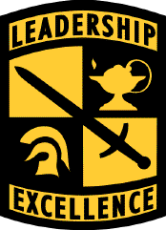
US Army Cadet Command
Presenter
2025-06-24 21:51:09
--------------------------------------------
Final Slide
Leaders for Life

Leadership Excellence
This We’ll Defend

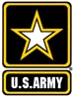

Reserve Officer Training Corps. (ROTC)

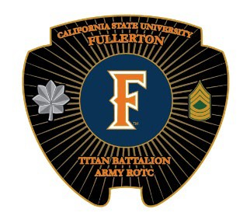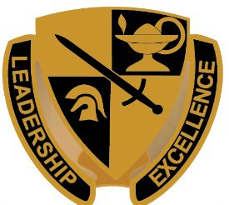

Mr. Steven R. Yach, GS Recruiting Operations Officer (ROO)
Cell 714-931-3440

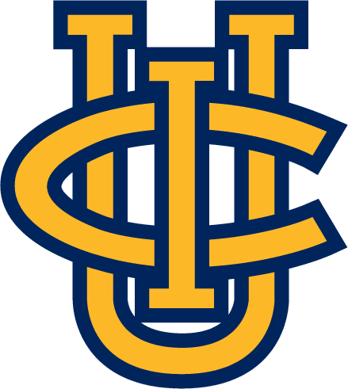
syach@fullerton.edu

CSUF Location, Parking & Contacts


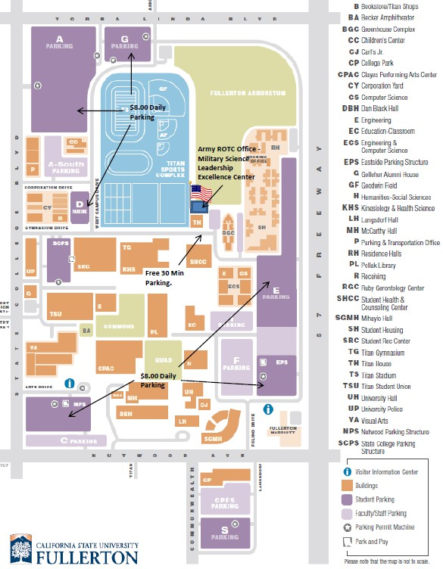

CSUF Military Science Dept. 800 N. State College Blvd.
Fullerton, CA 92831
Mr. Steven Yach
Recruiting Operations Officer syach@fullerton.edu
(714) 931-3440

MSG Jamie Pinto
ROTC Army Reserve Recruiter jpinto@fullerton.edu
Metered Parking
(661) 221-8388

Mr. Kurt Boehmke
CSUF Admin Support Coordinator armyrotc@fullerton.edu
(657) 278-3007

GOOGLE MAPS
https://goo.gl/maps/YFzJXaDCD38bKWY36


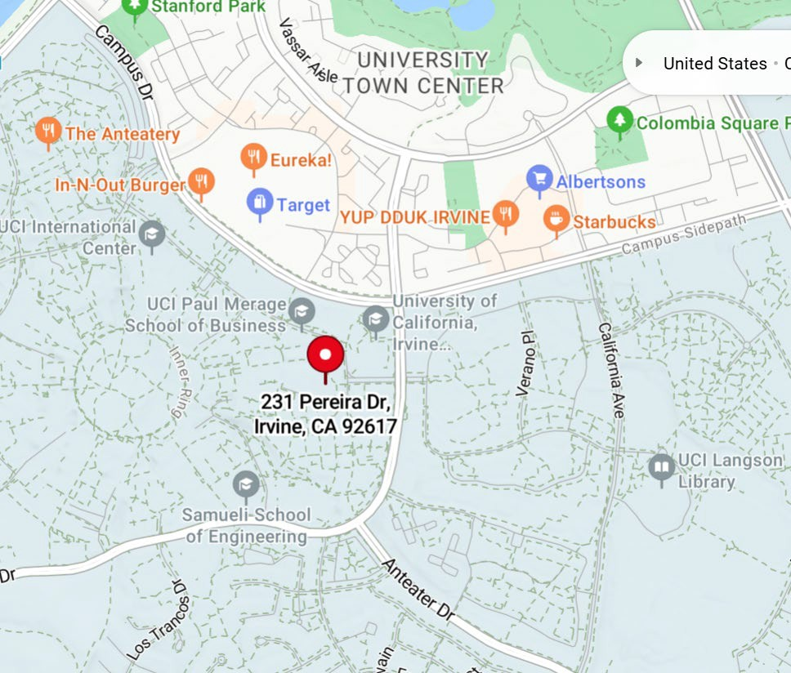

UCI Location, Parking & Contacts
UC Irvine Army ROTC 231 Pereira Dr. #201
Irvine, CA 92617

Office: (714) 770-9353
Email: armyrotc@uci.edu

MAJ Trent Frum
Anteater Detachment OIC/ Assistant Professor of Military Science
tfrum@uci.edu

Ms. Marisol Vilchis-Huizar
Program Assistant/Enrollment Advisor vilchish@uci.edu

SFC Joshua Paik
Assistant Recruiting Operation Officer/ National Guard SMP Accessions
jpaik2@uci.edu (714) 720-9322

ROTC Brief Talking Points

- How do I apply for college?
- What is ROTC and the Command Philosophy?
- Who is the Titan Battalion?
- Where does ROTC train?
- When does training occur?
- How does it all work?
- Am I applicable to enroll in the program?
- How do I apply for a scholarship?
- Can I be an Army Reservist or Guard Soldier and be in ROTC?
- Can I designate how I serve after ROTC, Active Duty or Reserve Component?
- What opportunities does ROTC offer while I’m in the program?
- What takes place after I graduate and commission as a 2nd Lieutenant?
- I have the calling to serve, is this the program?
- How to continue this interview process?

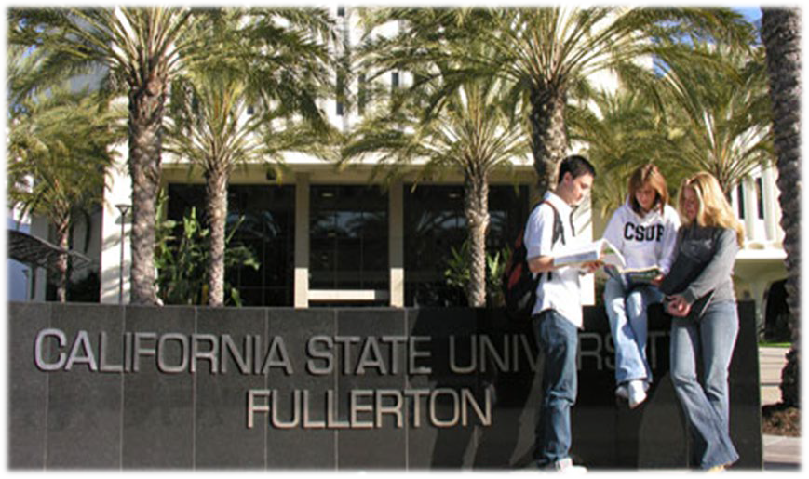
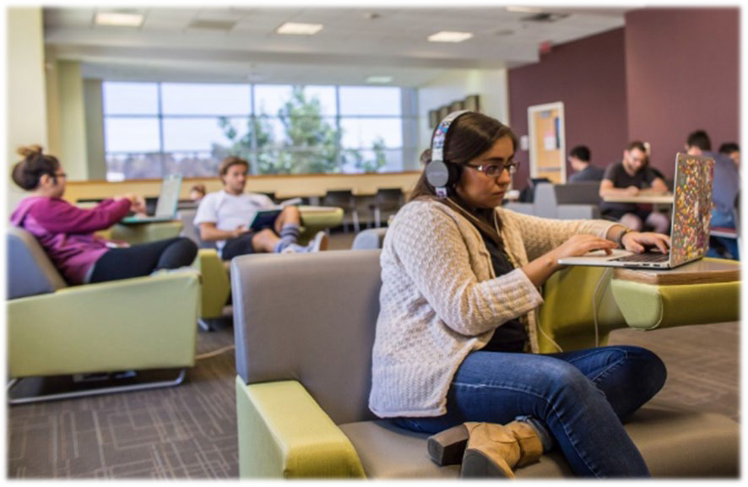
Apply for College
•
Universities offer Bachelors of Science (BS) or Bachelor of Arts (BA) degrees usually 120 Credits. That’s 15 Credits per semester, most classes are 3 Credits, so that’s 5 classes every semester for 4 years.
– 0-30 Credits Freshman (45 Qtr. Units)

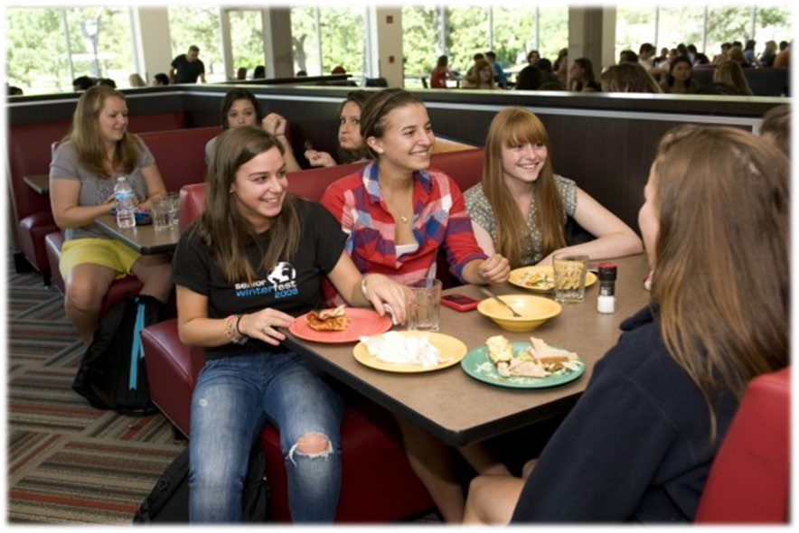
- 30-60 Credits Sophomore (90 Qtr. Units)
- 60-90 Credits Junior (135 Qtr. Units)
- 90-120 Credits Senior (180 Qtrs.)
- Specific STEM majors may be more
  - Community Colleges offer Associate Degrees and or student attends to reach 60 transferable credits, that’s 2 years.
    - 0-30 Credits Freshman
    - 30-60 Credits Sophomore
  - Community College Students can participate in ROTC with the intent of transferring to a University

Preparation & Planning for ROTC

Things to think about and plan prior to the first semester of college:
- Where will l live? (home, dormitory, apartment)
- How will I get to campus? (car, carpool, public trans, bike)
- What will I study? (career interests)
- How will I pay for tuition and books?
- Will I need a part time job?
- Can I work on campus? (Student Rec Center, Library…)
- How do I apply for scholarships/financial aid? (FAFSA)
- What clubs & social activities sound interesting to join? (ROTC, intramural sports, cultural clubs, STEM clubs…)

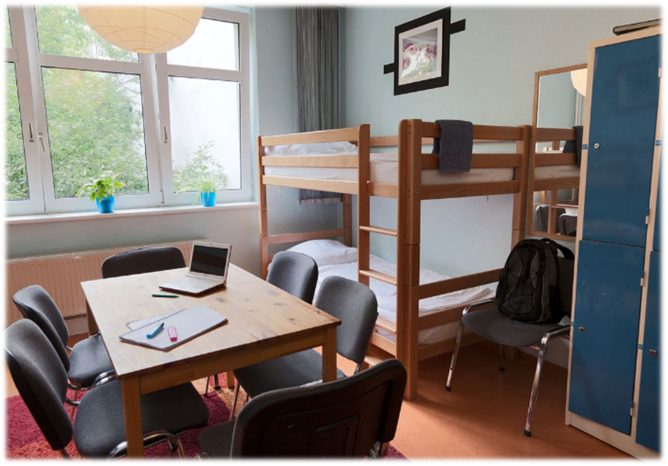

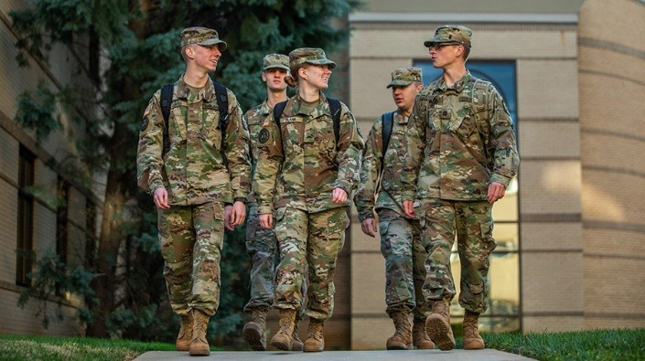

What is Army ROTC?

BLUF (Bottom Line Up Front)
Full time college students take a 3 credit course in Military Science each semester during college on top of their normal major coursework. Students who complete the ROTC Advance Course during their last four semesters of school are offered a commission as a US Army officer in the rank of Second Lieutenant. Once commissioned, they start their service as a leader in the US Army, Army Reserve or National Guard.

Making the best military officers in the world.
Army ROTC is the largest officer-producing organization with the American military, having over 600,000 men and women have earned a commission through the program. Among them are two chairmen of the Joint Chiefs of Staff, seven Army chiefs of staff, two Cabinet secretaries and a sitting Supreme Court associate justice. Few other military commissioning sources can claim such significant lineage.

History & Mission
The Army Reserve Officers' Training Corps (ROTC), as it exists today, began over a hundred years ago with President Wilson signing the National Defense Act of 1916. Although military training had been taking place in civilian colleges and universities as early as 1819, the signing of the National Defense Act brought this training under single, federally-controlled entity. Army ROTC develops, trains, and commissions future officers in all components of the United States Army. Fosters an integrity based environment that promotes academic excellence, physical fitness, and teambuilding.

ROTC vs. West Point Academy (USMA)
Army ROTC is officer training while getting the full college experience available at over 1,100 Colleges and Universities in the United States and Trust Territories and has guaranteed Reserve and National Guard career options unlike West Point (USMA).

Who is the TITAN Battalion?

Full time CSUF and non-CSUF students can register through open enrollment for Military Science & Leadership Classes (MSLC) conducted at the Host School (CSU-Fullerton) and
an Extension School (UC-Irvine).

Schools eligible for MSLC Class, Contract and Scholarship
CSU-Fullerton, UC-Irvine, Biola, Vanguard, Chapman & Whittier College

Schools eligible for MSLC Class through CSUF Extended Education Fullerton, Rancho Santiago, Cypress, Mt. San Antonio, Cerritos, Golden West,
Orange Coast, Mt. Sacramento, Rio Hondo, Santa Ana

Why the Titan Battalion?

- The premier ROTC Program in Orange County, California.
- Cadets receive Priority Registration for CSUF classes.
- ROTC Graduates receive 100% Army job placement as Commissioned Officers with service options in the Army Reserve, National Guard and Active Duty.
- ROTC graduates receive a Academic Minor in Military Science.
- US Army Obstacle Course on campus.
- CSUF is a member of HACU (Hispanic Association of Colleges and Universities).
- Cal State Fullerton has moved up to the top quartile of the nation’s ‘Best Value Colleges,’ according to
Forbes’ recently released annual ranking of higher education institutions.
- Cal State Fullerton is a leading campus of the CSU, serving as an intellectual and cultural center for Southern California and driver of workforce and economic development.
- U.S. News & World Report (September 2016) CSUF ranks in the "first tier" among top National Universities. In addition, CSUF is listed for "Best Ethnic Diversity," in part for Hispanic enrollment of 42 percent.
- Hispanic Outlook in Higher Education (August 2016) CSUF ranked No. 1 in California and fourth in the nation among top colleges and universities awarding bachelor's degrees to Hispanics, based on
2014 data from the U.S. Department of Education.

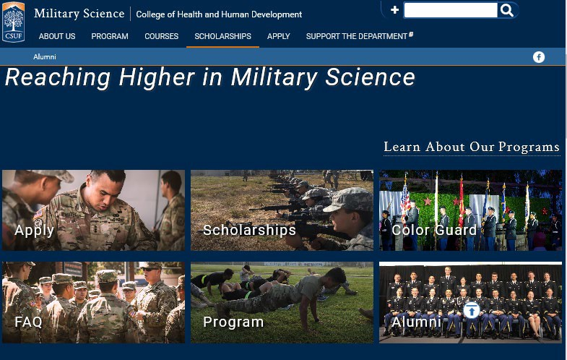
Start Here

NOTE* You will be contacted once you submit an online application to set up an appointment

How do I begin the process?
Contact the Recruiting Operations Officer (ROO) for customized student planning and specific information. In preparation for your vvirtual or in-person appointment/interview please follow the below guidance.
- Request and Confirm request an appointment at https://calendly.com/csufarmyrotcenrollment
- Review this ROTC brief closely and bring your questions.
- Plan you’re parking prior to arrival, see attached map. Your interview will last 20-30 minutes, there is free 30 parking outside our office. If you are traveling a far distance, plan to pay for parking so you have time to tour the campus.
- Dress appropriate for a professional interview.
- Bring your Resume with three professional contact references.
- First time freshmen bring a copy of your college acceptance letter(s), if already attending CSUF, include your Campus Wide ID Number (CWID).

Parents and or support are always encouraged to attend.
- Travel safe and if you are running late or need to reschedule, please contact me and I will accommodate. Resume example: https://www.themuse.com/advice/43-resume-tips-that-will-help-you-get-hired

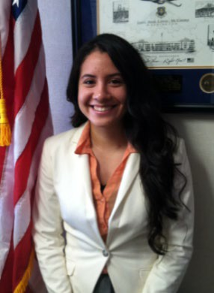
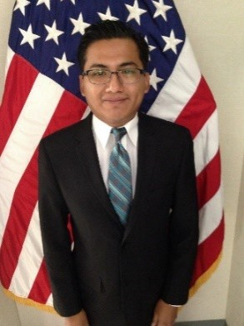
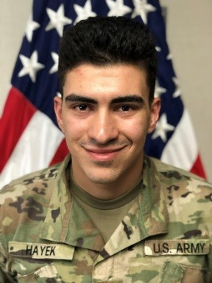
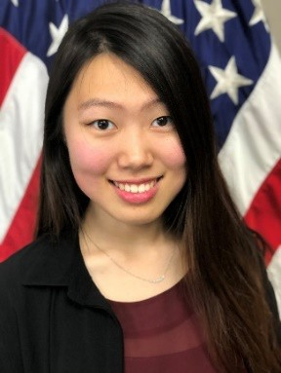
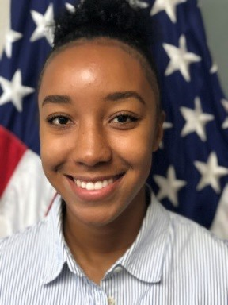
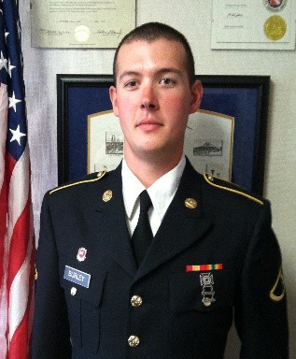

Military Science 101: Introduction to the Army Officer

- After you accepted your college admissions offer, declare a major and register for classes pursing your degree of choice. Make a list of all the classes you need to graduate, this will come in handy later.

- Register for 3 cr. Military Science Class (MSLC 101) at CSU-Fullerton or ROTC 11 & 10L at UCI
  - Physical Fitness Training (PT) M, W, F 0600-0700
  - Academic Leadership Class (once a week, times vary per semester)
  - Military Science Lab – (Fridays 0800-1100)
  - No military experience/JROTC necessary
  - No obligation to commit to the program or the US Army
  - Experience Army Officer Training on campus and learn about Army Opportunities!

- Generally during or after the first semester or quarter of ROTC, staff will assist students who want to pursue the program in their Medical, Physical, Academic and Legal validation process for contract and scholarship eligibility.
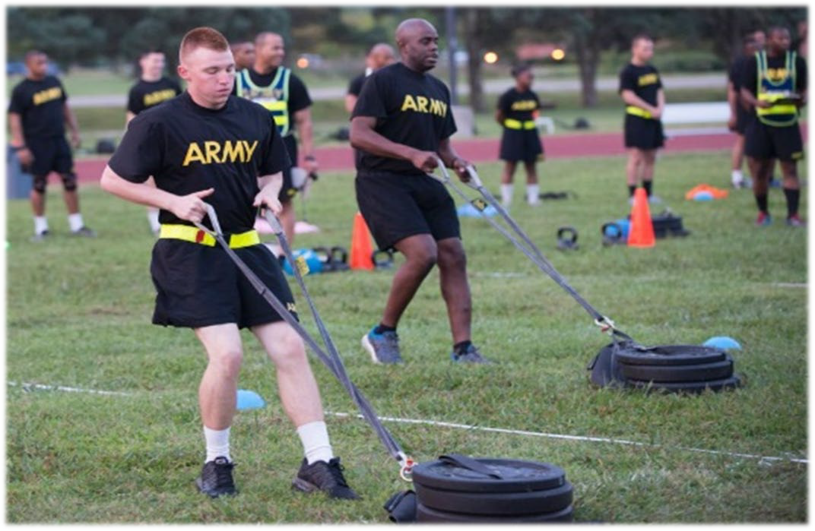
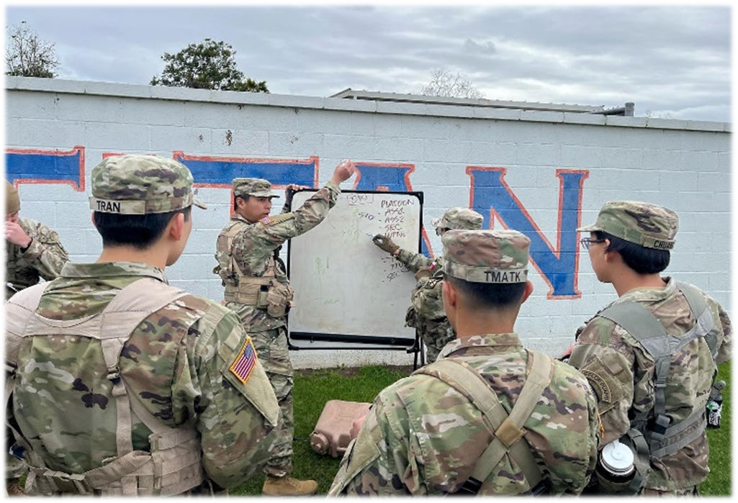
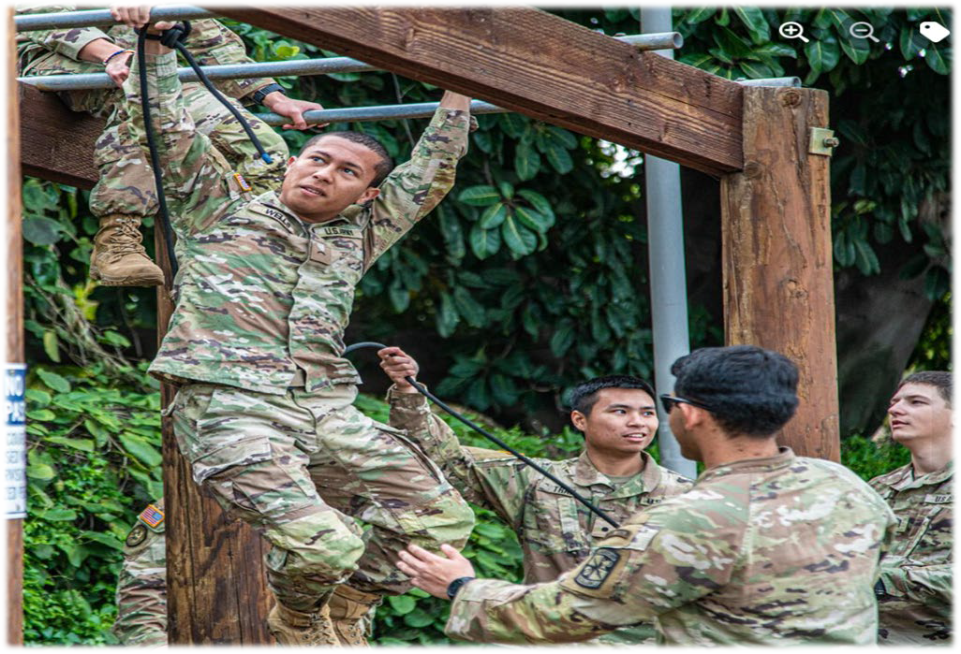

Military Science Class Registration

Register for the appropriate 3 Cr. Military Science Class (MSLC)
- First Time Freshman will register for MSLC 101 during the fall semester
- Non First Time Freshman new to ROTC will register MSLC 101 fall semester or MSLC 102 spring semester.
- Prior Military Service or Students in the Army Reserve or National Guard can register for fall MSLC 201, spring 202 or fall 301 depending on their academic alignment.

Note* If a student registers for MSLC after their freshman year or transfers to CSUF/UCI, ROTC has catch up opportunities to become aligned prior to their last 4 semesters of college and the ROTC Advance Course (Junior, Senior, Graduate status students).
Basic Course Lateral Entry Video
https://youtu.be/NihdMn-Pm2c

Basic Course Lateral Entry at Ft. Knox, KY Website
https://futurearmyofficers.army.mil/category/basic-camp/

Military Science 101 at CSUF

CSU-Fullerton Military Science Class 101 includes Lecture, PT, Lab and 3 credits as semester following the university academic calendar
Physical Fitness (PT) Monday, Wednesday. Fridays at 0600-0700 CSUF Sports Field
Military Science Leadership Class (MSLC) Mondays & Wednesdays at 0830-0945 classrooms vary each semester
Leadership Lab (Lab) Fridays at 0800-1100 CSUF Sports Field
- To avoid class schedule conflicts, Cadets are encouraged to take their major classes after 1200 and or TU and TH. If there is a schedule overlap conflict, Cadets can register for the MLSC “section 03” time TBD.
TITAN BATTALION
Military Science Class
Fall Semester 101 & Spring Semester 102
NAME: |  |  | MAJOR:
TIME | MONDAY | TUESDAY | WEDNESDAY | THURSDAY | FRIDAY
0600-0700 | Physical Training (PT) (MWF) 0600-0700  CSUF Sports Field |  | Physical Training (PT) (MWF) 0600-0700  CSUF Sports Field |  | Physical Training (PT) (MWF) 0600-0700  CSUF Sports Field
0700-0800 |  |  |  |  | Military Science Leadership Lab  (F) 0800-1100  CSUF Sports Field
0830-0945 | Military Science Class MSLC Class: 101  Section: 01  CRN: 19838  Time:(MW) 0830-0945 |  | Military Science Class MSLC Class: 101  Section: 01  CRN: 19838  Time:(MW) 0830-0945
1000-1100
1100-1200

ROTC 11 at UCI

UC-Irvine Military Science Class 11 is 1.0 unit and 10L is 1.0 a unit Lab per quarter following the university academic calendar.

During each quarter ROTC/Military Science class consists of multiple events:
- Physical Fitness (PT) Monday, Wednesday and Friday at 0600-0700 UCI ARC
- Leadership Class (MSLC) Tuesdays at 1100 Natural Science I Building ROTC Classroom
- Leadership Lab (Lab) Thursday at 0600-0850 On Campus Location TBA
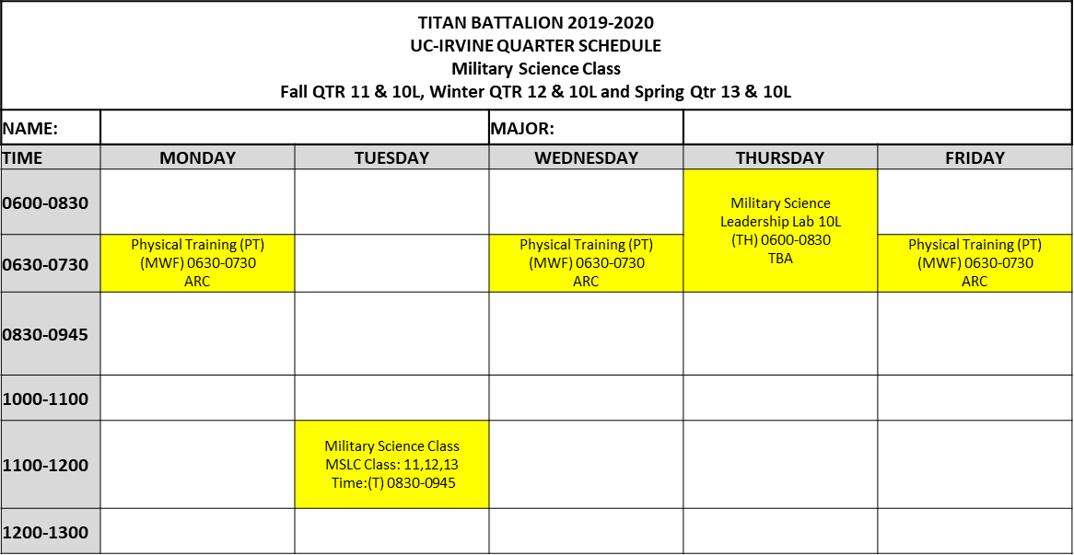
- Once a semester, Students participate in a Field Training Exercise (FTX) off campus

Alcohol Abuse and Substance Use Not Tolerated

CC Pam 145-4, Chapter 2/Section VI AR 145-1, Ch 3.
  - Never used chemical substances or drugs.
  - Self admitted limited, experimental use of chemical substances or drugs which occurred over 6 months prior to contracting, unless disqualified by DODMERB.

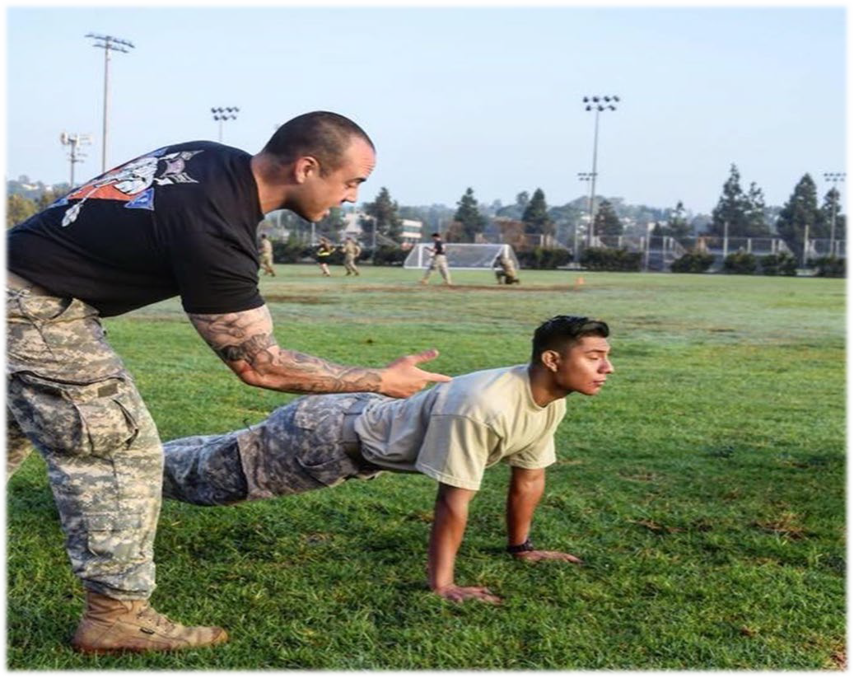




ROTC Scholarship

Awarded ROTC scholarship activates when the student signs their contract.

- Receives FULL TUITION (or up to $12,000 for R&B per year)
  - CSU-Fullerton, UC-Irvine, Chapman, Biola, Vanguard & Whittier College
  - Payment direct to the University by ROTC

- Receives BOOK ALLOWANCE of $1,200.00 per year
  - $600.00 every semester paid to Cadet’s direct deposit account

Methods of Applying for a ROTC Scholarship
  - High School National. Students apply while in High School awarded by US Army Cadet Command
https://www.goarmy.com/rotc/high-school-students/four-year-scholarship.html

  - Campus Based. Students apply while attending Military Science class and awarded by ROTC program. Schedule appointment with Mr. Yach. https://www.goarmy.com/rotc/college-students/three-year-scholarships.html

  - Minute Man. USAR/ANG serving students apply with a endorsement from a CASA or ARA. Minute Man Scholarship is awarded during the SMP process with a GRFD contract. https://www.usar.army.mil/MinutemanCampaign/ Schedule appointment with Mr. Steven Yach.

ROTC Program Activities

- Field Training Exercise located off campus to apply skills learned during the semester
- Yearly athletic competitions: Cadets vs. Vets Football, Basketball and Softball game
- Ranger Challenge Team training and competition
- Yearly formal military dining event. During the Military Ball Cadets practice the time honored customs and traditions of being a professional Army Officer.
- Yearly ROTC Awards Ceremony for outstanding cadet performance
- Participation in the ROTC co-ed Fraternity Alpha Lambda
- Military History field trip
- Color Guard Team Events
- Assist in building the program with volunteer recruiting opportunities!

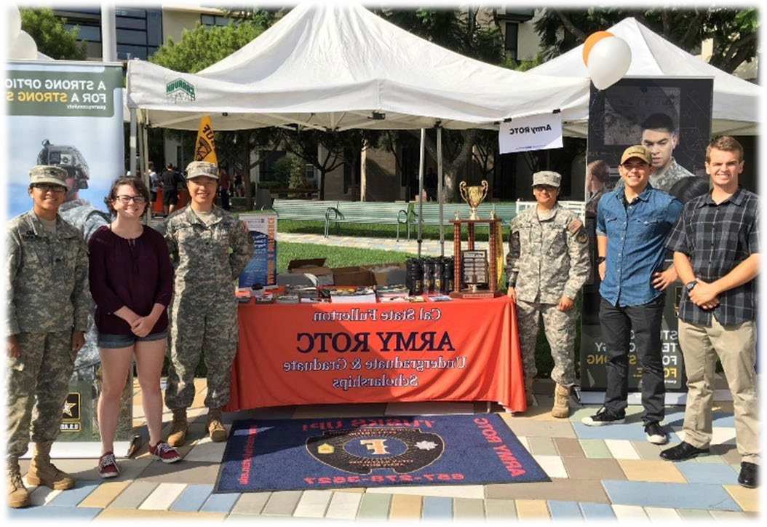
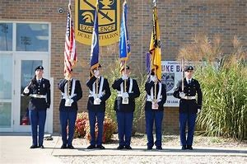
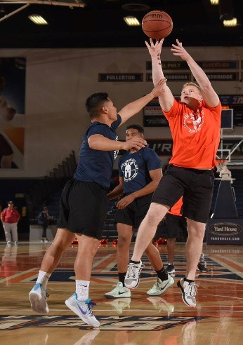
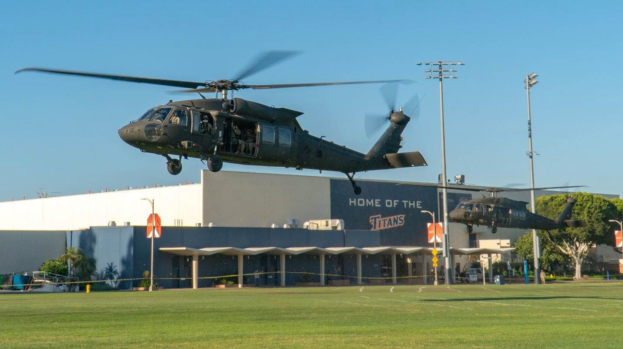

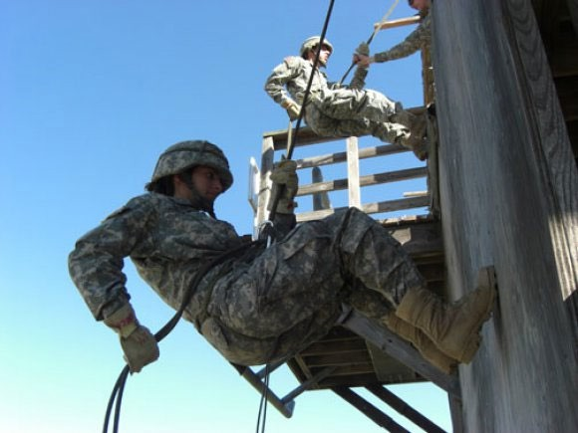
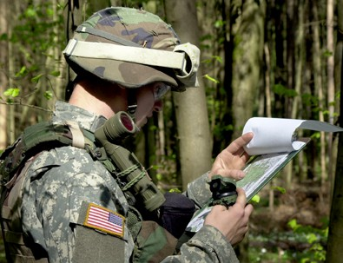
Field Training Exercise

Every semester Cadets get to participate in a weekend Field Training Exercise (FTX) practicing campus learned skills in a military field environment at Camp Pendleton or Los Alamitos, CA.
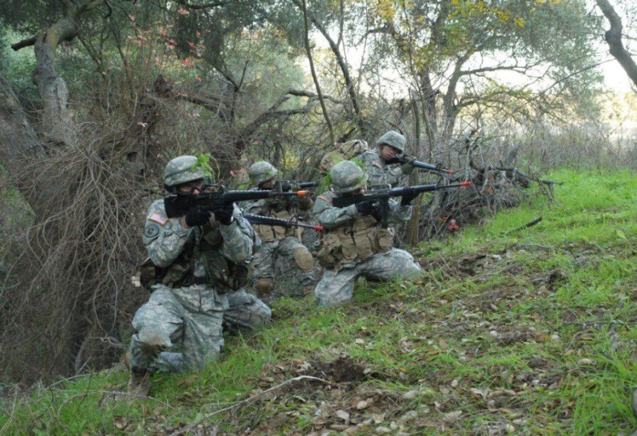
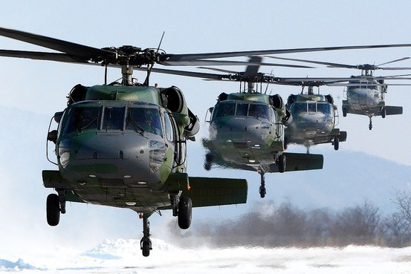

Optional US Army Training & Ranger Challenge

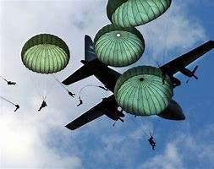
- Optional summer training and internships
- CTLT, CAIT, Airborne School, Air Assault School
- US and Overseas specialized internships
- Titan BN Ranger Challenge (RC) Team

Cadet Club that trains to compete in the annual Ranger Challenge Competition
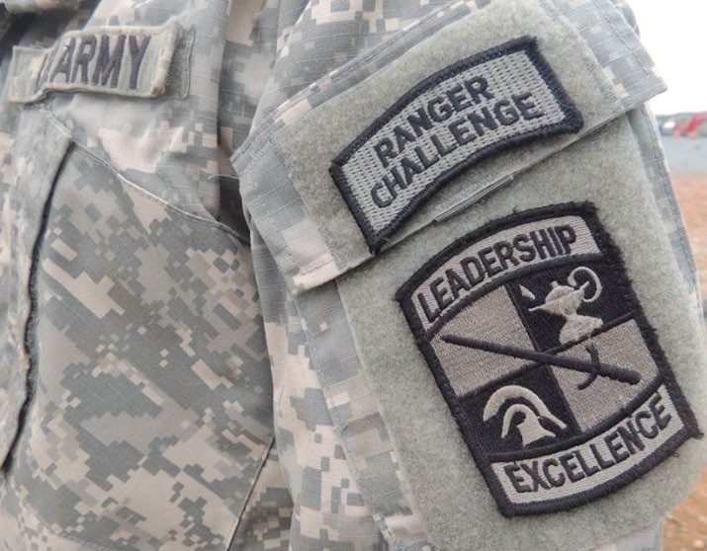
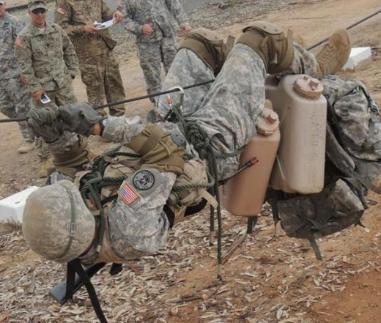
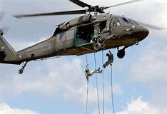

Cadet Summer Internships Available

Advanced Cyber Education (ACE) Wright-Patterson, OH
AFRICOM Voluntary Internship Program (AVIP) Germany, Stuttgart, Patch Barracks Army Cyber Institute (ACI) West Point, NY
Internship: Army Medical Department Internship Program (AMEDDIP) Bethesda, MD (NSA) Aberdeen Proving Ground, MD San Antonio, TX Schofield Barracks, HI Fort Campbell, KY Aberdeen Proving Ground, MD Fort Benning, GA Aberdeen Proving Ground, MD Fort Lewis - JBLM, WA Korea (Yongsan) Schofield Barracks, HI Frankfurt, GE Venice, IT Frankfurt, GE Nurnberg, GE
Chaplain Internship Program (CHIP) Hawaii
Communication. Electronics, Research and Development Center (CERDEC)
Aberdeen Proving Ground, MD
Congressional Internship Program (CIP) Washington DC
Cultural Property Protection Internship Program (CPPIP) Fort Drum, NY
Defense Forensic Science Center (DFSC)
EUCOM Voluntary Internship Program (EVIP)Germany, Stuttgart, Patch Barracks Federal Bureaus of Investigation - New York City (FBIIP) New York City, NY Forensic Internship Program (FIP) Largo, FL
Intelligence and Security Command Internship Program (INSCOM) Fort Belvoir, VA
Joint Manufacturing and Technology Center (JTMC) Rock Island, IL Lawrence Livermore National Lab (LLNL) Internship Program Livermore, CA MIT Lincoln Lab Internship (MITLL) Hanscom AFB, Lexington, MA
Museum Internship Program (MIP)
Internship: Nurse Summer Training Program (NSTP) Fort Stewart, GA Fort Shafter, HI Fort Belvoir, VA Fort Polk, LA Fort Campbell, KY
Nurse Summer Training Program (NSTP)Bethesda, MD Univ of Texas El Paso (UTEP )El Paso, TX
World Class Cyber Opposions Force (WCCO) Fort Belvoir, VA
NASA Ames Program (NASA-A) Moffett Field, CA

SMP Program

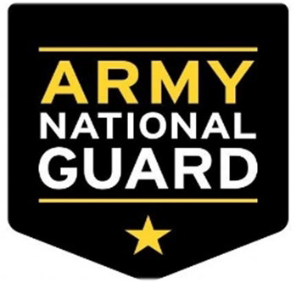
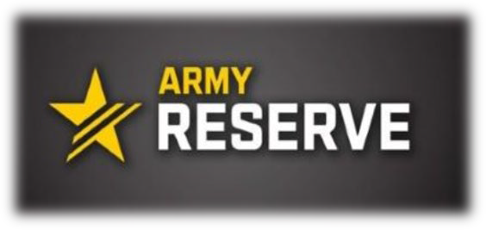
Can you be member of the US Army Reserve or National Guard, attend College as a full time student and be contracted in ROTC?
YES!
Simultaneous Membership Program(SMP)
Leadership development as a Cadet shadowing Officers in a local Reserve or Guard Unit.
Benefits:
- E5 Pay as a Cadet
- SMP Kicker (MOSQ)
- G.I. Bill
- Minute Man Scholarship
- Time in Service
- Training Opportunities (BCT, AIT, AT, Drill Weekends)
- Non-Deployable
- Part-Time job
- Unit experience as a Officer in Training
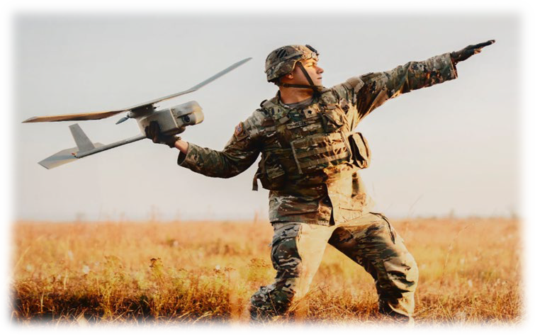


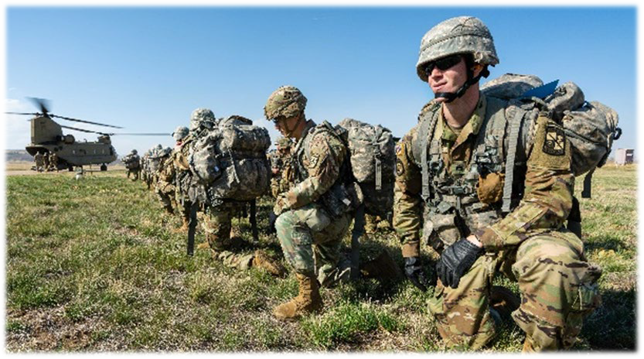
1 Reserve/Guard weekend + Full Time student + Contracted in ROTC = SMP

ROTC Steps towards Commission

Complete or enroll into the ROTC Basic Course.
Basic Course can be completed by one of the following:
- PROGRESSION. Enrolled in one Military Science Class per semester starting as a First Time Freshman.
- COMPRESSION. Enrollment in MS I and MS II the same year prior to MS III year.
- BASIC CAMP. Attend ROTC Basic Camp at Ft. Knox, KY the summer prior to MS III year.
- BASIC TRAINING. (Active, Reserve or Guard) other branches may apply Contract as an Army Officer Candidate enrolled in ROTC
Enroll into the Advance Course
CSUF MSLC 301,302, 401, 402 and 450
UCI ROTC 131,132,133,141,142,143 and 100L

Graduate Advance Camp is typically scheduled the summer prior to the MSIV year. Advance Camp is a required ROTC Training and Evaluation course located at Ft. Knox, KY.

Complete all ROTC requirements and graduate(d) with a B.S. or B.A.

1. Military Science Class Progression

ROTC Basic Course- Years 1 & 2 (No obligation necessary)
(MS I) Freshmen Year: Preparing for success as an Army Officer
- CSUF Fall semester register for MS 101 class & Spring semester register for MS 102 class
- UCI Fall Qtr. 11 & 10L, Winter Qtr. 12 & 10L and Spring Qtr. 13 & 10L

(MS II) Sophomore Year: The role of an Officer
- CSUF Fall semester register for MS 201 class & Spring semester register for MS 202 class
- UCI Fall Qtr. 21 & 10L, Winter Qtr. 22 & 10L and Spring Qtr. 23 & 10L
- Optional Cadet Summer Training Basic Course for contracted Cadets approx. 30 days at Ft. Knox, KY
- Summer paid ROTC internships available

ROTC Advanced Course- Years 3 & 4 (Contract necessary)

(MS III) Junior Year & 1st year graduate students: Leading Small Tactical Units
- CSUF Fall semester register for MS 201 class & Spring semester register for MS 202 class
- UCI Fall Qtr. 131 & 100L, Winter Qtr. 132 & 100L and Spring Qtr. 133 & 100L
- Required Cadet Summer Training Advance Course for all MS III, approx. 30 days at Ft. Knox, KY)
- Summer paid ROTC internships available

(MS IV) Senior Year & 2nd year graduate students: Transition to becoming an Officer
- CSUF Fall semester register for MS 201 class & Spring semester register for MS 202 class
- UCI Fall Qtr. 141 & 100L, Winter Qtr. 142 & 100L and Spring Qtr. 143 & 100L

*Note Cadets have Priority Registration at CSUF and are awarded a Military Science academic minor by Health & Human Development Dept. for completing the Advanced Course

2. Contract

Contract as an ROTC Officer Candidate by meeting federal requirements IAW AR 145-1
Contract Options:
Cadet Contract
DA 597-3 Scholarship Cadet Contract DA 597 Non Scholarship Cadet Contract

GRFD Cadet Contract (Guaranteed Reserve Forces Duty)
DA 597-3 & USACC Form 203-R SMP Scholarship Cadet Contract Endorsement DA 597 & USACC Form 202-R SMP Non-Scholarship Cadet Contract Endorsement


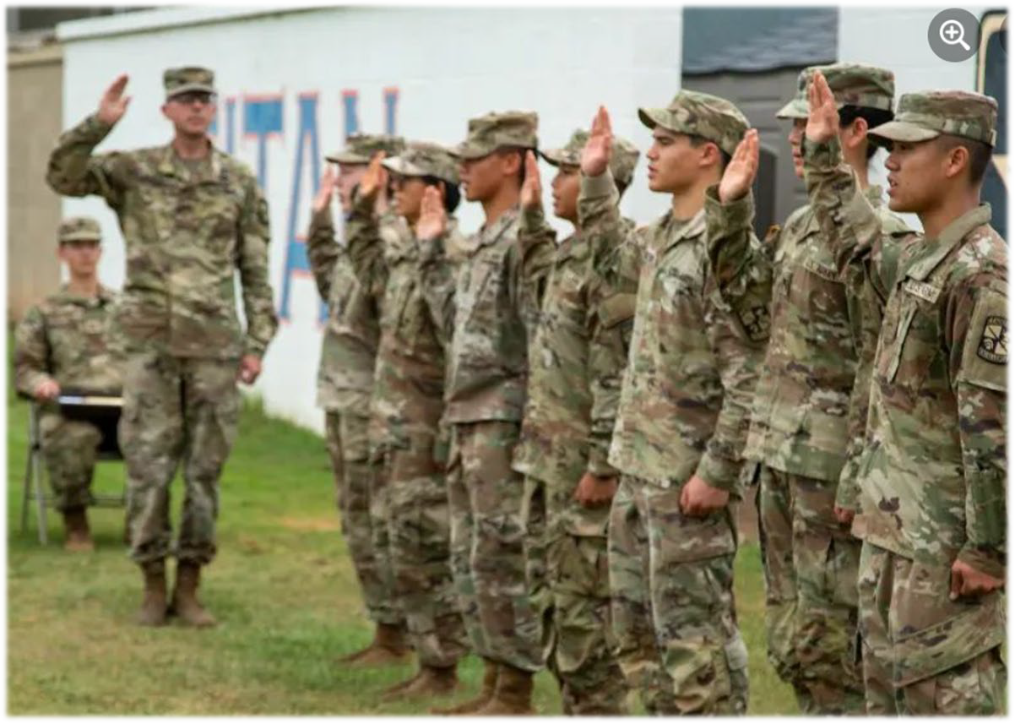

Contract Benefits

GRFD Contract (Guaranteed Reserve Forces Duty)
DA 597-3 & USACC Form 203-R SMP Scholarship Cadet Contract Endorsement DA 597 & USACC Form 202-R SMP Non-Scholarship Cadet Contract Endorsement
- Commissioned Officer will serve in the Reserve or Guard Component after commission

Cadet Contract
DA 597-3 Scholarship Cadet Contract DA 597 Non Scholarship Cadet Contract
- Cadet can compete for Active duty during ROTC or select Reserve/Guard Component service after commissioning

All contracted cadets earn a monthly living allowance (Stipend) for each month school is in session (10 of 12 months in a school year).
Freshman: $420.00 per month x 10mo. = $4,200.00
Sophomore: $420.00 per month x 10mo. = $4,200.00
Junior: $420.00 per month x 12mo. = $5,040.00
Senior: $420.00 per month x 12mo. = $5,040.00

Note* If the Cadet earned a campus based ROTC Scholarship or is a National ROTC Scholarship
27 recipient, payments will start at the time of contracting.

3. CST ROTC Advance Camp

ROTC MS III Cadets from all ROTC schools will attend US Army Cadet Command Cadet Summer Training (CST) Advance Camp at Ft. Knox, KY for 32+ days over the junior/senior summer.

Cadet summer stipend, airfare and uniforms provided.

Graduates of the Advance Course will enter their last year of ROTC in preparation of becoming an Commissioned Officer in the US ARMY.

Advance Course at Ft. Knox, KY Website
https://futurearmyofficers.army.mil/category/advanced-camp/

4. Complete ROTC, Graduation and Commission

Commissioning Ceremony generally occurs graduation weekend on campus.

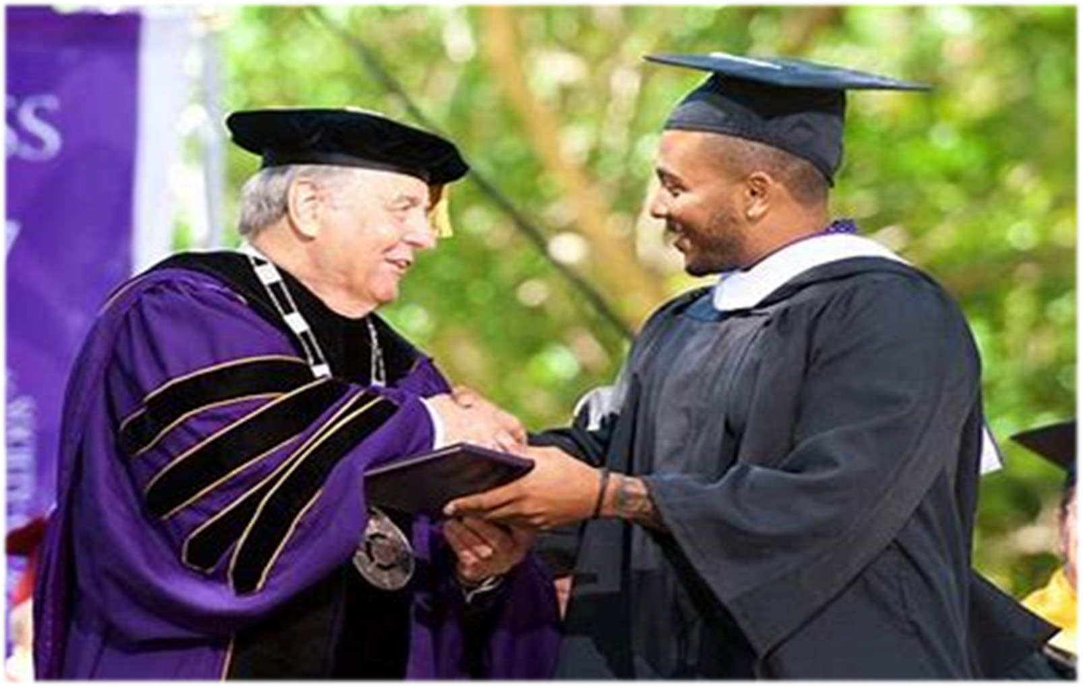
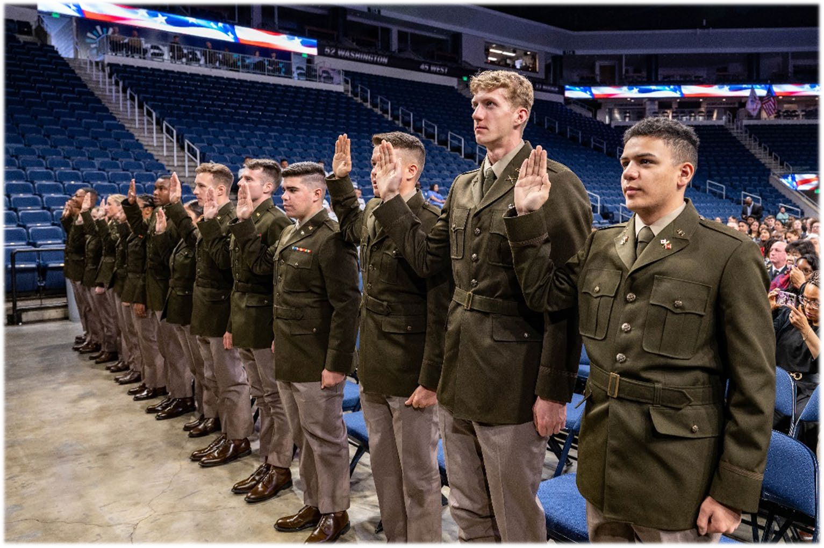

Branch Options & Service Component

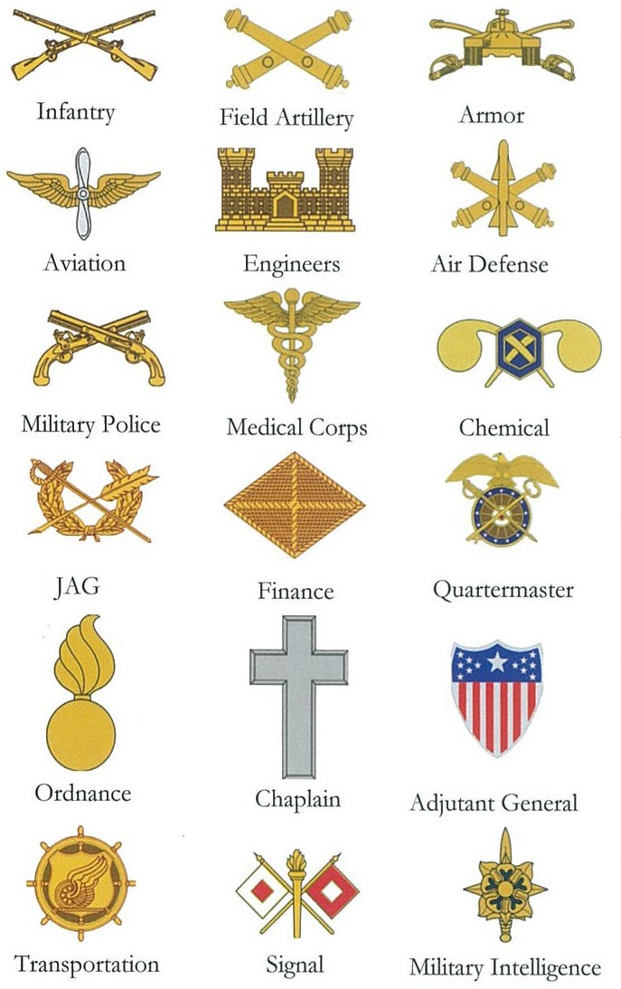
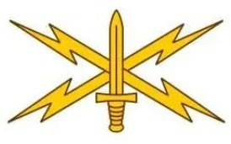
Prior to graduation the Cadet is awarded their career branch and component (active duty, reserve or guard).
Cyber

Branches are assigned by the Department of the Army based on many factors including Cadet’s preference, Cadet’s performance, Cadet’s contract and the needs of the Army.

Service Agreement & Promotions

Upon Completion of the two or four year ROTC program cadets are commissioned as a Second Lieutenant (2LT) and serve in the United States Army (4yr/4 IRR), United States Army Reserves (USAR 6yr/2 IRR) or Army National Guard (ARNG 6yr/2 IRR).

After initial service agreement is completed, Officers have the choice to continue serving for career advancement, rank promotion, educational opportunities and retirement benefits. The IRR (Individual Ready Reserve) is a no duty required status, the Officer is available in case of a presidential call up or Mobilization.
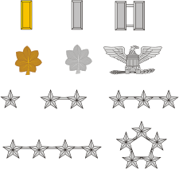

Start your Officer Career (100% Job Placement)

Active Duty or Reserve Component
After graduating with your degree, the newly commissioned 2LT will attend their Branch Course BOLC A: Officer Commissioning Program (ROTC) on campus
BOLC B: Officer Branch Course located at selected US Army training installation Complete BOLC B as a Branch Qualified Officer
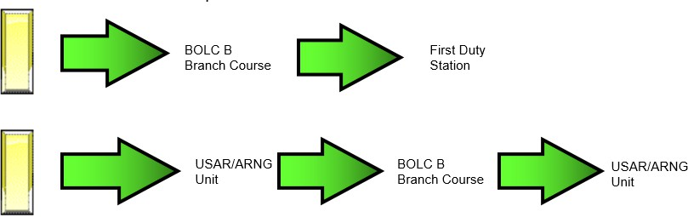

Review Questions

- How do I apply for college?
- What is ROTC and the Command Philosophy?
- Who is the Titan Battalion?
- Where does ROTC train?
- When does training occur?
- How does it all work?
- Am I applicable to enroll in the program?
- How do I apply for a scholarship?
- Can I be an Army Reservist or Guard Soldier and be in ROTC?
- Can I designate how I serve my commitment, AD or Reserve Component?
- What opportunities does ROTC offer while I’m in the program?
- What takes place after I graduate and commission as a 2nd Lieutenant?
- I have the calling to serve, is this the program?
- How to continue this interview process

Mr. Steven Yach, GS
Recruiting Operations Officer (ROO) 714-931-3440
syach@fullerton.edu syach@uci.edu

MSG Jamie Pinto
ROTC SMP/Army Reserve Recruiter 949-324-3477
japinto@fullerton.edu
Ms. Marisol Vilchis-Huizar, GS
UCI Program Assistant/Enrollment Advisor 714-770-9353
vilchish@uci.edu

SFC Joshua Paik
ROTC SMP/Army National Guard Recruiter 714-720-9322
jpaik2@uci.edu

Points of Contact

Make an appointment on line to learn more!
https://calendly.com/csufarmyrotcenrollment

