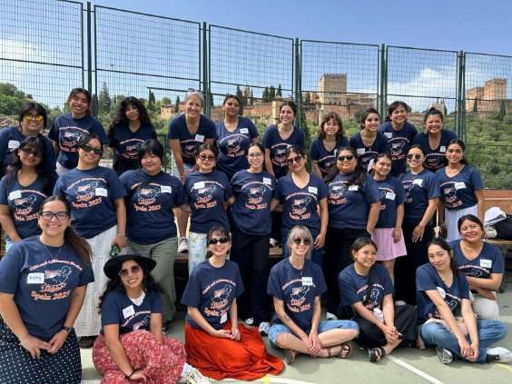

Department of
Child & Adolescent Studies (CAS)
2027 Short-Term Study Abroad Program Info Session:
Spain
Professor JudelMay Mariano
1


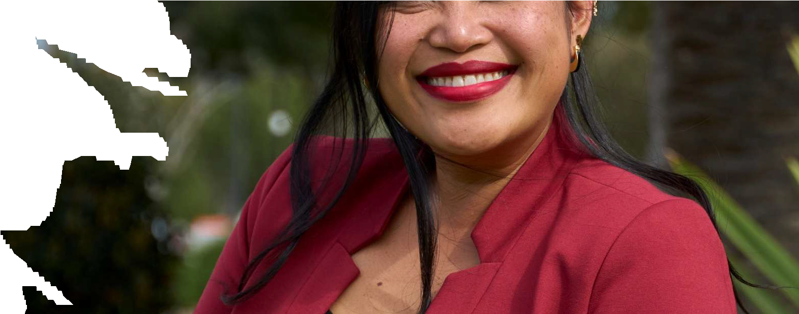


Who Is Teaching & Traveling?
Professor JudelMay Mariano
- CSUF CAS alumni
- CAS Dept:
  - 10th year teaching
  - 4th year as academic advisor
  - 2nd year as Study Abroad Lead Coordinator
- Hobbies: traveling, the great outdoors, musicals, camping, cozy fantasy books, family and friends, good eats, playing video games, and watching anime
- Travel: Broadly across the US, Japan, Costa Rica (2x), Spain, France, London,
Argentina, Uruguay, & Mexico
  - Upcoming Trips: London & Edinburgh, Scotland

Other Traveling Faculty: Dr. Claudia Pineda
2

What comes to mind when you hear study abroad?
3

What are your expectations in studying abroad?
4

Why Study Abroad?
- Transferable skills
- Use in your future career
- Theory into practice
- Increase resiliency, independence
- Make lifelong memories and friends
- Complete your practicum class
- Visit a different country and learn about a different culture
- Safe and secure
– with experienced professors/faculty
- Cheaper way to travel
- And much more…
5

CAS Practicum Classes
- As a CAS major, you must do two Practicum classes
  - CAS 394 (Intro)
    - Prereqs: CAS 101 & 201
    - If CAS Minor, this is one of your Minor Elective choices
  - CAS 400-level Advanced Practicum
    - Prereqs: CAS 394 & CAS 325A
- To pass class, you must complete class content and 60 hours outside of class time working with children and/or adolescents
  - Need a “C” grade or better
- Different formats to complete this:
  - Locally through CSUF CICE
    - https://www.fullerton.edu/cice/academic-internships/students/
  - Special short-term Study Abroad

- If you have completed both practicum courses, you may be able to enroll in 499 for 1 unit (special projects)
  - Attend all required meetings, complete special projects to fulfill class requirements, + travel
6

SS 2027 Short-Term Study Abroad Process
- Students apply through CSUF Study Abroad & Global Engagement (SAGE)
  - https://fullerton-sa.terradotta.com/
- Committee chooses 22 students
- Students receive an email; accept or waitlist
- Competitive; not guaranteed
- If accept, must do a deposit and follow all instructions to secure spot.
  - University also does a conduct check
  - Students will be issued a permit to register for Prof. Mariano’s special sections of practicum class: CAS 394, CAS 474, CAS 494, OR CAS 499

- If you plan on taking a practicum class in the Spring semester, register for one since acceptance for Spain is not guaranteed
7

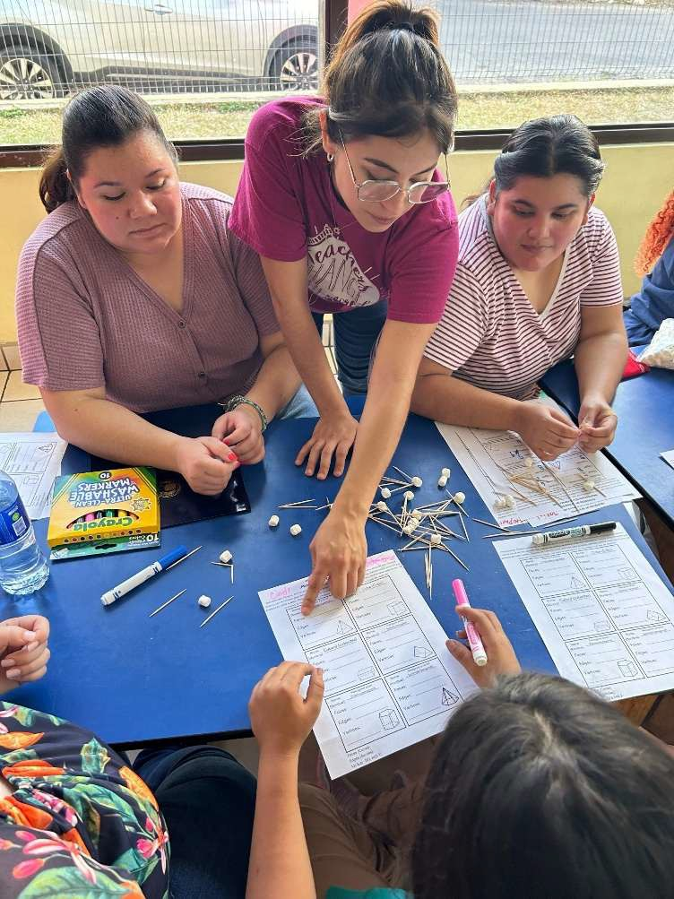
Components of study abroad
A practicum/service-learning course with required hours (60 hours):
This is Not Voluntourism (we are service learning/practicum students)
This is an Educational experience:
We are in an Educational travel role and representing CSUF/CAS
We are culturally humble:
We are traveling together as a class and learning about Spain
A Faculty/student collaboration:
This is a journey and transformational experience for each student!
8

SS 2027 Short-Term Study Abroad: Spain
- Class AND travel during Summer Session 2027
- Summer Session D class (8 weeks)
  - Hybrid
  - May 25, 2027 to July 16, 2027
- Travel dates of June 5 – 16, 2027
- Application: Opens soon
- Committee: Will meet in October
- Initial Deposit of $500: Due End of October
9

SS 2027 Short-Term Study Abroad Requirements
- Must pay Summer Session fees
- Accepted graduating Seniors must move their grad term to SS27
– One Commencement per year: can participate if completing graduation requirements in FA26, WI27, SP27, & SS27.
- $500 deposit to show commitment
- Meet once a month on Friday mornings during Spring 2027 semester for 2 hours
– Jan – May 2027, 10 am – 12 pm
10

2026-2027 Short-Term Study Abroad Process
- Lots of involvement with many moving, separate, and distinct entities before, during, and after class AND travel
  - CSUF & Cashier’s Office
  - Office of Study Abroad & Global Engagement (SAGE)
  - ARCOS Study Abroad: our on the ground vendor
  - CAS class
    - Spring semester monthly meetings
    - There will be a mandatory post-travel debrief meeting
    - Class and assignments will still be happening until mid-July
- Requires more from you
- STUDY abroad
11

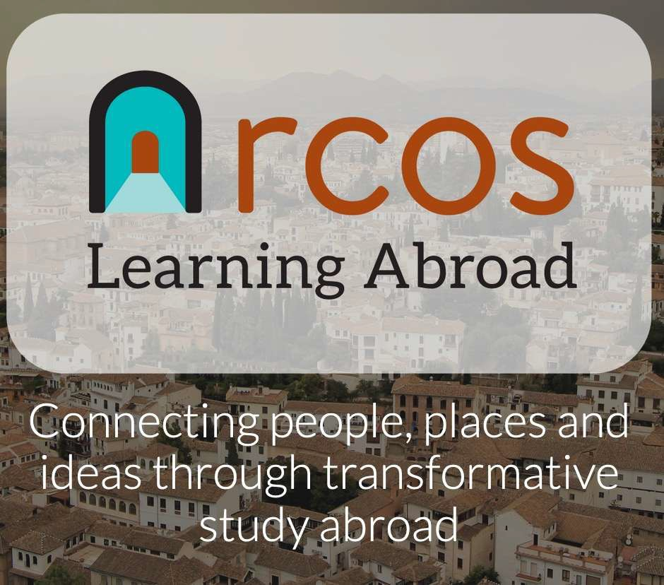

Third-Party Provider
https://www.arcosabroad.com/

ARCOS is a CSUF
approved vendor. We traveled with them for over 10 years to multiple locations.
12

SS27 Practicum Class: May 25, 2027 to July 16, 2027
- 8 weeks; hybrid class: mix of in-person, Zoom, and asynchronous work
- In person classes: 10:00 AM - 11:50 AM in EC 25
- Course assignments, attendance, & participation
- 60 practicum hours: 15 here & 45 in Spain
- Preparation activities aligned with the international experience will be both in class and abroad (all 60 hrs)
13

SS27 Study Abroad Class Hours:
60 hours minimum & 80 hours maximum
- 60 practicum hours: 15 here & 45 in Spain
- 15 hours throughout SS:
  - Work in Teaching Teams
  - Complete Lesson Plans
  - Parenting & Family Life Guest Speaker
  - ARCOS Pre-departure orientation
- 45 hours abroad:
  - Cultural activities
  - Service-learning hours
14

Granada, Spain School Visits and Debrief Sessions
In Granada
- CAS students will be working with students in a parochial/public elem school and stay at this educational setting for the majority of our visit.
- Conversation with parents, adolescents and/or young adults about parenting, preparing for careers or university and family life.
- Staying in residence halls (dorms)
15

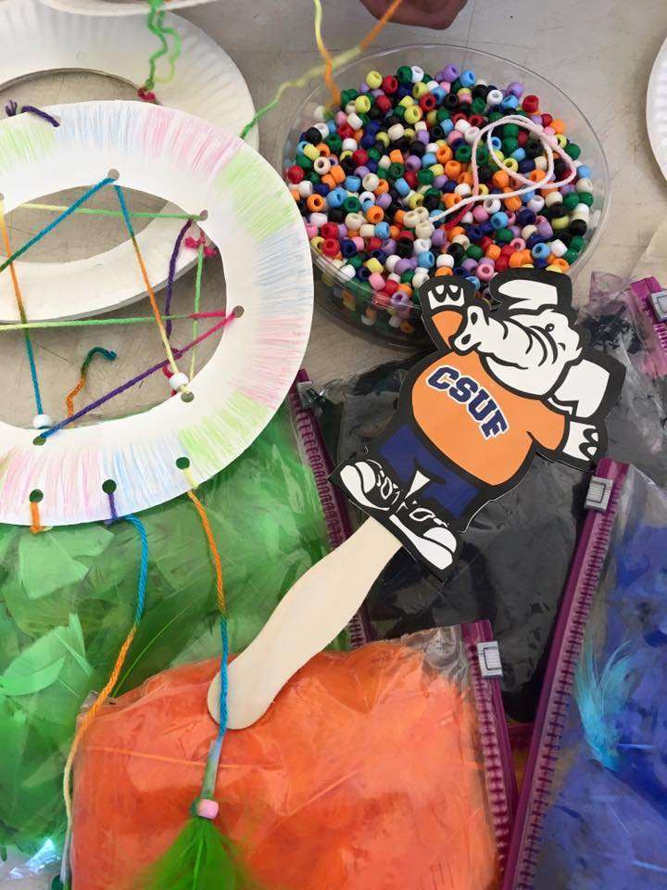
Prepare Activities (Lesson Plans)
- During your practicum course, you are responsible for developing 2 lesson plans and filler activities to implement abroad.
- You are required to take with you all lesson plans/ activities materials.
16

Date | ACTIVITY PROGRAM DATES: June 5 – 16, 2027
6/5/2027 | Arrive in Granada, Spain. Check in to school dorm.
6/6/2027 | In-country Orientation & City Tour.
6/7/2027 | Begin Practicum at Ave Maria school & Arabic Tea House.
6/8/2027 | Practicum at Ave Maria school.
6/9/2027 | Practicum at Ave Maria school & Sacromonte Cave Museum.
6/10/2027 | Practicum at Ave Maria school & Flamenco Dance Class &  Performance.
6/11/2027 | Complete Practicum at Ave Maria school.
6/12/2027 | Day Excursion: Nerja Beach Trip
6/13/2027 | Alhambra Palace Guided Cultural Activity Tour.
6/14/2027 | Guest Speaker about Spain Family & School Life and Royal  Chapel & Cathedral Tour
6/15/2027 | Free Day and Farewell Dinner
6/16/2027 | Program Concludes. Depart Spain and go back to USA.

17

Tentative
Itinerary Overview







Is this Program for Me?
It depends…
- Vacation vs. Educational trip
- Flexible vs. non-flexible
- Stress/anxiety -Types of lodging
- Teaching or student activities

Google images 2024
18

Student Expectations
- Lean into discomfort
- Responsible and committed
- Communicative
- Checks email frequently; responsive
- Keep up to date with class and tasks
- Prep work and mental health
- Passport (and Visa if a national of another country)
- If you can…try!
19


CAS in Spain 2025!
https://www.youtube.com/watch?v=rJcm6OP2RqQ
20

Date | ACTIVITY PROGRAM DATES: June 5 – 16, 2027
6/5/2027 | Arrive in Granada, Spain. Check in to school dorm.
6/6/2027 | In-country Orientation & City Tour.
6/7/2027 | Begin Practicum at Ave Maria school & Arabic Tea House.
6/8/2027 | Practicum at Ave Maria school.
6/9/2027 | Practicum at Ave Maria school & Sacromonte Cave Museum.
6/10/2027 | Practicum at Ave Maria school & Flamenco Dance Class &  Performance.
6/11/2027 | Complete Practicum at Ave Maria school.
6/12/2027 | Day Excursion: Nerja Beach Trip
6/13/2027 | Alhambra Palace Guided Cultural Activity Tour.
6/14/2027 | Guest Speaker about Spain Family & School Life and Royal  Chapel & Cathedral Tour
6/15/2027 | Free Day and Farewell Dinner
6/16/2027 | Program Concludes. Depart Spain and go back to USA.

21

Tentative
Itinerary Overview

Original program fee: $3115 With IRA Support: $1360
- Included for 12 days:
  - Lodging at school dorm
  - Airport Transfers and day trips
  - Travel Insurance
  - All breakfasts and most lunches and dinners
  - Cultural activities and excursions
  - Education/Community-based experiences and guest speakers
- Only $113.34/day
- Program fees do not include:
  - CSUF tuition for Summer Session 2027
  - Roundtrip flights
  - Passport fees, immunizations, health insurance, meals other than those indicated in the itinerary
  - Some teaching materials
  - Some meals
  - Other personal costs (e.g., entertainment, shopping)
22

If interested in joining…
- Complete online SAGE application (will open soon!)
- Create an account
- Carefully follow APPLY instructions

Deadline for Applications is beginning of October, and selections made approximately 1 - 2 weeks later. Check your Fullerton email on a regular basis.
23

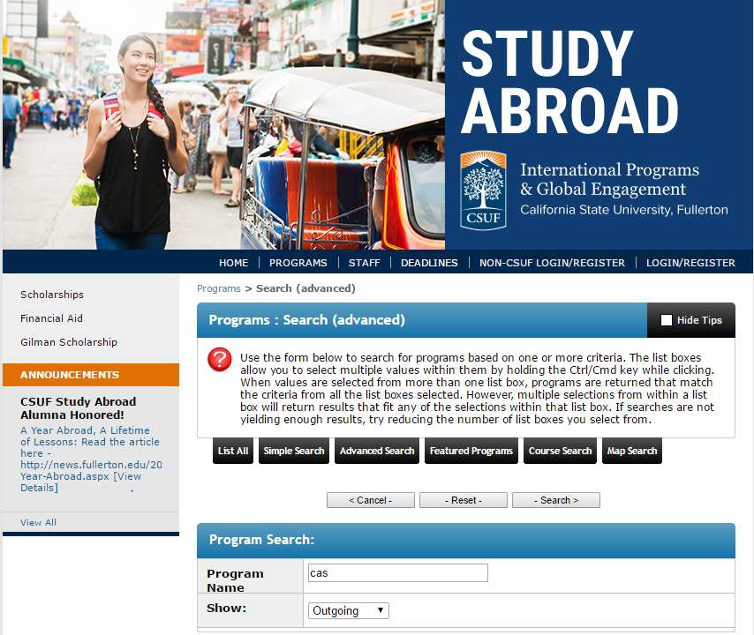
Look at how to Apply on the CSUF Study Abroad Website
- https://extension.fullerton.edu/studyabroad/default.aspx
If you click on the link listed above, click on Search Programs, enter “CAS” for program then pick CSUF: CAS International Internship, Option in Granada, Spain (SS27).

Explore ahead of time and make sure you can sign in to Portal.
Direct Application link will be provided at a later time.
24


•
•
•
•
•
•
•
•
Tips for Application
Leave ample time to complete Provide thoughtful responses Be descriptive and compelling Make it personal to you
No typos
No AI; we can tell
Stay address (TBD-leave blank)
Google images 2024
•
Enroll in another practicum class in case you are
not accepted
Submit by the due date and time!
25

Accepted? Do you read your Fullerton emails?
- Program Participants will be selected by a committee after the application due date
- Once selected, you will be notified via email
- You have 48 hours to accept or we move to the next person on the waitlist
- Read the email carefully and thoroughly and complete all things required
26

Contacts
- For Program Questions:
Professor JudelMay Mariano, CAS Short-term Study Abroad Program Coordinator (have Spain 2027 in the subject line): jmmariano@fullerton.edu
CAS Study Abroad website: https://hhd.fullerton.edu/cas/current-student/study-abroad/upcoming.html
- For Application Questions: SAGE
  - sabroad@fullerton.edu
27



Questions?
28

